Table of Contents

UNITED STATES

SECURITIES AND EXCHANGE COMMISSION

Washington, D.C. 20549

FORM 10-Q

(Mark One)

- QUARTERLY REPORT PURSUANT TO SECTION 13 OR 15(d) OF THE SECURITIES EXCHANGE ACT OF 1934

For the quarterly period ended March 31, 2022

OR

- TRANSITION REPORT PURSUANT TO SECTION 13 OR 15(d) OF THE SECURITIES EXCHANGE ACT OF 1934 For the transition period from to

Commission file number 001-39128

Momentus Inc.

(Exact name of registrant as specified in its charter)

Delaware

(State or other jurisdiction of incorporation or organization)

3901 N. First Street

San Jose, California

(Address of Principal Executive Offices)

(650) 564-7820

Registrant's telephone number, including area code

Securities registered pursuant to section 12(g) of the Act:

84-1905538

(I.R.S. Employer Identification No.)

95134

(Zip Code)

Title of each class | Trading Symbol(s) | Name of each exchange on which registered
Class A common stock | MNTS | The Nasdaq Capital Market LLC
Warrants | MNTSW | The Nasdaq Capital Market LLC

Indicate by check mark whether the registrant: (1) has filed all reports required to be filed by Section 13 or 15(d) of the Securities Exchange Act of 1934 during the preceding 12 months (or for such shorter period that the registrant was required to file such reports); and (2) has been subject to such filing requirements for the past 90 days. Yes x No o

Indicate by check mark whether the registrant has submitted electronically and posted on its corporate web site, if any, every Interactive Data File required to be submitted and posted pursuant to Rule 405 of Regulation S-T (§232.405 of this chapter) during the preceding 12 months (or for such shorter period that the registrant was required to submit and post such files). Yes x No o

Indicate by check mark whether the registrant is a large accelerated filer, an accelerated filer, a non-accelerated filer, or a smaller reporting company. See the definitions of “large accelerated filer,” “accelerated filer” and “smaller reporting company” in Rule 12b-2 of the Exchange Act. (Check one):

Large accelerated filer | o | Accelerated filer | o
Non-accelerated filer | x | Smaller reporting company | x
 |  | Emerging growth company | x
 |  | 1

Table of Contents

If an emerging growth company, indicate by check mark if the registrant has elected not to use the extended transition period for complying with any new or revised financial accounting standards provided pursuant to Section 13(a) of the Exchange Act.

o

Indicate by check mark whether the registrant is a shell company (as defined in Rule 12b-2 of the Act). Yes o No x

The registrant had outstanding 81,755,715 shares of common stock as of March 31, 2022.

2

Tables of Contents
 | TABLE OF CONTENTS
 |  | Page
Part I - Financial Information |  | 5
Item 1. Unaudited Financial Statements |  | 5
Condensed Consolidated Balance Sheets |  | 5
Condensed Consolidated Statements of Operations |  | 6
Condensed Consolidated Statements of Stockholders’ Equity (Deficit) |  | 7
Condensed Consolidated Statements of Cash Flows |  | 8
Notes to the Condensed Consolidated Financial Statements |  | 9
Item 2. Management's Discussion and Analysis of Financial Condition and Results of Operations |  | 32
Item 3. Quantitative and Qualitative Disclosures About Market Risk |  | 47
Item 4. Controls and Procedures |  | 48
Part II - Other Information |  | 49
Item 1. Legal Proceedings |  | 49
Item 1A. Risk Factors |  | 49
Item 2. Unregistered Sales of Equity Securities and Use of Proceeds |  | 49
Item 3. Defaults Upon Senior Securities |  | 49
Item 4. Mine Safety Disclosures |  | 49
Item 5. Other Information |  | 49
Item 6. Exhibits |  | 50
Signatures |  | 51

CAUTIONARY NOTE REGARDING FORWARD-LOOKING STATEMENTS

This quarterly report on Form 10-Q (this "Form 10-Q”), including, without limitation, statements under the headings "Management's Discussion and Analysis of Financial Condition and Results of Operations," includes forward-looking statements within the meaning of Section 27A of the Securities Act of 1933, as amended, (the "Securities Act") and Section 21E of the Securities Exchange Act of 1934, as amended, (the "Exchange Act"). Generally, statements that are not historical facts, including statements concerning Momentus Inc.’s (the “Company,” “we,” “us,” or “our”) possible or assumed future actions, business strategies, events, or results of operations, are forward-looking statements. These forward-looking statements can be identified by the use of forward-looking terminology, including the words "believes," "estimates," "anticipates," "expects," "intends," "plans," "may," "will," "potential," "projects," "predicts," "continue," or "should," or, in each case, their negative or other variations or comparable terminology, but the absence of these words does not mean that a statement is not forward-looking. There can be no assurance that actual results will not materially differ from expectations.

The forward-looking statements contained in this Form 10-Q are based on our current expectations and beliefs concerning future developments and their potential effects on us. Future developments affecting us may not be those that we have anticipated. These forward-looking statements involve a number of risks, uncertainties (some of which are beyond our control) and other assumptions that may cause actual results or performance to be materially different from those expressed or implied by these forward-looking statements. These risks and uncertainties include, without limitation, the ability of the Company to obtain licenses and government approvals for its missions, which are essential to its operations; the ability of the Company to effectively market and sell satellite transport services and planned in-orbit services; the ability of the Company to protect its intellectual property and trade secrets; the development of markets for satellite transport and in-orbit services; the ability of the Company to develop, test and validate its technology, including its water plasma propulsion technology; delays or impediments that the Company may face in the development, manufacture and deployment of next generation satellite transport systems; the ability of the Company to convert backlog or inbound inquiries into revenue; changes in applicable laws or regulations and extensive and evolving government regulations that impact operations and business, including export control license requirements; the ability to attract or maintain a qualified workforce with the required security clearances and requisite skills; level of product service or product or launch failures or delays that could lead customers to use competitors’ services; investigations, claims, disputes, enforcement actions, litigation and/or other regulatory or legal proceedings; the effects of the COVID-19 pandemic on the Company’s business; the Company’s ability to comply with the terms of its National Security Agreement (the “NSA”) and any related compliance measures instituted by the director who was approved by the Committee on Foreign Investment in the United States (“CFIUS”) Monitoring Agencies (the “Security Director”); the possibility that the Company may be adversely affected by other economic, business, and/or competitive factors; and/or other risks and uncertainties

3

Tables of Contents

described under Part II, Item 1A: "Risk Factors." Should one or more of these risks or uncertainties materialize, or should any of our assumptions prove incorrect, actual results may vary in material respects from those projected in these forward-looking statements. We undertake no obligation to update or revise any forward-looking statements, whether as a result of new information, future events, or otherwise, except as may be required under applicable securities laws. These risks and others described under Part II, Item 1A: "Risk Factors" may not be exhaustive.

By their nature, forward-looking statements involve risks and uncertainties because they relate to events and depend on circumstances that may or may not occur in the future. We caution you that forward-looking statements are not guarantees of future performance and that our actual results of operations, financial condition and liquidity, and developments in the industry in which we operate may differ materially from those made in or suggested by the forward-looking statements contained in this Form 10-Q. These statements are inherently uncertain and investors are cautioned not to unduly rely upon these statements. In addition, even if our results or operations, financial condition and liquidity, and developments in the industry in which we operate are consistent with the forward-looking statements contained in this Form 10-Q, those results or developments may not be indicative of results or developments in subsequent periods.

4

Tables of Contents

ITEM 1. FINANCIAL STATEMENTS

MOMENTUS INC.

CONDENSED CONSOLIDATED BALANCE SHEETS

(in thousands)

 | March 31, |  |  |  | December 31,
 | 2022 |  |  |  | 2021
 | (unaudited)
ASSETS
Current assets:
Cash and cash equivalents | $ | 135,602 |  | $ | 160,036
Restricted cash, current |  | 100 |  |  | 197
Prepaids and other current assets |  | 7,984 |  |  | 9,431
Total current assets |  | 143,686 |  |  | 169,664
Property, machinery and equipment, net |  | 4,726 |  |  | 4,829
Intangible assets, net |  | 656 |  |  | 349
Operating right of use asset |  | 7,282 |  |  | 7,604
Restricted cash, non-current |  | 324 |  |  | 314
Other non-current assets |  | 5,750 |  |  | 3,065
Total assets | $ | 162,424 |  | $ | 185,825
LIABILITIES AND STOCKHOLDERS’ EQUITY
Accounts payable | $ | 3,289 |  | $ | 1,911
Accrued expenses |  | 9,568 |  |  | 9,785
Loan payable, current |  | 9,432 |  |  | 20,907
Operating lease liability, current |  | 1,143 |  |  | 1,189
Share repurchase liability, current |  | 6,000 |  |  | —
Other current liabilities |  | 5,090 |  |  | 5,075
Total current liabilities |  | 34,522 |  |  | 38,867
Contract liabilities, non-current |  | 1,654 |  |  | 1,554
Loan Payable, non-current |  | 11,303 |  |  | —
Warrant liability |  | 6,200 |  |  | 5,749
Operating lease liability, non-current |  | 7,002 |  |  | 7,284
Other non-current liabilities |  | 488 |  |  | 483
Total non-current liabilities |  | 26,647 |  |  | 15,070
Total liabilities |  | 61,169 |  |  | 53,937
Commitments and Contingencies (Note 12)
Stockholders’ equity:
Common stock, $0.00001 par value; 250,000,000 shares authorized and 81,755,715 issued and outstanding as of March 31, 2022; 142,804,498 shares |  | 1 |  |  | 1
authorized and 81,211,781 issued and outstanding as of December 31, 2021 |  | 1 |  |  | 1
Additional paid-in capital |  | 336,771 |  |  | 340,570
Accumulated deficit |  | (235,517) |  |  | (208,683)
Total stockholders’ equity |  | 101,255 |  |  | 131,888
Total liabilities and stockholders’ equity | $ | 162,424 |  | $ | 185,825

The accompanying notes are an integral part of these condensed consolidated financial statements

The balance sheet at December 31, 2021 has been derived from the audited financial statements at that date

5

Tables of Contents
 |  | MOMENTUS INC.
 |  | CONDENSED CONSOLIDATED STATEMENTS OF OPERATIONS
 |  | (UNAUDITED)
 |  | (in thousands, except per share data)
 |  |  |  | Three Months Ended
 |  |  |  | March 31,
 |  |  | 2022 |  |  |  | 2021
Service revenue |  |  | $ | — |  | $ | 130
Cost of revenue |  |  |  | — |  |  | 48
Gross margin |  |  |  | — |  |  | 82
Operating expenses:
Research and development expenses |  |  |  | 9,971 |  |  | 9,906
Selling, general and administrative expenses |  |  |  | 14,853 |  |  | 14,005
Total operating expenses |  |  |  | 24,824 |  |  | 23,911
Loss from operations |  |  |  | (24,824) |  |  | (23,829)
Other income (expense):
Decrease in fair value of SAFE notes |  |  |  | — |  |  | 81,564
Decrease (increase) in fair value of warrants |  |  |  | (451) |  |  | 8,083
Realized loss on disposal of asset |  |  |  | (70) |  |  | —
Interest income |  |  |  | — |  |  | 1
Interest expense |  |  |  | (1,492) |  |  | (968)
Other income (expense) |  |  |  | 3 |  |  | (179)
Total other income (expense) |  |  |  | (2,010) |  |  | 88,500
Net income (loss) |  |  | $ | (26,834) |  | $ | 64,671
Net income (loss) per share, basic |  |  | $ | (0.34) |  | $ | 1.03
Net income (loss) per share, diluted |  | $ |  | (0.34) |  | $ | (0.28)
Weighted average shares outstanding, basic |  |  |  | 79,958,383 |  |  | 62,733,080
Weighted average shares outstanding, diluted |  |  |  | 79,958,383 |  |  | 87,684,818

The accompanying notes are an integral part of these condensed consolidated financial statements

6

Tables of Contents

MOMENTUS INC.

CONDENSED CONSOLIDATED STATEMENTS OF STOCKHOLDERS’ EQUITY (DEFICIT)
(UNAUDITED)
(in thousands, except share data)

Balance, December 31, 2021

Issuance of common stock upon exercise of stock options

Issuance of common stock upon vesting of RSUs

Share repurchase related to Section 16 Officer tax coverage exchange

Stock-based compensation – Stock options and RSAs

Share repurchase

Shares issued upon exercise of Warrant

Net loss

March 31, 2022

Balance, December 31, 2020

Retroactive application of recapitalization

Balance, December 31, 2020, as adjusted

Issuance of common stock upon exercise of stock options

Stock-based compensation – Stock options and RSAs

Net income

March 31, 2021

 |  |  |  |  |  |  |  |  |  |  |  |  |  |  |  |  |  |  | Common stock – |  |  |  |  |  |  |  |  |  | Common stock – |  |  |  |  |  |  |  |  |  |  |  |  |  |  |  |  |  |  | Common stock – |  |  |  |  |  |  |  |  |  |  |  |  |  |  |  |  |  |  | Total
 | Preferred stock |  |  |  |  |  |  |  |  | FF Preferred stock |  |  |  |  |  |  |  |  | Class A |  |  |  |  |  |  |  |  |  | Class B |  |  |  |  |  |  |  |  |  | Treasury Stock |  |  |  |  |  |  |  |  | Class A |  |  |  |  |  |  |  |  |  |  |  |  |  |  |  |  |  |  | Total
 |  |  |  |  |  |  |  |  |  |  |  |  |  |  |  |  |  |  |  |  |  |  |  |  |  |  |  |  |  |  |  |  |  |  |  |  |  |  |  |  |  |  |  |  |  |  |  |  |  |  |  |  |  |  |  |  | Additional paid |  |  |  |  |  | Accumulated |  |  |  | stockholders’
 | Shares |  |  |  |  | Amount |  |  |  | Shares |  |  |  | Amount |  |  |  |  | Shares |  |  |  |  | Amount |  |  |  |  | Shares |  |  |  |  | Amount |  |  |  |  | Shares |  |  |  | Amount |  |  |  |  | Shares |  |  |  |  | Amount |  |  |  |  | in capital |  |  |  |  | deficit |  |  |  | equity (deficit)
 | — |  |  | $ |  | — |  |  | — |  |  |  | $ |  | — |  |  | — |  |  |  | $ |  |  | — |  |  | — |  |  |  | $ |  |  | — |  |  | — |  |  |  | $ |  | — |  |  | 81,211,781 |  |  |  | $ |  | 1 |  |  | $ |  | 340,570 |  |  | $ |  | (208,683) |  | $ |  | 131,888
 | — |  |  |  |  | — |  |  |  | — |  |  |  |  | — |  |  |  | — |  |  |  |  |  | — |  |  |  | — |  |  |  |  |  | — |  |  |  | — |  |  |  |  | — |  |  | 170,751 |  |  |  |  |  | — |  |  |  |  | 48 |  |  |  |  | — |  |  |  | 48
 | — |  |  |  |  | — |  |  |  | — |  |  |  |  | — |  |  |  | — |  |  |  |  |  | — |  |  |  | — |  |  |  |  |  | — |  |  |  | — |  |  |  |  | — |  |  | 113,710 |  |  |  |  |  | — |  |  |  |  | — |  |  |  |  | — |  |  |  | —
 | — |  |  |  |  | — |  |  |  | — |  |  |  |  | — |  |  |  | — |  |  |  |  |  | — |  |  |  | — |  |  |  |  |  | — |  |  |  | — |  |  |  |  | — |  |  | (18,673) |  |  |  |  |  | — |  |  |  |  | (59) |  |  |  |  | — |  |  |  | (59)
 | — |  |  |  |  | — |  |  |  | — |  |  |  |  | — |  |  |  | — |  |  |  |  |  | — |  |  |  | — |  |  |  |  |  | — |  |  |  | — |  |  |  |  | — |  |  |  | — |  |  |  |  | — |  |  |  |  | 2,212 |  |  |  |  | — |  |  |  | 2,212
 | — |  |  |  |  | — |  |  |  | — |  |  |  |  | — |  |  |  | — |  |  |  |  |  | — |  |  |  | — |  |  |  |  |  | — |  |  |  | — |  |  |  |  | — |  |  |  | — |  |  |  |  | — |  |  |  |  | (6,000) |  |  |  |  | — |  |  |  | (6,000)
 | — |  |  |  |  | — |  |  |  | — |  |  |  |  | — |  |  |  | — |  |  |  |  |  | — |  |  |  | — |  |  |  |  |  | — |  |  |  | — |  |  |  |  | — |  |  | 278,146 |  |  |  |  |  | — |  |  |  |  | — |  |  |  |  | — |  |  |  | —
 | — |  |  |  |  | — |  |  |  | — |  |  |  |  | — |  |  |  | — |  |  |  |  |  | — |  |  |  | — |  |  |  |  |  | — |  |  |  | — |  |  |  |  | — |  |  |  | — |  |  |  |  | — |  |  |  |  | — |  |  |  |  | (26,834) |  |  |  | (26,834)
 | — |  |  | $ |  | — |  |  | — |  |  |  | $ |  | — |  |  | — |  |  |  | $ |  |  | — |  |  | — |  |  |  | $ |  |  | — |  |  | — |  |  |  | $ |  | — |  |  | 81,755,715 |  |  |  | $ |  | 1 |  |  | $ |  | 336,771 |  |  | $ |  | (235,517) |  | $ |  | 101,255
 |  |  |  |  |  |  |  |  |  |  |  |  |  |  |  |  |  |  | Common stock – |  |  |  |  |  |  |  |  |  | Common stock – |  |  |  |  |  |  |  |  |  |  |  |  |  |  |  |  |  |  | Common stock – |  |  |  |  |  |  |  |  |  |  |  |  |  |  |  |  |  |  | Total
 | Preferred stock |  |  |  |  |  |  |  |  | FF Preferred stock |  |  |  |  |  |  |  |  | Class A |  |  |  |  |  |  |  |  |  | Class B |  |  |  |  |  |  |  |  |  | Treasury Stock |  |  |  |  |  |  |  |  | Class A |  |  |  |  |  |  |  |  |  |  |  |  |  |  |  |  |  |  | Total
 |  |  |  |  |  |  |  |  |  |  |  |  |  |  |  |  |  |  |  |  |  |  |  |  |  |  |  |  |  |  |  |  |  |  |  |  |  |  |  |  |  |  |  |  |  |  |  |  |  |  |  |  |  |  |  |  | Additional paid |  |  |  |  |  | Accumulated |  |  |  | stockholders’
 | Shares |  |  |  |  | Amount |  |  |  | Shares |  |  |  | Amount |  |  |  |  | Shares |  |  |  |  | Amount |  |  |  |  | Shares |  |  |  |  | Amount |  |  |  |  | Shares |  |  |  | Amount |  |  |  |  | Shares |  |  |  |  | Amount |  |  |  |  | in capital |  |  |  |  | deficit |  |  |  | deficit
144,875,941 |  |  |  |  | — |  |  |  |  | 20,000,000 |  |  |  | — |  |  |  |  | 18,398,005 |  |  |  | — |  |  |  |  |  | 70,000,000 |  |  |  | — |  |  |  |  |  | — |  |  |  | — |  |  |  |  | — |  |  |  | $ | — |  |  |  | $ | 39,866 |  |  |  | $ | (329,338) |  |  | $ | (289,472)
 | (144,875,941) |  |  |  |  | — |  |  | (20,000,000) |  |  |  |  |  | — |  |  | (18,398,005) |  |  |  |  |  |  | — |  |  | (70,000,000) |  |  |  |  |  |  | — |  |  |  | — |  |  |  |  | — |  |  | 62,510,690 |  |  |  |  |  | 1 |  |  |  |  | — |  |  |  |  | — |  |  |  | —
 | — |  |  | $ |  | — |  |  |  | — |  |  | $ |  | — |  |  |  | — |  |  |  |  | $ | — |  |  |  | — |  |  |  |  | $ | — |  |  |  | — |  |  | $ |  | — |  |  | 62,510,690 |  |  |  | $ |  | 1 |  |  | $ |  | 39,866 |  |  | $ |  | (329,338) |  | $ |  | (289,472)
 | — |  |  |  |  | — |  |  |  | — |  |  |  |  | — |  |  |  | — |  |  |  |  |  | — |  |  |  | — |  |  |  |  |  | — |  |  |  | — |  |  |  |  | — |  |  | 270,582 |  |  |  |  |  | — |  |  |  |  | 24 |  |  |  |  | — |  |  |  | 24
 | — |  |  |  |  | — |  |  |  | — |  |  |  |  | — |  |  |  | — |  |  |  |  |  | — |  |  |  | — |  |  |  |  |  | — |  |  |  | — |  |  |  |  | — |  |  |  | — |  |  |  |  | — |  |  |  |  | 5,768 |  |  |  |  | — |  |  |  | 5,768
 | — |  |  |  |  | — |  |  |  | — |  |  |  |  | — |  |  |  | — |  |  |  |  |  | — |  |  |  | — |  |  |  |  |  | — |  |  |  | — |  |  |  |  | — |  |  |  | — |  |  |  |  | — |  |  |  |  | — |  |  |  |  | 64,671 |  |  |  | 64,671
— |  |  |  |  | $ | — |  |  |  | — |  |  |  | $ | — |  |  |  | — |  |  |  | $ |  | — |  |  |  | — |  |  |  | $ |  | — |  |  |  | — |  |  |  | $ | — |  |  |  | 62,781,272 |  |  |  | $ | 1 |  |  |  | $ | 45,658 |  |  |  | $ | (264,667) |  |  | $ | (219,009)

The accompanying notes are an integral part of these condensed consolidated financial statements

7

Tables of Contents

MOMENTUS INC.

CONDENSED CONSOLIDATED STATEMENTS OF CASH FLOWS
(UNAUDITED)
(in thousands)

Three Months Ended
March 31,

 | 2022 |  |  |  | 2021
Cash flows from operating activities:
Net income (loss) | $ | (26,834) |  | $ | 64,671
Adjustments to reconcile net income (loss) to net cash used in operating activities:
Depreciation and amortization |  | 294 |  |  | 199
Amortization of debt discount and issuance costs |  | 742 |  |  | 718
Accrued interest |  | 13 |  |  | —
(Decrease) increase in fair value of warrants |  | 451 |  |  | (8,083)
Decrease in fair value of SAFE notes |  | — |  |  | (81,564)
Impairment of prepaid launch costs |  | — |  |  | 750
Loss on disposal of fixed asset |  | 70 |  |  | —
Stock-based compensation expense |  | 2,212 |  |  | 5,768
Changes in operating assets and liabilities:
Prepaids and other current assets |  | 1,447 |  |  | (9,246)
Other non-current assets |  | (2,685) |  |  | 93
Accounts payable |  | 1,387 |  |  | (97)
Accrued expenses |  | (273) |  |  | 5,120
Other current liabilities |  | 14 |  |  | 80
Contract liabilities |  | 100 |  |  | 146
Lease liability and right of use asset |  | (6) |  |  | 245
Other non-current liabilities |  | 6 |  |  | —
Net cash used in operating activities |  | (23,062) |  |  | (21,199)
Cash flows from investing activities:
Purchases of property, machinery and equipment |  | (290) |  |  | (429)
Purchases of intangible assets |  | (231) |  |  | (3)
Net cash used in investing activities |  | (521) |  |  | (431)
Cash flows from financing activities:
Proceeds from issuance of SAFE notes |  | — |  |  | 30,853
Proceeds from issuance of loan payable |  | — |  |  | 25,000
Proceeds from exercise of stock options |  | 48 |  |  | 24
Repurchase of Section 16 Officer shares for tax coverage exchange |  | (59) |  |  | —
Payment of notes payable |  | (927) |  |  | —
Payment of debt issuance costs |  | — |  |  | (144)
Payment of warrant issuance costs |  | — |  |  | (31)
Net cash (used in) provided by financing activities |  | (938) |  |  | 55,702
Increase in cash, cash equivalents and restricted cash |  | (24,521) |  |  | 34,071
Cash, cash equivalents and restricted cash, beginning of period |  | 160,547 |  |  | 23,520
Cash, cash equivalents and restricted cash, end of period | $ | 136,026 |  | $ | 57,591
Supplemental disclosure of non-cash investing and financing activities
Deferred offering costs in accounts payable and accrued expenses at period end | $ | — |  | $ | 861
Operating lease right-of-use assets in exchange for lease obligations | $ | — |  | $ | 8,501
Share repurchase liability fair value | $ | 6,000 |  | $ | —
Supplemental disclosure of cash flow information
Cash paid for interest | $ | 750 |  | $ | 250

The accompanying notes are an integral part of these condensed consolidated financial statements

8

Tables of Contents

MOMENTUS INC.

NOTES TO THE CONDENSED CONSOLIDATED FINANCIAL STATEMENTS

Note 1. Nature of Operations

The Company

Momentus Inc. (together with its consolidated subsidiaries “Momentus” or the “Company”) is a U.S. commercial space company that plans to offer in-space infrastructure services, including in-space transportation, hosted payloads and in-orbit services. Momentus believes it can make new ways of operating in space possible with its planned in-space transfer and service vehicles that will be powered by an innovative water plasma-based propulsion system that is under development. The Company anticipates flying its Vigoride vehicle to Low Earth Orbit on a third-party launch provider as early as May 2022, subject to receipt of licenses and government approvals, and successful completion of our current efforts to get the system ready for flight.

On May 4, 2022, as a subsequent event, the Company received a favorable determination from the Federal Aviation Administration (the “FAA”) of its application for payload review in support of the Company’s inaugural flight of the Vigoride orbital transfer vehicle on the launch targeted for May 2022. Together with a license from the Federal Communications Commission (the “FCC”) received on April 28, 2022, and updates to existing licenses from the National Oceanic and Atmospheric Administration (the “NOAA”), the Company has received all required government approvals required for its inaugural flight. See Note 14.

Background and Business Combination

On August 12, 2021, the Company consummated a merger pursuant to certain Agreement and Plan of Merger, dated October 7, 2020, and as amended on March 5, 2021, April 6, 2021, and June 29, 2021 (the “Merger Agreement”), by and among Stable Road Acquisition Corp (“SRAC”), Project Marvel First Merger Sub, Inc., a Delaware corporation and a direct, wholly owned subsidiary of SRAC (“First Merger Sub”), and Project Marvel Second Merger Sub, LLC, a Delaware limited liability company and a direct, wholly owned subsidiary of SRAC (“Second Merger Sub”), pursuant to which First Merger Sub merged with and into Momentus Inc., a Delaware corporation (“Legacy Momentus”) with Legacy Momentus as the surviving corporation of the First Merger Sub, and immediately following which Legacy Momentus merged with and into the Second Merger Sub, with the Second Merger Sub as the surviving entity (the “Business Combination”). In connection with the closing of the Business Combination (the “Closing”), the Company changed its name from Stable Road Acquisition Corp. to Momentus Inc., and Legacy Momentus changed its name to Momentus Space, LLC.

The Merger was accounted for as a reverse recapitalization under ASC Topic 805, Business Combinations, ("ASC 805") in accordance with accounting principles generally accepted in the United States (“GAAP”). Under this method of accounting, SRAC, who was the legal acquirer, is treated as the “acquired” company for financial reporting purposes and Legacy Momentus is treated as the accounting acquirer. Accordingly, for accounting purposes, the Merger is treated as the equivalent of a capital transaction in which Legacy Momentus issued stock for the net assets of SRAC, with no goodwill or other intangible assets recorded, and Legacy Momentus’ financial statements became those of the Company. Reported shares and earnings per share available to holders of the Company’s common stock, prior to the Business Combination, have been retroactively restated as shares reflecting the exchange ratio established in the Business Combination. See Note 3 for more information.

Pursuant to the Amended and Restated Certificate of Incorporation of the Company, at the Closing, each share of SRAC’s Class B Common Stock, par value $0.0001 per share (the “Class B Common Stock”), converted into one share of SRAC’s Class A Common Stock. After the Closing and following the effectiveness of the Second Amended and Restated Certificate of Incorporation of the Company, each share of Class A Common Stock was automatically reclassified, redesignated and changed into one validly issued, fully paid and non-assessable share of the Company’s Common Stock, par value $0.00001 per share (the “Common Stock”), without any further action by the Company or any stockholder thereof.

Prior to the Business Combination, SRAC’s units, public shares, and public warrants were listed on the Nasdaq under the symbols “SRACU,” “SRAC,” and “SRACW,” respectively. On August 13, 2021, the Company's Class A common stock and public warrants began trading on the Nasdaq, under the symbols “MNTS” and “MNTSW,” respectively.

9

Tables of Contents

MOMENTUS INC.

NOTES TO THE CONDENSED CONSOLIDATED FINANCIAL STATEMENTS

On October 7, 2020 and July 15, 2021, SRAC entered into subscription agreements with certain investors (the “PIPE Investors”) to which such investors collectively subscribed for an aggregate of 11,000,000 shares of the Company’s Class A common stock at $10.00 per share for aggregate gross proceeds of $110.0 million (the “PIPE Investment”). The PIPE Investors were also granted an equal number of private warrants to purchase the Company’s Class A common stock at $11.50 per share. The warrants were recorded as a derivative liability under ASC Topic 815, Derivatives and Hedging, (“ASC 815”) and the warrant liability was initially valued at $30.5 million. See Note 11 for more information. The PIPE Investment was consummated concurrently with the closing of the Merger.

Note 2. Summary of Significant Accounting Policies

These consolidated financial statements should be read in conjunction with the audited consolidated financial statements and notes thereto included in our Annual Report on Form 10-K filed by the Company on March 9, 2022.

Unaudited Interim Financial Information

The accompanying interim unaudited condensed consolidated financial statements have been prepared in accordance with GAAP and pursuant to the rules and regulations of the Securities and Exchange Commission (the “SEC”). Certain information and footnote disclosures normally included in financial statements prepared in accordance with GAAP have been condensed or omitted pursuant to such rules and regulations. The balance sheet as of December 31, 2021 was derived from the Company’s audited financial statements but does not include all disclosures required by GAAP for audited financial statements. Any reference in these notes to applicable guidance is meant to refer to the authoritative GAAP as found in the Accounting Standards Codification (“ASC”) and Accounting Standards Update (“ASU”) of the Financial Accounting Standards Board (“FASB”).

The unaudited interim condensed consolidated financial statements have been prepared on the same basis as the audited financial statements. In the opinion of the Company’s management, the accompanying unaudited interim condensed consolidated financial statements contain all adjustments that are necessary to present fairly the Company’s financial position as of March 31, 2022 and December 31, 2021, the net income (loss) for the three months ended March 31, 2022 and 2021, the stockholders’ equity (deficit) for the three months ended March 31, 2022 and 2021, and cash flows for the three months ended March 31, 2022 and 2021. Such adjustments are of a normal and recurring nature. The results for the three months ended March 31, 2022 are not necessarily indicative of the results for the year ending December 31, 2022, or for any future period. These interim condensed consolidated financial statements should be read in conjunction with the audited financial statements as of and for the years ended December 31, 2021 and 2020, filed with the SEC in in our Annual Report on Form 10-K filed by the Company on March 9, 2022.

Basis of Presentation

The Business Combination was accounted for as a reverse recapitalization in accordance with GAAP. Under this method of accounting, SRAC is treated as the acquired company and Momentus Inc. is treated as the acquirer for financial statement reporting purposes (the “Combined Company”). Momentus Inc. was determined to be the accounting acquirer as Momentus Inc.'s stockholders prior to the Merger had the greatest voting interest in the combined entity, Momentus Inc. comprises all of the ongoing operations, and Momentus Inc.'s senior management directs operations of the combined entity.

Accordingly, for accounting purposes, the financial statements of the Combined Company represent a continuation of the financial statements of Momentus with the acquisition being treated as the equivalent of Momentus issuing stock for the net assets of SRAC, accompanied by a recapitalization. The net assets of SRAC are recorded at historical cost, with no goodwill or other intangible assets recorded.

One-time direct and incremental transaction costs incurred by the Company were recorded based on the activities to which the costs relate and the structure of the transaction; cost allocated to the issuance of equity were recorded as a reduction of the amount of equity raised, presented in additional paid in capital, while all costs allocated to the liability classified warrants were charged to expense.

In connection with the Business Combination, outstanding units of Momentus were converted into common stock of the Company, par value $0.00001 per share, representing a recapitalization. Momentus is deemed to be the predecessor of the Company, and the consolidated assets and liabilities and results of operations prior to the Closing

10

Tables of Contents

MOMENTUS INC.

NOTES TO THE CONDENSED CONSOLIDATED FINANCIAL STATEMENTS

Note 2. Summary of Significant Accounting Policies (cont.)

Date are those of Momentus. The shares and corresponding capital amounts and net income (loss) per share available to common stockholders, prior to the Business Combination, have been retroactively restated as shares reflecting the exchange ratio established in the Business Combination Agreement.

Reclassifications

Certain reclassifications have been made to the prior year’s financial statements to conform to the current year’s presentation. None of the reclassifications have changed the total assets, liabilities, stockholders’ deficit, income, expenses or net losses previously reported.

Principles of consolidation

The consolidated financial statements include the financial statements of all the subsidiaries. All inter-company transactions and balances have been eliminated upon consolidation.

Use of Estimates

The preparation of financial statements in conformity with GAAP requires management to make estimates and assumptions that affect the reported amounts in the financial statements and accompanying notes. Management bases its estimates on historical experience and on various other factors it believes to be reasonable under the circumstances, the results of which form the basis for making judgments about the carrying values of assets and liabilities. Accordingly, actual results could differ from those estimates. Significant estimates inherent in the preparation of the financial statements include, but are not limited to, accounting for useful lives of property, machinery and equipment, net, intangible assets, net, accrued liabilities, income taxes including deferred tax assets and liabilities, impairment valuation, stock-based awards, SAFE notes and warrant liabilities.

COVID-19 Pandemic

As a result of the COVID-19 pandemic, the U.S. government and various states implemented quarantine requirements and travel restrictions. The extent of the impact of COVID-19 on the Company’s financial statements will depend on future developments, including the duration of the outbreak, resurgences and emergence of variants, all of which are highly uncertain and cannot be predicted. The potential impact of COVID-19 on the Company’s operations is inherently difficult to predict and could adversely impact the Company’s business, financial condition or results of operations.

Emerging Growth Company Status

Section 102(b)(1) of the Jumpstart Our Business Startups Act of 2012 (the “JOBS Act”) exempts emerging growth companies from being required to comply with new or revised financial accounting standards until private companies are required to comply with the new or revised financial accounting standards. The JOBS Act provides that a company can choose not to take advantage of the extended transition period and comply with the requirements that apply to non-emerging growth companies, and any such election to not take advantage of the extended transition period is irrevocable. The Company is an “emerging growth company” as defined in Section 2(a) of the Securities Act of 1933, as amended (the “Securities Act”) and has elected to take advantage of the benefits of the extended transition period for new or revised financial accounting standards. The Company will remain an emerging growth company until the earliest of (i) the last day of the fiscal year in which the market value of Common Stock that is held by non-affiliates exceeds $700 million as of the end of that year’s second fiscal quarter, (ii) the last day of the fiscal year in which the Post-Combination Company has total annual gross revenue of $1.07 billion or more during such fiscal year (as indexed for inflation), (iii) the date on which the Company has issued more than $1 billion in non-convertible debt in the prior three-year period or (iv) December 31, 2024, and the Company expects to continue to take advantage of the benefits of the extended transition period, although it may decide to early adopt such new or revised accounting standards to the extent permitted by such standards. This may make it difficult or impossible to compare the Company’s financial results with the financial results of another public company that is either not an emerging growth company or is an emerging growth company that has chosen not to take advantage of the extended transition period exemptions because of the potential differences in accounting standards used.

Cash and cash equivalents

11

Tables of Contents

MOMENTUS INC.

NOTES TO THE CONDENSED CONSOLIDATED FINANCIAL STATEMENTS

Note 2. Summary of Significant Accounting Policies (cont.)

Cash and cash equivalents consist of cash on hand, cash in bank with no restrictions, as well as highly liquid investments which are unrestricted as to withdrawal or use, and which have remaining maturities of three months or less when initially purchased.

Restricted Cash

Restricted cash primarily represents deposited cash that is restricted by financial institutions for two purposes. $0.4 million is restricted as collateral for a letter of credit issued to the Company’s landlord in accordance with the terms of a lease agreement entered into in December 2020. A portion of this restricted cash ($0.1 million) is classified as a current asset as it will be returned to the Company one year following the completion of the Business Combination with SRAC, while the remaining $0.3 million is classified as a non-current asset as it will be returned to the Company upon the occurrence of future events which are expected to occur beyond at least one year from March 31, 2022.

Deferred Fulfillment and Prepaid Launch Costs

We prepay for certain launch costs to third party providers that will carry the transport vehicle to orbit. Prepaid costs allocated to the delivery of a customers’ payload are classified as deferred fulfillment costs and recognized as cost of revenue upon delivery of the customers’ payload. Prepaid costs allocated to our payload are classified as prepaid launch costs and are amortized to research and development expense upon the release of our payload. The allocation is determined based on the distribution between customer and out payload weight on each launch.

As of March 31, 2022, and December 31, 2021, the Company had $5.7 million and $3.0 million, respectively, of deferred fulfillment and prepaid launch costs in the accompanying consolidated balance sheets. On May 21, 2021, the Company received notification from one of its launch service providers that it was terminating two launch service agreements for flights scheduled during calendar year 2021 and that they considered the Company to be in default of prior payments totaling $8.7 million. The Company believed the prepayments would be non-recoverable as this was the third time the payload was rescheduled. As a result of the notification from one of its launch service providers, the Company recorded an impairment charge of $8.7 million of prepaid launch costs during the three months ended June 30, 2021. There was an unrelated impairment of $0.8 million the three months ended March 31, 2021.

On October 12, 2021, the Company began discussions with the same launch service provider about reestablishing a future launch schedule. As a result of the discussion, the Company signed a Launch Services Agreement on October 19, 2021 that reserves space on an upcoming launch, which is targeted for May 2022. While securing space on the manifest is an important step, our plan to launch in May 2022 remains subject to the receipt of licenses and other government approvals, and successful completion of our current efforts to get the system ready for flight. The Company determined that $2.7 million of the impaired deposits were potentially recoverable in connection with the reestablished schedule. The Company did not record any adjustments as a result of the discussions. See Note 4.

On May 4, 2022, as a subsequent event, the Company received a favorable determination from the Federal Aviation Administration (the “FAA”) of its application for payload review in support of the Company’s inaugural flight of the Vigoride orbital transfer vehicle on the launch targeted for May 2022. Together with a license from the Federal Communications Commission (the “FCC”) received on April 28, 2022, and updates to existing licenses from the National Oceanic and Atmospheric Administration (the “NOAA”), the Company has received all required government approvals required for its inaugural flight. See Note 14.

Property, Machinery and Equipment, net

Property and equipment are stated at cost less accumulated depreciation. Depreciation is generally recorded using the straight-line method over the estimated useful lives of the respective assets. The estimated useful lives of fixed assets by asset category are described below:

12

Tables of Contents

MOMENTUS INC.

NOTES TO THE CONDENSED CONSOLIDATED FINANCIAL STATEMENTS

Note 2. Summary of Significant Accounting Policies (cont.)

Fixed Assets |  | Estimated Useful Life
Computer equipment |  | Three years
Furniture and fixtures |  | Five years
Leasehold improvements |  | Lesser of estimated useful life or remaining lease term (one year to seven years)
Machinery and equipment |  | Seven years

Costs of maintenance or repairs that do not extend the lives of the respective assets are charged to expenses as incurred.

Intangible Assets, net

Intangible assets consist of patents and cloud computing implementation costs (in accordance with ASU 2018-15) and are reported at cost less accumulated amortization and accumulated impairment loss, if any. Amortization is recognized on a straight-line basis over 10 years for patents, and 3 years for cloud computing implementation costs, which is the estimated useful lives of the intangible assets.

Deferred Offering Costs

Offering costs consist of legal, accounting, underwriting fees and other costs incurred that were directly related to the Company’s Business Combination. Upon completion of the Business Combination, all deferred offering costs were netted with proceeds from the Business Combination, with costs relating to the issuance of equity recorded as a reduction of additional paid in capital, while all costs related to the liability classified warrants were charged to expense. See Note 3 for more information.

Loss Contingencies

We estimate loss contingencies in accordance with ASC 450-20, Loss Contingencies, which states that a loss contingency shall be accrued by a charge to income if both of the following conditions are met: (a) information available before the consolidated financial statements are issued or are available to be issued indicates that it is probable that a liability had been incurred at the date of the consolidated financial statements and (b) the amount of loss can be reasonably estimated. We regularly evaluate current information available to us to determine whether such accruals should be adjusted and whether new accruals are required. Refer to Note 12.

Revenue Recognition

The Company enters into contracts for ‘last-mile’ satellite and cargo delivery, payload hosting and in-orbit servicing options with customers that are primarily in the aerospace industry. From inception to March 31, 2022, the Company has not completed a commercial launch of customer cargo and as a result, has not recognized revenue to date for launch services. However, as of March 31, 2022, and December 31, 2021, the Company had collected $1.7 million and $1.6 million, respectively, in customer deposits related to signed contracts with customers, including firm orders and options (some of which have already been exercised by customers). These deposits are recorded as current and non-current contract liabilities in the Company’s consolidated balance sheets. Included in the collected amount as of March 31, 2022 are $1.7 million of non-current deposits. The Company’s first launch with customers is currently anticipated to occur as early as May 2022, subject to receipt of licenses and government approvals, and successful completion of our current efforts to get the system ready for flight. While a portion of the deposit balance relates to performance obligations that may be satisfied over the next twelve months, the Company will classify customer deposits as non-current until the inaugural launch date is reasonably assured.

On May 4, 2022, as a subsequent event, the Company received a favorable determination from the Federal Aviation Administration (the “FAA”) of its application for payload review in support of the Company’s inaugural flight of the Vigoride orbital transfer vehicle on the launch targeted for May 2022. Together with a license from the Federal Communications Commission (the “FCC”) received on April 28, 2022, and updates to existing licenses from the National Oceanic and Atmospheric Administration (the “NOAA”), the Company has received all required government approvals required for its inaugural flight. See Note 14.

The Company will recognize revenue (along with any other fees that have been paid) upon the earlier of the satisfaction of the Company’s performance obligation or when the customer cancels the contract. For the year ended December 31, 2021, the Company recognized revenue related to customer cancelled contracts of $0.3 million, which

13

Tables of Contents

MOMENTUS INC.

NOTES TO THE CONDENSED CONSOLIDATED FINANCIAL STATEMENTS

Note 2. Summary of Significant Accounting Policies (cont.)

were previously recorded as a contract liability. The Company also recorded $(0.1) million as a reduction of cost of revenue which represents the reversal of a contingency recorded during the prior year for loss contracts, partially offset by costs incurred related to one of the cancelled contracts. During the year ended December 31, 2021, in conjunction with the isolated refunds described below, the Company signed amendments with those customers considered in the contingency, such that the services will no longer be free of charge.

While the Company’s standard contracts do not contain refund or recourse provisions that enable its customers to recover any non-refundable fees that have been paid, the Company may issue full or partial refunds to customers on a case-by-case basis as necessary to preserve and foster future business relationships and customer goodwill. As a result of the Company’s inability to complete any launches in 2021 (refer to Note 4 for additional information), the Company issued customer refunds of $1.4 million during the year ended December 31, 2021.

Fair Value Measurement

The Company uses valuation approaches that maximize the use of observable inputs and minimize the use of unobservable inputs to the extent possible. A three-tiered hierarchy is established as a basis for considering such assumptions and for inputs used in the valuation methodologies in measuring fair value. This hierarchy requires that the Company use observable market data, when available, and minimize the use of unobservable inputs when determining fair value:

- Level 1, observable inputs such as quoted prices in active markets;

- Level 2, inputs other than the quoted prices in active markets that are observable either directly or indirectly, and

- Level 3, unobservable inputs in which there is little or no market data, which requires that the Company develop its own assumptions.

The fair values of cash and cash equivalents, accounts payable, and certain prepaid and other current assets and accrued expenses approximate carrying values due to the short-term maturities of these instruments which fall with Level 1 of the fair value hierarchy. The carrying value of certain other non-current assets and liabilities approximates fair value. The Company had no Level 2 inputs for the three months and fiscal year ended March 31, 2022 and December 31, 2021.

The Company’s SAFE note liabilities, prior to conversion, were marked-to-market liabilities pursuant to ASC 480 and are classified within Level 3 of the fair value hierarchy as the Company is using a backsolve method within the Black Scholes Option Pricing model, which allowed the Company to solve for the implied value of the business based on the terms of the SAFE investments. Significant unobservable inputs included volatility and expected term. Volatility is based upon on the actual historical volatility of a group of comparable publicly traded companies observed over a historical period equal to the expected remaining life of the SAFE investments. The expected term was based on the anticipated time until the SAFE investments would have a conversion event. Upon conversion, the SAFE notes were valued based on the closing price of Company’s common stock on the Closing Date.

The Company’s warrants are recorded as a derivative liability pursuant to ASC 815 and are classified within Level 3 of the fair value hierarchy as the Company is using the Black Scholes Option Pricing model. Significant unobservable inputs include stock price, volatility and expected term. Expected stock price volatility is based on the actual historical volatility of a group of comparable publicly traded companies observed over a historical period equal to the expected remaining life of the Warrants. The risk-free interest rate is based on the U.S. Treasury yield curve in effect on the date of valuation equal to the remaining expected life of the Warrants. The expected term was based on the maturity of the warrant, which is 5 years. The dividend yield percentage is zero because the Company does not currently pay dividends, nor does it intend to do so during the expected term of the warrants. Upon conversion of the Legacy Momentus private warrants immediately prior to the business combination, the key valuation input was the closing price of Company’s common stock on the Closing Date, as the expected term and volatility were immaterial to the pricing model.

The Company’s performance awards under the equity incentive plans are recorded as contingent liabilities pursuant to ASC 480, measured at fair value. The performance awards are classified within Level 3 of the hierarchy as the fair value is dependent on management assumptions about the likelihood of non-market outcomes (see Note 11). There were no transfers between levels of input during the three months ended March 31, 2022 and 2021.

14

Tables of Contents

MOMENTUS INC.

NOTES TO THE CONDENSED CONSOLIDATED FINANCIAL STATEMENTS

Note 2. Summary of Significant Accounting Policies (cont.)

Warrant Liability

The Company’s private warrants and stock purchase warrants (discussed in Note 11) are recorded as derivative liabilities pursuant to ASC 815 and are classified within Level 3 of the fair value hierarchy as the Company is using the Black Scholes Option Pricing model to calculate fair value. Significant unobservable inputs, prior to the Company’s stock being publicly listed, included stock price, volatility and expected term. At the end of each reporting period, changes in fair value during the period are recognized as a components of other income (expense), net within the consolidated statements of operations. The Company will continue to adjust the warrant liabilities for changes in fair value until the earlier of a) the exercise or expiration of the warrants or b) the redemption of the warrants, at which time the warrants will be reclassified to additional paid-in capital.

The warrants issued by Momentus Inc. prior to the Business Combination were exercised in connection with the Business Combination and as a result, the Company performed a fair value measurement of those warrants on the Closing Date and recorded the change in the instruments’ fair values prior to converting them to equity. The warrants assumed by the Company as a result of the Business Combination remain outstanding.

SAFE Notes

The Company issued Simple Agreement for Future Equity (“SAFE”) notes to investors during the three months ended March 31, 2021 and the years ended December 31, 2020 and 2019, which were converted to shares of common stock in connection with the Business Combination. Prior to conversion, the Company determined that the SAFE notes were not a legal form of debt (i.e., no creditors’ rights). The SAFE notes included a provision allowing for the investors to receive a portion of the proceeds upon a change of control equal to the greater of their investment amount or the amount payable based upon a number of shares of common stock equal to the investment amount divided by the liquidity price, the occurrence of which is outside the control of the Company. This provision required that the SAFE notes be classified as marked-to-market liabilities pursuant to ASC 480. See Note 9 for more information.

Basic and Diluted Income (Loss) Per Share

Net income (loss) per share is provided in accordance with FASB ASC 260-10, “Earnings per Share”. Basic net income (loss) per share is computed by dividing losses by the weighted average number of common shares outstanding during the period. Diluted income (loss) per share gives effect to all dilutive potential common shares outstanding during the period. Diluted loss per share excludes all potential common shares and SAFE notes if their effect is anti-dilutive. See Note 11.

Impairment of Long-lived Assets

The Company evaluates the carrying value of long-lived assets on an annual basis, or more frequently whenever circumstances indicate a long-lived asset may be impaired. When indicators of impairment exist, the Company estimates future undiscounted cash flows attributable to such assets. In the event cash flows are not expected to be sufficient to recover the recorded value of the assets, the assets are written down to their estimated fair value. During the three months ended March 31, 2022 and 2021 there were immaterial impairments of long-lived assets. See Note 5 and Note 6.

Stock-based Compensation

The Company has a stock incentive plan under which equity awards are granted to employees, directors, and consultants. All stock-based payments are recognized in the consolidated financial statements based on their respective grant date fair values.

Restricted stock unit fair value is based on our closing stock price on the day of the grant. Stock option fair value is determined using the Black Scholes Merton Option Pricing model. The model requires management to make a number of assumptions, including expected volatility of the Company’s stock, expected life of the option, risk-free interest rate, and expected dividends. Employee Stock Purchase Plan (“ESPP”) compensation fair value is also determined using the Black Scholes Merton Option Pricing model, using a six month expected term to conform with the six month ESPP offering period.

15

Tables of Contents

MOMENTUS INC.

NOTES TO THE CONDENSED CONSOLIDATED FINANCIAL STATEMENTS

Note 2. Summary of Significant Accounting Policies (cont.)

The fair value of equity awards are expensed over the related service period which is typically the vesting period, and expense is only recognized for awards that are expected to vest. The Company accounts for forfeitures as they occur.

Research and Development Costs

Research and development costs are expensed as incurred. Research and development costs include activities to develop existing and future technologies for the Company’s vehicles. Research and development activities include basic research, applied research, design, development, and related test program activities. Costs incurred for developing our vehicles primarily include equipment, material, and labor hours (both internal and subcontractors).

Once the Company has achieved technological feasibility, the Company will capitalize the costs to construct any additional components of the vehicle systems.

Nonrefundable advance payments for goods or services that will be used or rendered for future research and development activities related to an executory contractual arrangement are deferred and capitalized. These advance payments are recognized as an expense as the related goods are delivered or services performed. When the related goods are no longer expected to be delivered or services rendered, the capitalized advance payment should be charged to expense.

Leases

The Company leases real estate facilities under non-cancelable operating leases with various expiration dates through February 2028. The Company determines if an arrangement contains a lease at inception based on whether there is an identified property, plant or equipment and whether the Company controls the use of the identified asset throughout the period of use.

The Company adopted the ASU No. 2016-02, Leases (Topic 842) on January 1, 2020. The Company elected the package of practical expedients for transition under which the Company did not reassess its prior conclusions about lease identification, lease classification and initial direct costs. Additionally, the Company elected the hindsight practical expedient for transition under which conclusions around lease term and impairment will not be reassessed.

Operating leases are included in the accompanying consolidated balance sheets. Operating lease right-of-use (“ROU”) assets represent the Company’s right to use an underlying asset for the lease term. Lease liabilities represent the Company’s obligation to make lease payments arising from the lease and are included in current and non-current liabilities. Operating lease ROU assets and lease liabilities are recognized at the lease inception date based on the present value of lease payments over the lease term discounted based on the more readily determinable of (i) the rate implicit in the lease or (ii) the Company’s incremental borrowing rate (which is the estimated rate the Company would be required to pay for a collateralized borrowing equal to the total lease payments over the term of the lease). Because the Company’s operating leases generally do not provide an implicit rate, the Company estimates its incremental borrowing rate based on the information available at lease commencement date for borrowings with a similar term.

The Company’s operating lease ROU assets are measured based on the corresponding operating lease liability adjusted for (i) payments made to the lessor at or before the commencement date, (ii) initial direct costs incurred and (iii) tenant incentives under the lease. The Company does not assume renewals or early terminations unless it is reasonably certain to exercise these options at commencement. The Company elected the practical expedient which allows the Company to not allocate consideration between lease and non-lease components. Variable lease payments are recognized in the period in which the obligation for those payments are incurred. In addition, the Company elected the practical expedient such that it does not recognize ROU assets or lease liabilities for leases with a term of 12 months or less of all asset classes. Operating lease expense is recognized on a straight-line basis over the lease term.

Income Taxes

The Company accounts for income taxes in accordance with authoritative guidance, which requires the use of the asset and liability method. Under this method, deferred income tax assets and liabilities are determined based upon the difference between the financial statement carrying amounts and the tax basis of assets and liabilities and are

16

Tables of Contents

MOMENTUS INC.

NOTES TO THE CONDENSED CONSOLIDATED FINANCIAL STATEMENTS

Note 2. Summary of Significant Accounting Policies (cont.)

measured using the enacted tax rate expected to apply to taxable income in the years in which the differences are expected to be reversed.

Significant judgment is required in determining any valuation allowance recorded against deferred tax assets. In assessing the need for a valuation allowance, management considers all available evidence, including past operating results, estimates of future taxable income, and the feasibility of tax planning strategies.

In the event that management changes its determination as to the amount of deferred tax assets that can be realized, the Company will adjust its valuation allowance with a corresponding impact to the provision for income taxes in the period in which such determination is made.

The Company is required to evaluate the tax positions taken in the course of preparing its tax returns to determine whether tax positions are “more likely than not” of being sustained by the applicable tax authority. Tax benefits of positions not deemed to meet the “more likely than not” threshold would be recorded as a tax expense in the current year. The amount recognized is subject to estimate and management judgment with respect to the likely outcome of each uncertain tax position. The amount that is ultimately sustained for an individual uncertain tax position or for all uncertain tax positions in the aggregate could differ from the amount that is initially recognized.

Concentrations of Risk

Financial instruments that are exposed to concentrations of credit risk consist primarily of cash and cash equivalents. The Company places its cash and cash equivalents in banks that management believes are creditworthy, however deposits may exceed federally insured limits.

Segment Reporting

Operating segments are defined as components of an enterprise about which separate financial information is available that is evaluated regularly by the chief operating decision maker in deciding how to allocate resources and in assessing operating performance. In consideration of ASC 280, “Segment Reporting,” we are not organized around specific services or geographic regions. We currently operate in one service line providing in-space transportation services.

Our chief operating decision maker uses condensed financial information to evaluate our performance, which is the same basis on which our results and performance are communicated to our Board of Directors. Based on the information described above and in accordance with the applicable literature, management has concluded that we are organized and operated as one operating and reportable segment.

Recently Issued Accounting Standards

Although there are several new accounting pronouncements issued or proposed by the FASB, which have been adopted or will be adopted as applicable, management does not believe any of these accounting pronouncements has had or will have a material impact on the Company’s financial position or results of operations.

Recently Adopted Accounting Standards

In August 2020, the FASB issued ASU 2020-06, Accounting for Convertible Instruments and Contracts in an Entity’s Own Equity, which simplifies the guidance on the issuer’s accounting for convertible debt instruments by removing the separation models for (1) convertible debt with a cash conversion feature and (2) convertible instruments with a beneficial conversion feature. As a result, entities will not separately present in equity an embedded conversion feature in such debt. Instead, they will account for a convertible debt instrument wholly as debt, unless certain other conditions are met. The elimination of these models will reduce reported interest expense and increase reported net income for entities that have issued a convertible instrument that was within the scope of those models before the adoption of ASU 2020-06. Also, ASU 2020-06 requires the application of the if-converted method for calculating diluted earnings per share and the treasury stock method will be no longer available. The provisions of ASU 2020-06 are applicable for fiscal years beginning after December 15, 2021, with early adoption permitted no earlier than fiscal years beginning after December 15, 2020. The Company adopted this standard on

17

Tables of Contents

MOMENTUS INC.

NOTES TO THE CONDENSED CONSOLIDATED FINANCIAL STATEMENTS

Note 2. Summary of Significant Accounting Policies (cont.)

January 1, 2022. There was no impact to the Company's condensed consolidated financial statements on the date of adoption.

In December 2019, the FASB issued ASU 2019-12, Income Taxes (Topic 740): Simplifying the accounting for income taxes, which simplifies the accounting for income taxes by removing certain exceptions to the general principles in income taxes. The amendments also improve consistent application of and simplify GAAP for other areas of Topic 740 by clarifying and amending existing guidance. The Company adopted this standard on January 1, 2021. The adoption of this standard did not have a material impact on the Company’s financial statements.

Note 3. Reverse Recapitalization

As discussed in Note 1, "Nature of Operations," on the Closing Date, SRAC completed the acquisition of Momentus Inc. and acquired 100% of Momentus Inc.’s shares and Momentus Inc. received gross proceeds of $247.3 million, which included $110.0 million in proceeds from the PIPE Investment, and $137.3 million in proceeds from issuance of common stock upon the closing of the Business Combination.

Proceeds from the issuance of common stock comprised of $172.5 million of public investment in SRAC, reduced by redemptions of $35.6 million. SRAC had additional stockholder deficit of $8.5 million, inclusive of $0.4 million of additional cash in trust from operations, which reduced the total proceeds to $238.8 million.

The Merger was accounted for as a reverse recapitalization under ASC 805, with Momentus Inc. as the accounting acquirer and SRAC as the acquired company for accounting purposes. Momentus Inc. was determined to be the accounting acquirer as Momentus Inc.'s stockholders prior to the Merger had the greatest voting interest in the combined entity, Momentus Inc. comprises all of the ongoing operations, and Momentus Inc.'s senior management directs operations of the combined entity. Accordingly, all historical financial information presented in these unaudited condensed consolidated financial statements represents the accounts of Momentus Inc. and its wholly owned subsidiary. Net assets were stated at historical cost consistent with the treatment of the transaction as a reverse recapitalization of Momentus Inc.

One-time direct and incremental transaction costs incurred by the Company were recorded based on the activities to which the costs relate and the structure of the transaction. Costs of $27.8 million allocated to the issuance of equity were recorded as a reduction of equity raised, presented in additional paid in capital, while costs of $4.8 million allocated to the liability classified warrants were charged to expense. On the Closing Date, each holder of Momentus Inc. preferred and common stock received approximately 0.2467416 shares of the Company’s Class A common stock, par value $0.00001 per share. See Note 11 for additional details of the Company's stockholders' equity (deficit) prior to and subsequent to the Merger.

All equity awards of Momentus Inc. were assumed by the Company and converted into comparable equity awards that are settled or exercisable for shares of the Company’s Class A common stock. As a result, each outstanding stock option was converted into an option to purchase shares of the Company’s Class A common stock based on an exchange ratio of 0.2467416, and each outstanding restricted stock award was converted into restricted stock awards of the Company that, upon vesting, may be settled for shares of the Company’s Class A common stock based on an exchange ratio of 0.2467416.

Outstanding private warrants of Momentus Inc. common stock were also converted into warrants to purchase shares of the Company’s Class A common stock based on an exchange ratio of 0.2467416.

Each public and private warrant of SRAC that was unexercised at the time of the Merger was assumed by the Company and represents the right to purchase one share of the Company’s Class A common stock upon exercise of such warrant. See Note 11 for more information.

Lock-up Agreements

In conjunction with the Closing, certain insider stockholders executed lock-up agreements, pursuant to which such stockholders agree not to transfer any shares of Class A common stock for a period of six months after the Closing or, if earlier, the first date the closing price of the Class A common stock equals or exceeds $12.00 per share for any 20 trading days within any 30-trading day period following the Closing.

PIPE Investment

18

Tables of Contents

MOMENTUS INC.

NOTES TO THE CONDENSED CONSOLIDATED FINANCIAL STATEMENTS

On October 7, 2020 and July 15, 2021, SRAC entered into subscription agreements with the PIPE Investors to which such investors collectively subscribed for an aggregate of 11,000,000 shares of the Company’s Class A common stock at $10.00 per share for aggregate gross proceeds of $110.0 million. The PIPE Investors were also granted an equal number of private warrants to purchase the Company’s Class A common stock at $11.50 per share. The warrants were recorded as a derivative liability under ASC 815, and the warrant liability was initially valued at $30.5 million. See Note 11 for more information. The PIPE Investment was consummated concurrently with the closing of the Merger.

Note 4. Prepaids and Other Current Assets

Prepaids and other current assets consisted of the following:

(in thousands) | March 31, |  |  |  | December 31,
(in thousands) | 2022 |  |  |  | 2021
Prepaid research and development |  | 4,108 |  |  | 4,870
Prepaid insurance and other assets |  | 3,876 |  |  | 4,562
Total | $ | 7,984 |  | $ | 9,431

As of March 31, 2022 and December 31, 2021, the non-current portion of prepaid launch costs recorded in other non-current assets was $5.7 million and $3.0 million, respectively. FAA application
On May 10, 2021, the Company received a letter from the U.S. Federal Aviation Administration (“FAA”) denying the Company’s application for a payload review for the then-planned June 2021 launch. According to the letter, during an interagency consultation, the FAA was informed that the launch of the Company’s payload posed national security concerns associated with the Company’s then-current corporate structure. The letter further stated that the FAA understood that the Company was undergoing a process that might resolve the national security concerns, and that the FAA could reconsider a payload application when that process was completed.

As a result of the FAA application denial, on May 21, 2021, the Company received notification from one of its launch service providers that it was terminating two launch service agreements for flights scheduled during calendar year 2021 and that they considered the Company to be in default of prior payments totaling $8.7 million. The Company believed the prepayments were non-recoverable as this was the third time the payload was rescheduled. As a result of the notification from one of its launch service providers, the Company recorded an impairment charge of $8.7 million of prepaid launch costs during the three months ended June 30, 2021. There was an unrelated impairment of $0.8 million for the three months ended March 31, 2021.

On October 12, 2021, the Company began discussions with the same launch service provider about reestablishing a future launch schedule. As a result of the discussion, the Company signed a Launch Services Agreement on October 19, 2021 that reserves space on an upcoming launch, which is targeted for May 2022. While securing space on the manifest is an important step, our plan to launch in May 2022 remains subject to the receipt of licenses and other government approvals, and successful completion of our current efforts to get the system ready for flight. The Company determined that $2.7 million of the impaired deposits were potentially recoverable in connection with the reestablished schedule. The Company did not record any adjustments as a result of the discussions.

On May 4, 2022, as a subsequent event, the Company received a favorable determination from the Federal Aviation Administration (the “FAA”) of its application for payload review in support of the Company’s inaugural flight of the Vigoride orbital transfer vehicle on the launch targeted for May 2022. Together with a license from the Federal Communications Commission (the “FCC”) received on April 28, 2022, and updates to existing licenses from the National Oceanic and Atmospheric Administration (the “NOAA”), the Company has received all required government approvals required for its inaugural flight. See Note 14.

19

Tables of Contents

MOMENTUS INC.

NOTES TO THE CONDENSED FINANCIAL STATEMENTS

Note 5. Property, Machinery and Equipment, net

Property, machinery and equipment, net consisted of the following:

(in thousands) | March 31, |  |  |  | December 31,
(in thousands) | 2022 |  |  |  | 2021
Computer equipment | $ | 178 |  | $ | 178
Furniture and fixtures |  | 55 |  |  | 206
Leasehold improvements |  | 2,693 |  |  | 2,693
Machinery and equipment |  | 3,406 |  |  | 3,332
Construction in-progress |  | 396 |  |  | 247
Property, machinery and equipment, gross |  | 6,728 |  |  | 6,656
Less: accumulated depreciation |  | (2,002) |  |  | (1,827)
Property, machinery and equipment, net | $ | 4,726 |  | $ | 4,829

Depreciation expense related to property, machinery and equipment was $0.3 million and $0.2 million for the three months ended March 31, 2022 and 2021, respectively.

Note 6. Intangible Assets, net

Intangible assets, net consisted of the following as of March 31, 2022:

(in thousands) |  | Gross Value |  |  | Accumulated |  |  | Net Value |  | Weighted average remaining
(in thousands) |  |  |  |  | Amortization |  |  | Net Value |  | amortization period (in years)
Patents/Intellectual Property | $ | 415 |  | $ | (102) |  | $ | 313 |  | 7.3
Capitalized cloud implementation costs |  | 377 |  |  | (34) |  |  | 343 | 2.8
Total | $ | 793 |  | $ | (136) |  | $ | 656

Intangible assets, net consisted of the following as of December 31, 2021:

(in thousands) | Gross Value |  |  | Accumulated |  |  | Net Value |  |  | Weighted average remaining
(in thousands) | Gross Value |  |  | Amortization |  |  | Net Value |  |  | amortization period (in years)
Patents/Intellectual Property | $ | 404 |  | $ | (91) |  | $ | 313 |  | 7.5
Capitalized cloud implementation costs |  | 43 |  |  | (7) |  |  | 36 | 2.6
Total | $ | 447 |  | $ | (98) |  | $ | 349

Amortization expense related to intangible assets was $0.04 million and $0.01 million for the three months ended March 31, 2022 and 2021, respectively.

As of March 31, 2022, the future estimated amortization expense related to intangible assets is as follows:

(in thousands)
Remainder of 2022 | $ |  | 170
2023 |  |  | 170
2024 |  |  | 162
2025 |  |  | 58
2026 |  |  | 44
Thereafter |  |  | 52
Total |  |  | 656
 | 20

Tables of Contents

MOMENTUS INC.

NOTES TO THE CONDENSED CONSOLIDATED FINANCIAL STATEMENTS

There were no intangible asset impairments during both the three months ended March 31, 2022 and 2021.

Note 7. Leases

The Company leases office space under non-cancellable operating leases with terms expiring from April 2022 through February 2028. The leases require monthly lease payments that are subject to annual increase throughout the lease term.

In January 2021, the Company commenced a lease at a new location in San Jose, California. The lease expires in February 2028. The Company is obligated to pay approximately $11 million over the term of the lease. Prior to December 31, 2021, the Company modified two minor leases to extend access until April 2022 to aid the full transition to the San Jose facility. The Company has one additional minor lease expiring in November 2022.

The components of operating lease expense were as follows:
(in thousands) |  | Three Months Ended
(in thousands) |  |  | March 31,
 | 2022 |  |  |  |  |  |  |  | 2021
Operating lease cost | $ |  | 440 |  |  | $ |  |  | 435
Variable lease expense |  |  | 150 |  |  |  |  |  | 147
Short-term lease expense |  |  |  | — |  |  |  |  | 3
Total lease expense | $ |  | 591 |  |  | $ |  |  | 586
Variable lease expense consists of the Company’s proportionate share of operating expenses, property taxes, and insurance.
As of March 31, 2022, the weighted-average remaining lease term was 5.9 years and the weighted-average discount rate was 5.7%.
As of March 31, 2022, the maturities of the Company’s operating lease liabilities were as follows:
(in thousands)
Remainder of 2022 |  |  | $ |  |  |  |  |  | 1,188
2023 |  |  |  |  |  |  |  |  | 1,533
2024 |  |  |  |  |  |  |  |  | 1,580
2025 |  |  |  |  |  |  |  |  | 1,627
2026 |  |  |  |  |  |  |  |  | 1,674
Thereafter |  |  |  |  |  |  |  |  | 2,026
Total lease payments |  |  |  |  |  |  |  |  | 9,628
Less: Imputed interest |  |  |  |  |  |  |  |  | (1,483)
Present value of lease liabilities |  |  |  | $ |  |  |  |  | 8,145
Note 8. Accrued Expenses
Accrued expenses consisted of the following:
(in thousands) |  | March 31, |  |  |  |  |  |  | December 31,
(in thousands) | 2022 |  |  |  |  |  |  |  | 2021
Legal and other professional services |  |  | 4,942 |  |  |  |  |  | 4,121
Compensation expense | $ |  | 1,615 |  |  | $ |  |  | 3,862
Research and development projects |  |  | 1,903 |  |  |  |  |  | 1,240
Other current expense |  |  | 939 |  |  |  |  |  | 399
Payroll tax expense |  |  | 168 |  |  |  |  |  | 163
Total |  | $ | 9,568 |  |  |  |  | $ | 9,785
21

Tables of Contents

MOMENTUS INC.

NOTES TO THE CONDENSED CONSOLIDATED FINANCIAL STATEMENTS

Note 9. SAFE Notes (cont.)

Note 9. SAFE Notes

The Company issued SAFE notes to investors. During the three months ended March 31, 2021, the Company issued SAFE notes to investors in exchange for aggregate proceeds of $30.9 million. On August 12, 2021, as a result of the Business Combination, all of the Company’s outstanding SAFE notes, representing principal of $78 million and a fair value of $136 million on the conversion date, converted into 12,403,469 shares of Class A common stock of the combined company.

Prior to conversion, the Company determined that the SAFE notes were not a legal form of debt (i.e., no creditors’ rights). The SAFE notes included a provision allowing for cash redemption upon the occurrence of a change of control, the occurrence of which was outside the control of the Company. The provision required the SAFE notes be classified as marked-to-market liabilities pursuant to ASC 480. The income (loss) reported from the decrease (increase) in the estimated fair value of the SAFE notes was $81.6 million for the three months ended March 31, 2021. These amounts are included in other income (expense).

Note 10. Loan Payable

Term Loan

On February 22, 2021, the Company entered into a Term Loan and Security Agreement (“Term Loan”) which provided the Company with up to $40.0 million in borrowing capacity at an annual interest rate of 12%. $25.0 million of the Term Loan was immediately available for borrowing by the Company at the inception of the agreement, the Company borrowed this amount on March 1, 2021. The remaining $15.0 million of borrowing capacity is no longer available as the Company did not achieve certain milestones by the June 30, 2021 deadline. The repayment terms of the Term Loan provide for interest-only payments beginning March 1, 2021 through February 28, 2022.

Under the original terms, the principal amount was due and payable on March 1, 2022. However, during January 2022 the Company exercised its option to pay back the principal amount of the Term Loan over two years beginning on March 1, 2022 and ending on February 28, 2024.

In conjunction with the Term Loan, warrants to purchase preferred stock up to 1% of the fully diluted capitalization (including allowance for conversion of all outstanding convertible notes, SAFE notes and such warrants) of the Company were granted to the lender exercisable at the lender’s option. 80% of the 1% of the warrants were earned by the lender upon execution of the agreement. The additional 20% of the warrants was forfeited as of June 30, 2021. The warrant’s original estimated fair value of $15.6 million was recorded as a derivative liability under ASC 815 with the offset recorded as a debt discount. On August 12, 2021 the lender exercised the warrant; see Note 11 for discussion on the valuation and conversion of the warrants as of the conversion date. Additionally, the Company incurred debt issuance costs of $0.1 million, which were recorded as a direct deduction from the carrying amount of the Term Loan.

The Company allocated the proceeds from the Term Loan agreement to the note and warrants comprising the financing agreement based on the relative fair value of the individual securities on the February 22, 2021 closing date of the agreements. The discount attributable to the note, an aggregate of $15.8 million, primarily related to the value of the warrant liability with immaterial issuance costs, is amortized using the effective interest method over the term of the note, originally maturing on March 1, 2022, but now being repaid over two years, recorded as interest expense. Because the discount on the note exceeds 63% of its initial face value, and because the discount is amortized over the period from issuance to maturity, the calculated effective interest rate up until January 2022 was 126.0%.

As a result of the exercised extended repayment schedule, the unamortized discount and issuance costs were recast over the updated term of the loan and resulted in a recalculated effective interest rate of 28.2%. Interest expense amortization was $0.7 million and $1.0 million for the three months ended March 31, 2022 and 2021, respectively.

As of March 31, 2022, the Company’s Loan payable consisted of gross Term Loan payable of $24.1 million and accrued interest of $0.01 million, offset by unamortized debt discount and issuance costs of $3.4 million. The Term

22

Tables of Contents

MOMENTUS INC.

NOTES TO THE CONDENSED CONSOLIDATED FINANCIAL STATEMENTS

Note 10. Loan Payable (cont.)

Loan principal has future scheduled maturities for the remainder of 2022 of $8.8 million, as well as $13.0 million and $2.3 million for 2023 and 2024, respectively. Promissory Notes
On June 29, 2021, the Company and SRAC amended the Merger Agreement which, among other things, provided for the issuance by the Company of two second lien notes (the “Promissory Notes”). The notes, in the amount of $1.5 million each, were held by the Company’s outside counsel and SRAC, and were for certain legal fees and expenses incurred by SRAC and the Company in relation to the Merger Agreement. As a result of the Business Combination, the amount due to SRAC became an intercompany transaction which was eliminated from the combined entity’s consolidated balance sheets. During the year ended December 31, 2021, the Company signed an agreement with its outside counsel and made a payment which settled the Promissory Notes as well as all outstanding payables. The agreement resulted in a reduction of $2.6 million in the amount due for expenses incurred during the year, which was recorded as a reduction to legal expenses.

Note 11. Stockholders’ Equity (Deficit) and Stock-based Compensation

Common Stock and Preferred Stock

Pursuant to the terms of the Second Amended and Restated Certificate of Incorporation, the Company is authorized and has available a total of 270,000,000 shares of stock, consisting of (i) 250,000,000 shares of Class A common stock, par value $0.00001 per share (“Common Stock”), and (ii) 20,000,000 shares of preferred stock, par value $0.00001 per share (“Preferred Stock”).

At the Closing of the Business Combination, the Company had 79,772,262 shares of Common Stock outstanding and no shares of Preferred Stock outstanding. The following summarizes the

Company’s | Common | Stock | outstanding | immediately | after | the |  | Business |  | Combination:
 |  |  |  |  |  |  |  | Shares |  | %
Momentus Space, LLC unit holders |  |  |  |  |  |  |  | 50,419,505 |  | 63 | %
Public stockholders |  |  |  |  |  |  |  | 13,695,257 |  | 17 | %
SRAC and its affiliates |  |  |  |  |  |  |  | 4,657,500 |  | 6 | %
PIPE investors |  |  |  |  |  |  |  | 11,000,000 |  | 14 | %
Total |  |  |  |  |  |  |  | 79,772,262 |  | 100 %

Co-Founder Divestment and Share Repurchase

In accordance with the NSA and pursuant to certain Repurchase Agreements entered into with the Company, effective as of June 8, 2021, each of Mr. Kokorich, Nortrone Finance S.A. and Brainyspace LLC (collectively “the Co-Founders”) sold 100% of their respective equity interests in the Company on June 30, 2021. In exchange for their equity interests, the Company initially paid each entity $1, but will additionally pay up to an aggregate of $50,000,000, out of funds legally available therefor, to the Co-Founders, on a pro rata basis, as follows: (i) an aggregate of $40,000,000 to be paid out of funds legally available therefor, within 10 business days after the earlier of (A) a business combination or capital raising transaction or series of transactions (whether in the form of debt or equity) resulting in cash proceeds of no less than $100,000,000 and (B) the Business Combination (the “First Payment Date”); and (ii) an aggregate of $10,000,000 to be paid out of funds legally available therefor, within 10 business days after a business combination or capital raising transaction or series of transactions (whether in the form of debt or equity) resulting in cash proceeds of no less than $250,000,000 (determined without any reduction for the $100,000,000 previously received in respect of the First Payment Date).

As a result of the Business Combination, which generated $247.3 million of gross proceeds (as described in Note 3), the Company paid the Co-Founders $40.0 million in addition to the initial consideration paid of $3. The Company recorded the consideration paid as a reduction of common stock and additional paid in capital. Pursuant to the NSA, a portion of those divestment proceeds were placed in escrow accounts, and may not be released to the divested investors until after completion of audit by a third party auditor of the investors compliance with the NSA and the lapse of a 15 day period without an objection from the CFIUS Monitoring Agencies. Following the third party audit

23

Tables of Contents

MOMENTUS INC.

NOTES TO THE CONDENSED CONSOLIDATED FINANCIAL STATEMENTS

Note 11. Stockholders’ Equity and Stock-based Compensation (cont.)

of the investors’ NSA compliance, all of the escrowed divestment proceeds were released to the Co-Founders as of March 1, 2022 in accordance with the NSA.

If the Company were to undertake a business combination or capital raising transaction or series of transactions (whether in the form of debt or equity) resulting in cash proceeds of approximately $2.7 million or more, the Company would need to pay an aggregate of $10.0 million to the Co-Founders.

The Company evaluated this potential consideration as a liability under ASC 480 utilizing a probability-weighted approach. Certain factors which would enable successful fundraising were considered, including progress toward compliance with the NSA, research and development progress, and agreements with launch providers, resulting in an estimated liability of $6.0 million expected to be paid to the Co-Founders with a corresponding offset to additional paid in capital, as of March 31, 2022.

Stock Purchase Warrants

In February 2021, the Company entered into a term loan (the “Term Loan”) to provide the Company up to $40.0 million of borrowing capacity, of which $25.0 million was borrowed. In conjunction with the Term Loan, warrants up to 1% of the fully diluted capitalization (including allowance for conversion of all outstanding convertible notes, SAFE notes and such warrants) of the Company were granted to the lender exercisable at the lender’s option. 80% of the 1% of the warrants were earned by the lender upon execution of the agreement. The remaining 20% of the warrants were forfeited on June 30, 2021. The warrant’s original estimated fair value of $15.6 million was recorded as a derivative liability under ASC 815 with the offset recorded as a debt discount. The Company recorded the decrease in the estimated fair value of the warrant of $(7.0) million for the three months ended March 31, 2021, within other income (expense) in the accompanying consolidated income statements. The warrants were exercised by the lender immediately prior to the Business Combination. The loan remains outstanding as of March 31, 2022.

In March 2020, the Company entered into an equipment financing agreement to fund the acquisition of specific and eligible equipment (“Equipment Loan”). In conjunction with the equipment financing agreement, the Company issued stock purchase warrants to the lender, which allowed for the purchase of 191,108 shares of common stock in a subsequent round of financing. These warrants were also accounted for as a derivative liability and the decrease in the estimated fair value of the warrant of $(1.1) million for the three months ended March 31, 2021 was recorded within other income (expense) in the accompanying consolidated income statements. The warrants were exercised by the lender immediately prior to the Business Combination.

Public and Private Warrants

As of March 31, 2022, the Company had public and private warrants outstanding to purchase 8,625,000 and 11,272,500 of Class A common stock, respectively, related to the Business Combination. The warrants entitle the registered holder to purchase stock at a price of $11.50 per share, subject to adjustment, at any time commencing on August 12, 2021. The public and private warrants expire on the fifth anniversary of the Business Combination, or earlier upon redemption or liquidation.

Additionally, the Company had private warrants outstanding to purchase 308,569 shares of Class A common stock, with an exercise price of $0.20 per share, unrelated to the Business Combination, which were exercised on a net basis for 278,146 shares during the three months ended March 31, 2022.

The private warrants assumed in connection with the Business Combination were accounted for as a derivative liability and the increase in estimated fair value of the warrants of $0.5 million for the three months ended March 31, 2022 was recorded within other expense. The public warrants and the legacy outstanding private warrants were recorded as equity.

Contingent Sponsor Earnout Shares

As a result of the Business Combination, the Company modified the terms of 1,437,500 shares of Class A common stock (the “Sponsor Earnout Shares”) held by SRAC’s sponsor, such that all such shares will be forfeited if the share price of Class A common stock does not reach a volume-weighted average closing sale price of $12.50, two thirds of such shares will be forfeited if the share price of Class A common stock does not reach a volume-weighted average closing sale price of $15.00, and one third of such shares will be forfeited if the share price of Class A common stock does not reach a volume-weighted average closing sale price of $17.50, in each case, prior to the fifth

24

Tables of Contents

MOMENTUS INC.

NOTES TO THE CONDENSED CONSOLIDATED FINANCIAL STATEMENTS

Note 11. Stockholders’ Equity and Stock-based Compensation (cont.)

anniversary of the Business Combination. Certain events which change the number of outstanding shares of Class A common stock, such as a split, combination, or recapitalization, among other potential events, will equitably adjust the target vesting prices above. The Sponsor Earnout Shares may not be transferred without the Company’s consent until the shares vest.

The Sponsor Earnout Shares are recorded within equity. Due to the contingently forfeitable nature of the shares, the Sponsor Earnout Shares are excluded from basic EPS calculations, but are considered potentially dilutive shares of the purposes of diluted EPS (refer to “Income (Loss) Per Share” below).

Stock Incentive Plans

Legacy Stock Plans

In May 2018, the Board of Directors of Momentus Inc. approved the 2018 Stock Plan (the “Initial Plan”) that allowed for granting of incentive and non-qualified stock options and restricted stock awards to employees, directors, and consultants. The Initial Plan was terminated in November 2018. Awards outstanding under the Initial Plan continue to be governed by the terms of the Initial Plan.

In February and March 2020, the Board approved an amendment and restatement to the New 2018 Stock Plan (the “2018 Plan”). No additional grants have been made since 2020 and no new grants will be made from the Amended and Restated 2018 Stock Plan, however, the options issued and outstanding under the plan continue to be governed by the terms of the Amended and Restated 2018 Stock Plan. Forfeitures from the legacy plans become available under the 2021 Equity Incentive Plan, described below.

2021 Equity Incentive Plan

In connection with the Closing, the Company adopted the 2021 Equity Incentive Plan (the “2021 Plan”), under which 5,982,922 shares of common stock were initially reserved for issuance. The 2021 Plan allows for the issuance of incentive stock options (“ISOs”), non-qualified stock options (“NSOs”), restricted stock awards (“RSAs”), stock appreciation rights (“SARs”), restricted stock units (“RSUs”), and performance awards. The Board of Directors determines the period over which grants become exercisable. The 2021 Plan became effective immediately following the Closing. The 2021 Plan has an evergreen provision which allows for shares available for issuance under the plan to be increased on the first day of each fiscal year beginning with the 2022 fiscal year and ending on (and including) the first day of the 2031 fiscal year, in each case, in an amount equal to the lessor of (i) three percent (3.0%) of the outstanding shares on the last day of the immediately preceding fiscal year and (ii) such number of Shares determined by the Board. During the three months ended March 31, 2022, the shares available for grant under the 2021 Plan increased by 2,436,353 and 171,331 due to the evergreen provision and forfeitures from the Legacy Stock Plans, respectively. As of March 31, 2022, there were 1,700,854 shares remaining available for grant. Grant activity under the 2021 Plan is described below.

2021 Employee Stock Purchase Plan

In connection with the Closing, the Company adopted the Employee Stock Purchase Plan (the “2021 ESPP Plan”), under which 1,595,445 shares of common stock were initially reserved for issuance. The Plan provides a means by which eligible employees of the Company may be given an opportunity to purchase shares of common stock at a discount as permitted under the Internal Revenue Code of 1986, as amended. The 2021 ESPP Plan has an evergreen provision which allows for shares available for issuance under the plan to be increased on the first day of each fiscal year beginning with the 2022 fiscal year and ending on (and including) the first day of the 2031 fiscal year, in each case, in an amount equal to the lessor of (i) half a percent (0.5%) of the outstanding shares on the last day of the calendar month prior to the date of such automatic increase and (ii) 1,595,445 shares. The 2021 ESPP Plan became effective immediately following the Closing. During the three months ended March 31, 2022, the shares available for issuance under the 2021 ESPP Plan increased by 406,059 due to the evergreen provision. As of March 31, 2022, no shares have been issued under the 2021 ESPP Plan. The Company has an outstanding liability pertaining to the ESPP of $0.2 million as of March 31, 2022, included in accrued expenses, for employee contributions to the 2021 ESPP Plan, pending issuance at the end of the offering period.

25

Tables of Contents

MOMENTUS INC.

NOTES TO THE CONDENSED CONSOLIDATED FINANCIAL STATEMENTS

Note 11. Stockholders’ Equity and Stock-based Compensation (cont.)

2022 Inducement Equity Plan

In February 2022, the Company adopted the 2022 Inducement Equity Plan (the “2022 Plan”), under which 4,000,000 shares of common stock were initially reserved for issuance. The 2022 Plan allows for the issuance of NSOs, RSAs, SARs, RSUs, and stock bonus awards. The Board of Directors determines the period over which grants become exercisable and grants generally vest over a four-year period. As of March 31, 2022 only RSU grants have been made under the 2022 Plan and there were 3,295,556 shares remaining available for grant. Grant activity under the 2022 Plan is described below.

Options Activity

The following table sets forth the summary of options activity, under the 2018 and 2021 Plans, for the three months ended March 31, 2022:

 |  |  |  | Weighted- Average |  | Weighted- Average
(in thousands, except share-based data) | Total Options |  |  |  |  | Remaining Contractual |  | Aggregate Intrinsic Value
(in thousands, except share-based data) | Total Options |  | Exercise Price Per Share |  |  | Term (in years)
Outstanding as of December 31, 2021 | 4,043,492 | $ |  | 0.27
Granted | 1,064,862 |  |  | 2.54
Vested exercised | (173,883) |  |  | 0.28
Forfeitures | (171,331) |  |  | 0.28
Outstanding as of March 31, 2022 | 4,763,140 | $ |  | 0.77 |  | 7.4 |  | $ | 11,510
Exercisable as of March 31, 2022 | 2,682,330 | $ |  | 0.26 |  | 6.3 |  | $ | 7,856
Vested and expected to vest as of March 31, 2022 | 4,763,140 | $ |  | 0.77 |  | 7.4 |  | $ | 11,510

As of March 31, 2022, there was a total of $2.1 million in unrecognized compensation cost related to unvested options, which is expected to be recognized over a weighted-average period of 2.2 years.

The total intrinsic value of options exercised during the three months ended March 31, 2022 and 2021 was $0.4 million and $4.9 million, respectively.

The assumptions used under the Black-Scholes-Merton Option Pricing model and weighted average fair value of options on the grant date are as follows:

 |  | Three Months Ended March 31,
 |  | 2022 |  |  | 2021
Expected term (in years) |  | 5.8 |  |  | N/A
Risk-free interest rate | 2.35% |  |  |  | N/A
Expected volatility | 61.90% |  |  |  | N/A
Dividend yield | 0.00% |  |  |  | N/A
Fair value on grant date | $1.46 |  |  |  | N/A
 | 26

Tables of Contents

MOMENTUS INC.

NOTES TO THE CONDENSED CONSOLIDATED FINANCIAL STATEMENTS

Note 11. Stockholders’ Equity and Stock-based Compensation (cont.)

Restricted Stock Unit and Restricted Stock Award Activity

The following table sets forth the summary of RSU and RSA activity, under the Initial, 2018, 2021, and 2022 Plans, for the three months ended March 31, 2022. RSAs were an immaterial portion of activity for the period:

 | Shares |  | Weighted Average Grant Date Fair
 | Shares |  |  | Value (i.e. share price)
Outstanding as of December 31, 2021 |  | 2,812,110 | $ | 10.87
Granted |  | 4,017,046 |  | 2.54
Vested |  | (121,424) |  | 9.81
Forfeited |  | (573,444) |  | 10.91
Outstanding as of March 31, 2022 |  | 6,134,288 | $ | 5.42

As of March 31, 2022, there was a total of $30.0 million in unrecognized compensation cost related to unvested RSUs, which is expected to be recognized over a weighted-average period of 1.9 years. Outstanding unvested and expected to vest RSUs had an intrinsic value of $19.6 million.

Stock-based Compensation

The following table sets forth the stock-based compensation under the Legacy and 2021 Plans by expense type:

 |  | Three Months Ended March 31,
(in thousands) |  | 2022 |  |  | 2021
Research and development expenses | $ | 373 |  | $ | 68
Selling, general and administrative expenses |  | 1,839 |  |  | 5,700
Total | $ | 2,212 |  | $ | 5,768
The following table sets forth the stock-based compensation under the Legacy and 2021 Plans by award type:
 |  | Three Months Ended March 31,
(in thousands) |  | 2022 |  |  | 2021
Options | $ | 77 |  | $ | 5,768
RSUs & RSAs |  | 2,075 |  |  | —
ESPP |  | 60 |  |  | —
Total | $ | 2,212 |  | $ | 5,768

Performance Awards

Performance awards under the 2021 Plan are accounted for as liability-classified awards, as the obligations are typically a fixed monetary amount which is settled on a future date in a variable number of shares of the Company’s common stock. The variable number of potentially settled shares is not limited. Performance awards are measured at their fair value based on management’s estimates of potential outcomes of the performance. Outstanding performance awards correspond to 21,944 shares if they were settled on March 31, 2022.

Stock Option Modifications

On August 31, 2021, in connection with the resignation of one of the Company’s former officers, the Company modified the former officer’s outstanding awards, which resulted in the vesting of options for 273,571 shares. The modified option awards have an exercise price of $0.28 per share, expected term of 6.25 years, a risk-free rate of 0.86%, expected volatility of 97% and no expected dividends. This Type III modification resulted in a remeasured fair value of $10.91 per share. The incremental compensation related to the accelerated options totaled $2.9 million.

On May 22, 2021, in connection with the resignation of one of the Company’s former directors, the Company modified the former director’s outstanding award, which resulted in the vesting of options for 205,618 shares. The

27

Tables of Contents

MOMENTUS INC.

NOTES TO THE CONDENSED CONSOLIDATED FINANCIAL STATEMENTS

Note 11. Stockholders’ Equity and Stock-based Compensation (cont.)

modified option award has an exercise price of $0.28 per share, expected term of one year, a risk-free rate of 0.04%, expected volatility of 65% and no expected dividends. This Type III modification resulted in a remeasured fair value of $10.78 per share. The incremental compensation related to the accelerated options totaled $2.2 million.

On January 25, 2021, in connection with the resignation of the Company’s former Chief Executive Officer (“CEO”), Mikhail Kokorich, the Company modified his outstanding awards, which resulted in the vesting of options for 261,070 shares. The modified option awards have exercise prices ranging from $0.04 to $0.28 per share, an expected term of one year, a risk-free interest rate of 0.10%, an expected volatility of 78% and no expected dividends. This Type III modification resulted in a remeasured fair values ranging from $20.67 to $20.91 per share. The incremental compensation related to the accelerated options totaled $5.4 million.

401(k) Plan

The Company has a 401(k) plan that it offers to its full-time employees. The Company did not contribute to the plan for the three months ended March 31, 2022 and 2021.

Income (Loss) Per Share
The following table sets forth the computation of diluted net income (loss) per share:
Diluted Net Income (Loss) Per Share |  | Three Months Ended
Diluted Net Income (Loss) Per Share |  | March 31,
(in thousands, except share-based data) |  | 2022 |  |  | 2021
Numerator:
Net income (loss) | $ | (26,834) |  | $ | 64,671
Less:
Decrease in fair value of SAFE notes |  | — |  |  | (81,564)
Increase in fair value of warrants |  | — |  |  | (8,081)
Undistributed loss allocated to common stockholders for diluted net loss per share | $ | (26,834) |  | $ | (24,974)
Denominator:
Denominator for basic net income (loss) per share - weighted average shares outstanding |  | 79,958,383 |  |  | 62,733,080
Dilutive options and unvested stock units outstanding |  | — |  |  | 6,914,766
Dilutive warrants outstanding |  | — |  |  | 1,163,377
Dilutive SAFE notes outstanding (shares not reserved) |  | — |  |  | 16,873,595
Denominator for diluted net income (loss) per share - adjusted weighted average shares outstanding |  | 79,958,383 |  |  | 87,684,818
Net income (loss) per share - diluted | $ | (0.34) |  | $ | (0.28)

Net income (loss) per share is provided in accordance with ASC 260-10, Earnings Per Share. Basic earnings per share is computed by dividing net income (loss) for the period by the weighted-average number of common shares outstanding during the period. Diluted earnings per share gives effect to all dilutive potential common shares outstanding during the period. It is computed by dividing undistributed earnings allocated to common stockholders for the period by the weighted average number of common shares outstanding during the period, plus the dilutive effect of outstanding preferred shares, options and unvested stock units, and warrants outstanding pursuant to the treasury stock method.

As the Company incurred a net loss for the three months ended March 31, 2022, the inclusion of certain options, unvested stock units, warrants, and contingent Sponsor Earnout Shares in the calculation of diluted earnings per share would be anti-dilutive, and, accordingly, were excluded from the diluted loss per share calculation. As the Company had net income for the three months ended March 31, 2021, there were no exclusions from the diluted income per share calculation.

28

Tables of Contents

MOMENTUS INC.

NOTES TO THE CONDENSED CONSOLIDATED FINANCIAL STATEMENTS

Note 11. Stockholders’ Equity and Stock-based Compensation (cont.)

The following table summarizes potential common shares that were excluded as their effect is anti-dilutive:

Three Months Ended
March 31,

 | 2022 |  |  | 2021
Options and unvested stock units outstanding |  | 6,884,261 |  | N/A
Warrant outstanding |  | 20,156,621 |  | N/A
Contingent Sponsor Earnout Shares |  | 1,437,500 |  | N/A
Total |  | 28,478,382 |  | N/A

Note 12. Commitments and Contingencies

Purchase Obligations

Momentus enters into purchase obligations in the normal course of business. These obligations include purchase orders and agreements to purchase goods or services that are enforceable, legally binding, and have significant terms and minimum purchases stipulated. As of March 31, 2022, the Company’s future unconditional purchase obligations are as follows:

(in thousands)
2022 | $ | 10,277
2023 |  | 11,300
Thereafter |  | —
Total | $ | 21,577

Legal Proceedings

Securities Class Actions

On July 15, 2021, a purported stockholder of SRAC filed a putative class action complaint against SRAC, SRC-NI Holdings, LLC ("Sponsor"), Brian Kabot (SRAC CEO), James Norris (SRAC CFO), Momentus, and the Company's co-founder and former CEO, Mikhail Kokorich, in the United States District Court for the Central District of California, in a case captioned Jensen v. Stable Road Acquisition Corp., et al., No. 2:21-cv-05744 (the "Jensen class action"). The complaint alleges that the defendants omitted certain material information in their public statements and disclosures regarding the Proposed Transaction, in violation of the securities laws, and seeks damages on behalf of a putative class of stockholders who purchased SRAC stock between October 7, 2020 and July 13, 2021.

On July 22, 2021 and August 4, 2021, purported stockholders of SRAC filed putative class action complaints against SRAC, SRC-NI Holdings, LLC, Brian Kabot, James Norris, Momentus, and Mikhail Kokorich in the United States District Court for the Central District of California, in cases captioned Hall v. Stable Road Acquisition Corp., et al., No. 2:21-cv-05943 (the "Hall class action") and Depoy v. Stable Road Acquisition Corp., et al., No. 2:21-cv-06287 (the "Depoy class action"). The allegations in the Hall and Depoy class actions are substantially the same as the allegations in the Jensen class action (collectively, referred to as the "securities class actions") and the purported class period is identical. On October 20, 2021, the securities class actions were consolidated in the first filed matter. Other, similar suits may follow.

On November 12, 2021, Lead Plaintiff Hartmut Haenisch filed an Amended Consolidated Class Action Complaint (the “Amended Complaint”) against SRAC, Sponsor, Brian Kabot, Juan Manuel Quiroga, James Norris, James Hofmockel, Momentus, Mikhail Kokorich, Dawn Harms, and Fred Kennedy. Ms. Harms and Mr. Kennedy, and others, were added as defendants in the Amended Complaint. The Amended Complaint alleges that the defendants made certain material misrepresentations, and omitted certain material information, in their public statements and disclosures regarding the Proposed Transaction, in violation of the securities laws, and seeks damages on behalf of a putative class of stockholders who purchased SRAC stock between October 7, 2020 and July 13, 2021. On February 14, 2022, Momentus filed a motion to dismiss the Amended Complaint. Momentus disputes the allegations in the Amended Complaint and intends to vigorously defend the litigation.

29

Tables of Contents

MOMENTUS INC.

NOTES TO THE CONDENSED CONSOLIDATED FINANCIAL STATEMENTS

Note 12. Commitments and Contingencies (cont.)

These securities class actions and other such litigation matters may be time-consuming, divert management’s attention and resources, cause the Company to incur significant defense and settlement costs or liability, even if we believe the claims asserted against us are without merit. We intend to vigorously defend against all such claims. Because of the potential risks, expenses and uncertainties of litigation, as well as claims for indemnity from various of the parties concerned, we may from time to time, settle disputes, even where we believe that we have meritorious claims or defenses. Because litigation is inherently unpredictable, further compounded by various claims for indemnity which may or may not be fully insured, we cannot assure that the results of these actions, either individually or in the aggregate, will not have a material adverse effect on our operating results and financial condition.

SEC Settlement and CFIUS Review

On January 24, 2021, the Company received a subpoena from the Division of Enforcement of the U.S. Securities and Exchange Commission ("Division of Enforcement") requesting documents regarding the Registration Statement on Form S-4 and Amendment No. 1 thereto (the "Registration Statement") filed by SRAC in connection with the Business Combination. The Company entered into a settlement with the SEC on July 8, 2021. As a result of the settlement, in accordance with ASC Topic 450, Contingencies, (“ASC 450”) the Company paid a fine of $2 million and recorded a liability of $5 million, due one year from the settlement date.

In February 2021, the Company and Mr. Kokorich, with support from SRAC, submitted a joint notice to the CFIUS for review of the historical acquisition of interests in the Company by Mr. Kokorich, his wife, and entities that they control in response to concerns of the U.S. Department of Defense regarding the Company’s foreign ownership and control. On June 8, 2021, U.S. Departments of Defense and the Treasury, on behalf of CFIUS, Mr. Kokorich, on behalf of himself and Nortrone Finance S.A. (an entity controlled by Mr. Kokorich), Lev Khasis and Olga Khasis, each in their respective individual capacities and on behalf of Brainyspace LLC (an entity controlled by Olga Khasis) entered into a National Security Agreement (the "NSA").

In accordance with the NSA and pursuant to certain Repurchase Agreements entered into with the Company, effective as of June 8, 2021, each of Mr. Kokorich, Nortrone Finance S.A. and Brainyspace LLC (collectively “the Co-Founders”) sold 100% of their respective equity interests in the Company on June 30, 2021. In exchange for their equity interests, the Company initially paid each entity $1, but will additionally pay up to an aggregate of $50,000,000, out of funds legally available therefor, to the Co-Founders, on a pro rata basis, as follows: (i) an aggregate of $40,000,000 to be paid out of funds legally available therefor, within 10 business days after the earlier of (A) a business combination or capital raising transaction or series of transactions (whether in the form of debt or equity) resulting in cash proceeds of no less than $100,000,000 and (B) the Business Combination (the “First Payment Date”); and (ii) an aggregate of $10,000,000 to be paid out of funds legally available therefor, within 10 business days after a business combination or capital raising transaction or series of transactions (whether in the form of debt or equity) resulting in cash proceeds of no less than $250,000,000 (determined without any reduction for the $100,000,000 previously received in respect of the First Payment Date).

As a result of the Business Combination, which generated $247.3 million of gross proceeds (as described in Note 3), the Company paid the Co-Founders $40.0 million in addition to the initial consideration paid of $3. The Company recorded the consideration paid as a reduction of common stock and additional paid in capital. Pursuant to the NSA, a portion of those divestment proceeds were placed in escrow accounts, and may not be released to the divested investors until after completion of audit by a third party auditor of the investors compliance with the NSA and the lapse of a 15 day period without an objection from the CFIUS Monitoring Agencies. Following the third party audit of the investors’ NSA compliance, all of the escrowed divestment proceeds were released to the Co-Founders as of March 1, 2022 in accordance with the NSA.

If the Company were to undertake a business combination or capital raising transaction or series of transactions (whether in the form of debt or equity) resulting in cash proceeds of approximately $2.7 million or more, the Company would need to pay an aggregate of $10.0 million to the Co-Founders (see Note 11).

The Company evaluated this potential consideration as a liability under ASC 480 utilizing a probability-weighted approach. Certain factors which would enable successful fundraising were considered, including progress toward compliance with the NSA, research and development progress, and agreements with launch providers, resulting in an estimated liability of $6.0 million expected to be paid to the Co-Founders with a corresponding offset to additional paid in capital, as of March 31, 2022.

30

Tables of Contents

MOMENTUS INC.

NOTES TO THE CONDENSED CONSOLIDATED FINANCIAL STATEMENTS

Note 12. Commitments and Contingencies (cont.)

The NSA establishes various requirements and restrictions on the Company to protect national security, certain of which may materially and adversely affect the Company’s operating results due to the cost of compliance, limitations on the Company’s control over certain U.S. facilities, contracts, personnel, vendor selection and operations, and any potential penalties for noncompliance with such requirements and restrictions. The NSA provides for quarterly compliance auditing by an independent auditor. The NSA further provides for liquidated damages up to $1,000,000 per breach of the NSA. If the CFIUS monitoring agencies, the U.S. Departments of Defense and Treasury, find noncompliance, the CFIUS monitoring agencies could impose penalties, including liquidated damages.

The Company incurred legal expenses related to these matters of approximately $0.8 million during the three months ended March 31, 2022 and expects to continue to incur legal expenses in the future.

Other Litigation and Related Matters

From time to time, the Company may be a party to litigation and subject to claims incident to the ordinary course of business on in connection with the matters discussed above. Although the results of litigation and claims cannot be predicted with certainty, the Company currently believes that the final outcome of these matters will not have a material adverse effect on its business. Regardless of the outcome, litigation can have an adverse impact on the Company because of judgment, defense and settlement costs, diversion of management resources and other factors. At each reporting period, the Company evaluates whether or not a potential loss amount or a potential range of loss is probable and reasonably estimable under ASC 450, Contingencies. Legal fees are expensed as incurred.

Note 13. Income Taxes

The Company’s effective tax rate for the three months ended March 31, 2022 and 2021 was zero percent. The effective tax rate may vary significantly from period to period and can be influenced by many factors. These factors include, but are not limited to, changes to the statutory rates in the jurisdictions where the Company has operations and changes in the valuation of deferred tax assets and liabilities. The difference between the effective tax rate and the federal statutory rate of 21% primarily relates to certain nondeductible items, state and local income taxes and a full valuation allowance for deferred tax assets.

Note 14. Subsequent Events

Regulatory approval for inaugural launch

On May 4, 2022, the Company received a favorable determination from the Federal Aviation Administration (the “FAA”) of its application for payload review in support of the Company’s inaugural flight of the Vigoride orbital transfer vehicle on the launch targeted for May 2022. Together with a license from the Federal Communications Commission (the “FCC”) received on April 28, 2022, and updates to existing licenses from the National Oceanic and Atmospheric Administration (the “NOAA”), the Company has received all required government approvals required for its inaugural flight.

31

Tables of Contents

ITEM 2. MOMENTUS’ MANAGEMENT’S DISCUSSION AND ANALYSIS OF FINANCIAL CONDITION AND RESULTS OF OPERATIONS

The following discussion and analysis provides information which our management believes is relevant to an assessment and understanding of our results of operations and financial condition. This discussion and analysis should be read together with our audited and unaudited financial statements and related notes appearing elsewhere in this Quarterly Report on Form 10-Q (this “Form 10-Q”). This discussion and analysis should also be read together with our financial information for the period ended and as of March 31, 2022. In addition to historical financial information, this discussion and analysis contains forward-looking statements that reflect our plans, estimates, and beliefs that involve risks, uncertainties and assumptions. As a result of many factors, such as those set forth under the “Risk Factors” in the Annual Report on Form 10-K filed by the Company on March 9, 2022 and “Cautionary Statement Regarding Forward-Looking Statements” elsewhere in this Form 10-Q, our actual results may differ materially from those anticipated in these forward-looking statements.

Certain figures, such as interest rates and other percentages, included in this section have been rounded for ease of presentation. Percentage figures included in this section have not in all cases been calculated on the basis of such rounded figures but on the basis of such amounts prior to rounding. For this reason, percentage amounts in this section may vary slightly from those obtained by performing the same calculations using the figures in our financial statements or in the associated text. Certain other amounts that appear in this section may similarly vary slightly due to rounding.

Overview

Momentus plans to offer transportation and infrastructure services to help enable the commercialization of space. Satellite operators are our principal customers and target customers. Services that we plan to provide include “last mile” satellite transportation, payload-hosting, on-orbit satellite refueling, on-orbit inspection, on-orbit satellite maintenance, de-orbiting, debris removal, and other satellite-to-satellite service offerings. We believe our planned service offerings will increase deployment options for satellite operators and lower their operating costs relative to traditional approaches while also minimizing environmental impact given our choice of water as a propellant.

Our transportation service offering will focus on delivering our customers’ satellites to precision orbits of their choosing. To accomplish this, we plan to create a hub-and-spoke transportation network in partnership with leading launch service providers, such as SpaceX. Under this model, our customers’ satellites would “ride share” from Earth to space on a midsized or large rocket. Our Orbital Transfer Vehicles (“OTVs”) would then provide “last mile” transportation services from the rocket’s drop-off orbit to a custom orbit of the satellite operator’s choosing. We believe our hub-and-spoke model has the potential to expand our customers’ deployment options relative to what they would be able to achieve with ride share launch alone, while reducing their costs relative to what they could achieve with a dedicated small launch vehicle. Over time, we plan to begin introducing additional services beyond “last mile” transportation.

Since our founding in 2017, we have been working to develop, test and enhance our vehicles and supporting technologies, particularly our water plasma propulsion technology, and have signed contracts for approximately $69 million in backlog (potential revenue), as of April 30, 2022. These agreements contain firm orders as well as options, allowing customers to opt-in to launches on shorter notice without requiring a separate agreement. The breadth of these signed contracts spans across 25 companies. In general, our customers have the right to cancel their contracts with the understanding that they will forgo their deposits. If a customer cancels a contract before it is required to pay non-refundable deposits, we may not receive revenue from these orders, except for an initial deposit which is paid at the time the contract is signed. Refer to “Risk Factors — We may not be able to convert our orders in backlog into revenue,” in our Annual Report on Form 10-K filed by the Company on March 9, 2022.

Our first launch with customers is currently anticipated to occur as early as May 2022, subject to receipt of licenses and government approvals, and successful completion of our current efforts to get the system ready for flight. Prior planned launches were cancelled due to not receiving required licenses and other governmental approvals and other factors, and we can offer no assurances that our first launch will occur in May 2022 or that we will ever receive the required licenses and other governmental approvals.

On May 4, 2022, as a subsequent event, the Company received a favorable determination from the Federal Aviation Administration (the “FAA”) of its application for payload review in support of the Company’s inaugural flight of the Vigoride orbital transfer vehicle on the launch targeted for May 2022. Together with a license from the Federal Communications Commission (the “FCC”) received on April 28, 2022, and updates to existing licenses from the National Oceanic and Atmospheric Administration (the “NOAA”), the Company has received all required government approvals required for its inaugural flight. See Note 14.

32

Table of Contents

Our services are made possible by the space industry’s rapid technological developments over the past two decades, driven predominantly by significant decreases in launch costs, as well as the advent of smaller, lower-cost satellites. This convergence of these trends has resulted in substantial growth in the commercial space market, rooted in higher accessibility for companies entering the new space economy that aim to offer communication, earth observation and data collection services, and other satellite services

We anticipate there could be considerable growth over the coming years in the space transportation segment as companies continue to seek versatile and low-cost ways to deliver single satellites to specific orbits or deploy their satellite constellations. We anticipate that the need for small satellite transportation to low-Earth orbit (“LEO”) will continue to drive overall demand growth for space transportation services in the short-term as technology advancements continue to make space more accessible to new market entrants, although new applications beyond LEO are also emerging. We also believe that over the next decade, new space-based businesses may emerge, for example the generation of solar energy in space, space manufacturing or space data processing. The advent of these new business models could substantially increase demand for space transportation and other space infrastructure services.

Beyond transportation, we anticipate that growth of the satellite constellations market may drive demand for our Hosted Payload, on-orbit satellite refueling, on-orbit inspection, on-orbit satellite maintenance, de-orbiting, debris removal, and other satellite-to-satellite service offerings, if we are successful in executing on our business plan, including fully developing and validating our technology in space. Satellite constellations have relatively short lifespans and, in our view, will require maintenance, de-orbiting, and other general servicing with higher frequency.

We expect our expenses to increase substantially in connection with our ongoing activities, particularly as we continue to advance the development of our vehicles, build corporate infrastructure and enhance our sales and marketing functions.

The technology underlying our anticipated service offerings is still in the process of being developed, and has not been fully tested or validated in space. Our ability to execute on our business plan is dependent on the successful development and commercialization of the technologies described in this Quarterly Report on Form 10-Q. Although we believe our water plasma propulsion technology will be a key differentiator of our product offerings, we have to date only conducted one test of this technology in space. Although we believe our test unit generated plasma in space and validated the theoretical basis of our technology, we have yet to experimentally confirm the unit’s ability to generate thrust in space, which is crucial to our ability to conduct actual spacecraft maneuvers in orbit. Until we can accomplish this, the technology will remain in the experimental stages. Moreover, even if the unit generates thrust, there can be no assurance that it can be operated in a manner that is sufficiently reliable and efficient to permit full commercialization of the technology. Our statements and beliefs about the viability of our technology are primarily based on theoretical analyses and experimentally observed results during ground testing and our single test of this technology in space. Development of space technologies is extremely complex, time consuming, and expensive, and there can be no assurance that our predicted theoretical and ground-based results will translate into operational space vehicles that operate within the parameters we expect, or at all. This Quarterly Report on Form 10-Q describes Momentus’ current business plans for continuing to develop its technology and marketing and commercializing its products, however there can be no assurance that Momentus will be able to successfully develop its technologies and implement them in commercially viable vehicles. Refer to “Risk Factors — A key component of our business model is the delivery of satellites using our vehicles from low earth orbit to other orbits. The technology for this maneuver is still in the development stage...” in our Annual Report on Form 10-K filed by the Company on March 9, 2022.

Services Overview

When our technology is fully developed and validated in the future, we currently plan to provide the following infrastructure services to the space economy:

Space Transportation. We are designing a space transportation service based on a hub-and-spoke model, which combines ride share launch on a medium or large rocket with last-mile delivery using one of our OTVs. Under this model, our customers will deliver their payload to us a few months prior to launch for integration onto our vehicle. Once we have integrated our customers’ payloads, we will then ship our vehicle, holding the customer payload fixture, to the launch site, where it will be integrated onto the rocket. The rocket will then transport our vehicle to the drop-off orbit. After separation from the rocket, our vehicle will transport our customers’ payloads to their chosen final orbit.

We are designing our water plasma thrusters to enable our vehicle to efficiently transport each customer payload to its respective orbit. We believe our hub-and-spoke model has the potential to expand our customers’ deployment

33

Table of Contents

options relative to what they could achieve with ride share launch alone, while reducing their costs relative to what they could achieve with a dedicated small launch vehicle.

Initially, after delivering our customer payloads to their final orbits, our vehicles will de-orbit. However, our plan is to develop the capability for our vehicles to be reusable, such that, upon delivery of the payload, they will be capable of remaining in space to conduct additional missions.

Hosted Payload. We are designing our transfer vehicles for modularity and ease of integration with customer payloads, and with a full suite of capabilities that our customers will need on orbit. Under our Hosted Payload model, our vehicle, after transporting a customer payload to a specific orbit, would stay connected to the payload for the duration of its mission to provide continuous power, orbit maintenance, orientation, and communications to support telemetry, commanding, and downlinking of payload data. Our objective is to offer a higher degree of modularity which we believe has the potential to significantly increase orbital accessibility and/or lower manufacturing costs for a wide range of satellite operators.

In-Orbit Servicing. We view in-orbit servicing of satellites as a quickly growing business opportunity. As the number of satellites in space increases, so does their need to be serviced. We plan to design Momentus’ future reusable vehicles to be capable of performing in-orbit servicing and are pursuing development activities that support this objective. Although we are still in very preliminary stages for developing this technology, our aim is to equip future vehicles with robotic arms and the ability to maneuver in close proximity to other spacecraft and dock or berth with them. Once fully developed, we believe these capabilities could allow us to offer a suite of different in-orbit services, such as inspection, refueling, life extension, re-positioning, salvage missions, maintenance and repair, and de-orbiting.

Factors Affecting Our Performance

We believe that our performance and future success depend to a substantial extent on our ability to capitalize on the following opportunities, which in turn is subject to significant risks and challenges, including those discussed below and in the section titled “Risk Factors” in our Annual Report on Form 10-K filed by the Company on March 9, 2022.

In-Space Transport and Service Vehicles and Related Technology Development

Our primary research and development objectives focus on the development of our existing and future in-space transfer and service vehicles and related water plasma propulsion technology.

Vigoride is the first vehicle that Momentus is developing. Once fully developed, tested and validated in space, we expect Vigoride will be sufficient to meet our initial operating plan of offering in-space transportation in LEO to small satellites. Vigoride is intended to transport up to 750 kg of customer payload in LEO, although our payload capacity will likely be lower in most common configurations. We have set the delta-v and host power objectives for Vigoride at 2 km/sec and 1 kW, respectively, which we believe we can achieve a few years into our product roadmap. We have entered into a launch services agreement with SpaceX that secures space for Vigoride on a launch vehicle that SpaceX currently targets operating as early as May 2022. This would represent the inaugural launch of a complete Momentus vehicle into space and would allow us to further validate Vigoride’s capabilities. While securing space on the manifest is an important step, our plan to launch in May 2022 remains subject to the receipt of licenses and other government approvals, and successful completion of our current efforts to get the system ready for flight.

On May 4, 2022, as a subsequent event, the Company received a favorable determination from the Federal Aviation Administration (the “FAA”) of its application for payload review in support of the Company’s inaugural flight of the Vigoride orbital transfer vehicle on the launch targeted for May 2022. Together with a license from the Federal Communications Commission (the “FCC”) received on April 28, 2022, and updates to existing licenses from the National Oceanic and Atmospheric Administration (the “NOAA”), the Company has received all required government approvals required for its inaugural flight. See Note 14.

Beyond our planned May 2022 launch, we are planning to fly Vigoride again in the second half of 2022, subject to receipt of licenses and government approvals, and successful completion of our current efforts to get the system ready for flight.

Early Vigoride vehicles will not be reusable, meaning that we will de-orbit them following delivery of their customer payloads. However, around the middle of this decade, we plan to make our vehicles capable of reuse such that, upon delivery of their payloads, they will be able to remain in space to conduct follow-on missions. Establishing reusable vehicles will require significant additional research and technological developments. We

34

Table of Contents

believe our choice of water as a propellant will help with the creation of reusable vehicles because water can be stored without special conditions, other than ensuring lines and tanks do not freeze or become obstructed with ice, for an indefinite amount of time and pumped easily. Additionally, water is safe and non-hazardous relative to commonly used propellants such as cryogenic components and hypergolic toxic fuels for chemical propulsion, or highly pressurized noble gases (such as xenon or krypton) for electrical propulsion. We believe that if we are able to achieve reusability, it will allow us to lower manufacturing and launch costs on a per-ride basis and achieve higher margins and returns for our investors while also reducing our environmental impact.

Beyond Vigoride, we envision bringing two progressively larger vehicles to market, which we call Ardoride and Fervoride. These vehicles will be similar to our Vigoride vehicle, but with larger structures, larger solar arrays, and more powerful propulsion systems in order to carry progressively larger payloads progressively further from Earth

The successful development of our vehicles with water plasma propulsion technology involves uncertainties, including:

- timing in finalizing systems design and specifications;

- successful completion of test programs and demonstration missions;

- whether we will receive and the timing of receipt of licenses and government approvals that will allow us to fly our vehicles in space and gather valuable data that will assist in further development of our vehicles;

- meeting stated technological objectives and goals for the design on time, on budget and within target cost objectives;

- our ability to obtain additional applicable approvals, licenses or certifications from regulatory agencies and maintaining current approvals, licenses or certifications;

- our ability to secure slots on our launch providers’ manifests;

- performance of our manufacturing facility despite risks that disrupt productions, such as natural disasters;

- performance of our third-party contractors that support our research and development activities;

- performance of a limited number of suppliers for certain raw materials and supplied components and their willingness to do business with us;

- our ability to protect our intellectual property critical to the design and function of our orbital transfer vehicles;

- our ability to continue funding and maintaining our current research and development activities;

- the impact of the COVID-19 pandemic on us, our customers, suppliers and distributors, and the global economy; and

- our ability to comply with the terms of the NSA and any related compliance measures instituted by the Security Director.

A change in the outcome of any of these variables could delay the development of our vehicles which in turn could impact our business and results of operations. Refer to “Risk Factors,” in our Annual Report on Form 10-K filed by the Company on March 9, 2022.

Initial and Successive Launches

Our water plasma propulsion technology (that we are developing) is based on the use of microwave electrothermal or “MET,” thrusters, which we believe could ultimately provide safe, affordable, reliable, and regular in-space services, including Space Transportation, Hosted Payload, and In-Orbit Servicing. To accomplish this, we currently intend to:

Launch our commercial program for in-space transportation. We currently plan to fly our Vigoride vehicle on a SpaceX Transporter flight as early as May 2022, subject to receipt of licenses and government approvals, and successful completion of our current efforts to get the system ready for flight.

On May 4, 2022, as a subsequent event, the Company received a favorable determination from the Federal Aviation Administration (the “FAA”) of its application for payload review in support of the Company’s inaugural flight of the Vigoride orbital transfer vehicle on the launch targeted for May 2022. Together with a license from the Federal Communications Commission (the “FCC”) received on April 28, 2022, and updates to existing licenses from the National Oceanic and Atmospheric Administration (the “NOAA”), the Company has received all required government approvals required for its inaugural flight. See Note 14.

35

Table of Contents

Launch our commercial program for Hosted Payload. If in the future our vehicles are operationalized for their intended in-space transport uses, we plan to develop a modular approach to satellite systems through our hosted payload model. For missions that require significant power for the payload and/or specific orbits, our objective is for Momentus to be able to provide a unique combination of a low-cost service model, in-orbit flexibility, and high electrical power generation.

Launch our commercial program for In-Orbit Servicing. If we develop reusability for our vehicles as currently contemplated, we believe we will be able to begin offering a suite of different in-orbit services to our clients. Although we have not yet developed these capabilities or the technology that would be required to provide these services, such services may include inspection, refueling, life extension, re-positioning, salvage missions, maintenance and repair, and de-orbiting. As the quantity of satellites sent into space continues to increase, we anticipate growing demand from such services.

The success of our in-space infrastructure services business will depend on our ability to successfully and regularly deliver customer satellites into custom orbits. Our planned inaugural launch is intended to be a demonstration mission. While we plan to transport a few paying customer payloads, the primary goals of our inaugural mission are to test Vigoride on orbit and learn from any issues that we may encounter. The lessons learned from this initial flight will help inform changes we can make to future missions as we seek to ultimately certify a design for production. Depending on the nature of issues we encounter, our schedule for future launches and other planned activities could be adversely affected. There can be no assurance that we will not experience operational or process failures and other problems during our inaugural mission or on any other mission. Any failures or setbacks, particularly on our inaugural mission, could harm our reputation and have a material adverse effect on our business, financial condition and results of operation.

Customer Demand

Ahead of our first Vigoride launch, we have received significant interest from a range of satellite operators, satellite manufacturers, satellite aggregators, launch service providers, and others. While we have not recognized any revenue from completed commercial launches through March 31, 2022, we had collected approximately $1.7 million in customer deposits related to future launches. While our standard contracts do not contain refunds or recourse provisions that enable our customers to recover any non-refundable deposits that have been paid, we issued refunds totaling $1.4 million to customers during the year ended December 31, 2021 due to cancelled launches for 2021 in order to foster future business relationships and customer goodwill.

Because our technologies have not yet been fully tested, our service offering to our customers on our inaugural mission will be limited. To reflect this, we expect to provide discounts to customers on this mission relative to the price we intend to eventually charge for our transportation services. During our inaugural mission, we plan to demonstrate Vigoride’s ability to deploy satellites. Once all customer payloads have been released, we plan to perform certain maneuvers and technology demonstrations to validate our technology and establish the potential commercial viability of our strategy. This approach limits risk for us as well as for our customers.

We have signed contracts for approximately $69 million in backlog (potential revenue), as of April 30, 2022. These agreements contain firm orders as well as options, allowing customers to opt-in to launches on shorter notice without requiring a separate agreement. The breadth of these signed contracts spans across 25 companies in 15 countries. In general, our customers have the right to cancel their contracts with the understanding that they will forgo their deposits. If a customer cancels a contract before it is required to pay non-refundable deposits, we may not receive revenue from these orders, except for an initial deposit which is paid at the time the contract is signed. In the three months ended March 31, 2022, we recognized no revenue related to customer contracts.

Our backlog is subject to meaningful customer concentration risk. As of April 30, 2022, approximately 70% of the total dollar value of our backlog related to four launch services providers and aggregators of launch services capacity, and their affiliates. The top 10 customers in our backlog represent approximately 95% of the total dollar value of our backlog.

In addition, backlog is typically subject to large variations from quarter to quarter and comparisons of backlog from period to period are not necessarily indicative of future revenues. Furthermore, some contracts comprising the backlog are for services scheduled many years in the future, and the economic viability of customers with whom we have contracted is not guaranteed over time. As a result, the contracts comprising our backlog may not result in actual revenue in any particular period, or at all, and the actual revenue from such contracts may differ from our backlog estimates. The timing of receipt of revenues, if any, on projects included in the backlog could change because many factors affect the scheduling of missions and adjustments to contracts may also occur. The failure to realize some portion of our backlog could adversely affect our revenues and gross margins.

36

Table of Contents

COVID-19 Impact

While the COVID-19 pandemic has affected our business and our timeline for our formerly planned launch in April 2020, to date, it has not impacted us in a way that we believe will materially affect our future growth outlook.

We are currently planning for our first commercial launch as early as May 2022, subject to receipt of licenses and government approvals, and successful completion of our current efforts to get the system ready for flight. We do not foresee any delays due to COVID-19. The same applies to launches scheduled for the remainder of 2022 and beyond.

On May 4, 2022, as a subsequent event, the Company received a favorable determination from the Federal Aviation Administration (the “FAA”) of its application for payload review in support of the Company’s inaugural flight of the Vigoride orbital transfer vehicle on the launch targeted for May 2022. Together with a license from the Federal Communications Commission (the “FCC”) received on April 28, 2022, and updates to existing licenses from the National Oceanic and Atmospheric Administration (the “NOAA”), the Company has received all required government approvals required for its inaugural flight. See Note 14.

We do not anticipate that the COVID-19 pandemic will materially affect our customer backlog and ability to secure new contracts going forward.

Our non-operations personnel began working from home in March 2020 as we reduced our in-person operations to prioritize the safety of our employees. We have begun to gradually bring essential personnel back to the office, while adhering to Centers for Disease Control and Prevention, federal, state and local protective standards. Subject to local regulations and the effectiveness of vaccination initiatives, we intend to gradually bring all employees back to the office; until then, we will continue to support our employees working from home. While remote working arrangements have affected our manufacturing and development timelines, the overall impact of this arrangement has not materially adversely affected the timeline of future launches.

In May 2020, to strengthen our liquidity position, we received a Paycheck Protection Program loan (the “PPP Loan”) in the amount of $1.0 million under the Coronavirus Aid, Relief, and Economic Security Act (“the CARES Act”); however, in September 2020, we repaid the PPP Loan in full.

Notwithstanding the foregoing, the impact of the COVID-19 pandemic on the Company’s business, results of operations and overall financial performance will ultimately depend on future developments, including the duration of the pandemic, possible recurrent outbreaks, the appearance of variants and the effectiveness of vaccines and other mitigation measures against variants, all of which are highly uncertain and cannot be predicted. See “Risk Factors” in our Annual Report on Form 10-K filed by the Company on March 9, 2022, for additional discussion of the potential impact of the COVID-19 pandemic on our business.

Recent Developments

Consummation of Business Combination

On August 12, 2021, the Company consummated a merger pursuant to certain Agreement and Plan of Merger, dated October 7, 2020, and as amended on March 5, 2021, April 6, 2021, and June 29, 2021 (the “Merger Agreement”), by and among Stable Road Acquisition Corp (“SRAC”), Project Marvel First Merger Sub, Inc., a Delaware corporation and a direct, wholly owned subsidiary of SRAC (“First Merger Sub”), and Project Marvel Second Merger Sub, LLC, a Delaware limited liability company and a direct, wholly owned subsidiary of SRAC (“Second Merger Sub”), pursuant to which First Merger Sub merged with and into Momentus Inc., a Delaware corporation (“Legacy Momentus”) with Legacy Momentus as the surviving corporation of the First Merger Sub, and immediately following which Legacy Momentus merged with and into the Second Merger Sub, with the Second Merger Sub as the surviving entity (the “Business Combination”). In connection with the closing of the Business Combination (the “Closing”), the Company changed its name from Stable Road Acquisition Corp. to Momentus Inc., and Legacy Momentus changed its name to Momentus Space, LLC.

The Business Combination is accounted for as a reverse recapitalization in accordance with GAAP. Under this method of accounting, SRAC is treated as the “acquired” company for financial reporting purposes. We are deemed the accounting predecessor of the combined business, and Momentus Inc., as the parent company of the combined business, is the successor SEC registrant, meaning that our consolidated financial statements for previous periods are disclosed in the registrant’s future periodic reports filed with the SEC.

The Business Combination will have a significant impact on our future reported financial position and results as a consequence of the reverse recapitalization. The most significant changes in Momentus’s future reported financial

37

Table of Contents

position and results are an increase in cash of $247.3 million, offset by additional transaction costs for the Business Combination. See Note 3 “Reverse Recapitalization” for more information.

As a result of the Business Combination, we became the successor to an SEC-registered and Nasdaq-listed company, which will require us to hire additional personnel and implement procedures and processes to address public company regulatory requirements and customary practices. We have begun to incur additional recurring expenses as a public company for, among other things, directors’ and officers’ liability insurance, director fees, and additional internal and external accounting, legal and administrative resources.

Term Loan and Security Agreement

On February 22, 2021, the Company entered into a Term Loan and Security Agreement (the “Term Loan”) which provided the Company with up to $40.0 million in borrowing capacity at an annual interest rate of 12%. $25.0 million of the Term Loan was immediately available for borrowing by the Company at the inception of the agreement, the Company borrowed this amount on March 1, 2021. The remaining $15.0 million of borrowing capacity is no longer available as the Company did not achieve certain milestones needed by the June 30, 2021 deadline. Under the terms of the loan, if certain operating cash ratios are not met, the lender is granted a lien on the Company’s intellectual property while the loan is outstanding. Prior to the Business Combination, the lien was granted but was subsequently released as a result of the proceeds from the Business Combination. The repayment terms of the Term Loan provide for interest-only payments beginning March 1, 2021 through February 28, 2022.

Under the original terms of the loan, the principal amount was due and payable on March 1, 2022, however, during January 2022, the Company exercised its option to pay back the Term Loan over 24 months. The extended payment term resulted in a recast schedule with a lower effective interest rate. See Note 10.

In conjunction with the Term Loan, warrants to purchase preferred stock up to 1% of the fully diluted capitalization (including allowance for conversion of all outstanding convertible notes, SAFE notes and such warrants) of the Company were granted to the lender exercisable at the lender’s option. 80% of the 1% of the warrants were earned by the lender upon execution of the agreement. The additional 20% of the warrants was forfeited as of June 30, 2021. On August 12, 2021 the lender exercised the warrant; see Note 11 for discussion on the valuation and conversion of the warrants.

In addition, the lender will have certain rights to participate in future private equity offerings (including convertible notes or bridge financings) of Momentus.

SEC Settlement and CFIUS Review

We have incurred significant expenses in connection with the CFIUS review described below and have incurred and expect to incur significant expenses in connection with the implementation of the NSA described below. We have also incurred significant expenses related to the SEC settlement discussed below. As of March 31, 2022, the Company had incurred legal expenses of approximately $8.3 million related to these matters.

SEC Settlement

On July 13, 2021, the Company agreed to a settlement with the SEC on a “neither admit nor deny” basis, in anticipation of cease-and-desist proceedings relating to certain violations of antifraud provisions of the federal securities laws alleged by the SEC. As a result of the settlement, the Company agreed to a civil penalty of $7.0 million, $2.0 million of which was paid immediately and $5.0 million of which is payable within one year of the settlement order, and outstanding as of March 31, 2022.

CFIUS Review and NSA

In February 2021, Momentus and its co-founder Mikhail Kokorich, with support from SRAC, submitted a joint notice to CFIUS for review of the historical acquisitions of interests in Momentus by Mr. Kokorich, his wife, and entities that they control in response to concerns of the U.S. Department of Defense (the “DoD”) regarding Momentus’ foreign ownership and control. On June 8, 2021, the Company entered into a National Security Agreement with Mr. Kokorich, on behalf of himself and Nortrone Finance S.A. (an entity controlled by Mr. Kokorich), Lev Khasis and Olga Khasis, each in their respective individual capacities and on behalf of Brainyspace LLC (an entity controlled by Olga Khasis), and the U.S. government, represented by the DoD and the U.S Department of the Treasury (the “NSA”). In accordance with the NSA, Mr. Kokorich, Nortrone Finance S.A., Lev Khasis and his wife Olga Khasis, and Brainyspace LLC divested all the equity interests in Momentus owned or beneficially owned by them by selling such equity interests to the Company on June 8, 2021 (see below “Co-Founder Divestment”). The NSA also establishes various requirements and restrictions on the Company in order to

38

Table of Contents

protect national security, certain of which may materially and adversely affect our operating results due to uncertainty associated with and the cost of compliance with security measures, and limitations on our control over certain U.S. facilities, contracts, personnel, vendor selection and operations.

Co-Founder Divestment

In accordance with the NSA and pursuant to certain Repurchase Agreements entered into with the Company, effective as of June 8, 2021, each of Mr. Kokorich, Nortrone Finance S.A. and Brainyspace LLC (collectively “ the Co-Founders”) sold 100% of their respective equity interests in the Company on June 30, 2021. In exchange for their equity interests, the Company initially paid each entity $1, but will additionally pay up to an aggregate of $50,000,000, out of funds legally available therefor, to the Co-Founders, on a pro rata basis, as follows: (i) an aggregate of $40,000,000 to be paid out of funds legally available therefor, within 10 business days after the earlier of (A) a business combination or capital raising transaction or series of transactions (whether in the form of debt or equity) resulting in cash proceeds of no less than $100,000,000 and (B) the Business Combination (the “First Payment Date”); and (ii) an aggregate of $10,000,000 to be paid out of funds legally available therefor, within 10 business days after a business combination or capital raising transaction or series of transactions (whether in the form of debt or equity) resulting in cash proceeds of no less than $250,000,000 (determined without any reduction for the $100,000,000 previously received in respect of the First Payment Date).

As a result of the Business Combination, which generated $247.3 million of gross proceeds (as described in Note 3), the Company paid the Co-Founders $40.0 million in addition to the initial consideration paid of $3. The Company recorded the consideration paid as a reduction of common stock and additional paid in capital. Pursuant to the NSA, a portion of those divestment proceeds were placed in escrow accounts, and may not be released to the divested investors until after completion of audit by a third party auditor of the investors compliance with the NSA and the lapse of a 15 day period without an objection from the CFIUS Monitoring Agencies. Following the third party audit of the investors’ NSA compliance, all of the escrowed divestment proceeds were released to the Co-Founders as of March 1, 2022 in accordance with the NSA.

If the Company were to undertake a business combination or capital raising transaction or series of transactions (whether in the form of debt or equity) resulting in cash proceeds of approximately $2.7 million or more, the Company would need to pay an aggregate of $10.0 million to the Co-Founders (see Note 11).

The Company evaluated this potential consideration as a liability under ASC 480 utilizing a probability-weighted approach. Certain factors which would enable successful fundraising were considered, including progress toward compliance with the NSA, research and development progress, and agreements with launch providers, resulting in an estimated liability of $6.0 million expected to be paid to the Co-Founders with a corresponding offset to additional paid in capital, as of March 31, 2022.

The payment came from proceeds of the Business Combination and PIPE Investment and therefore reduce the proceeds available to Momentus to fund its operations and capital expenditures going forward.

As part of the Repurchase Agreements, both Messrs. Kokorich and Khasis agreed to a broad waiver and release of all claims (broadly defined) against the Company. The Company has maintained that this release is effective as to various advancement or indemnification claims either individual may have against the Company. Both Messrs. Kokorich and Khasis have, through counsel, disagreed with the Company's position. Absent a negotiated resolution, there is a chance that the parties may litigate the matter. The total cumulative potential exposure for the disputes with both Messrs. Kokorich and Khasis is presently unknown but exceeds $1 million. We express no opinion on the probable outcome of these matters.

See “Risk Factors — We may require substantial additional funding to finance our operations, but adequate additional financing may not be available when we need it, on acceptable terms or at all,” in our Annual Report on Form 10-K filed by the Company on March 9, 2022.

Components of Results of Operations

Service Revenue

We enter into contracts for ‘last-mile’ satellite and cargo delivery, payload hosting and in-orbit servicing options with customers that are primarily in the aerospace industry. From inception to March 31, 2022, we have not yet completed a commercial launch of customer cargo. However, as of March 31, 2022 we have signed contracts with customers and have collected approximately $1.7 million in customer deposits, which are recorded as non-current contract liabilities in our consolidated balance sheets. The Company’s first launch with customers is currently anticipated to occur as early as May 2022, subject to receipt of licenses and government approvals, and successful

39

Table of Contents

completion of our current efforts to get the system ready for flight. While a portion of the deposit balance relates to performance obligations that may be satisfied over the next 12 months, the Company will classify customer deposits as non-current until the inaugural launch date is reasonably assured.

On May 4, 2022, as a subsequent event, the Company received a favorable determination from the Federal Aviation Administration (the “FAA”) of its application for payload review in support of the Company’s inaugural flight of the Vigoride orbital transfer vehicle on the launch targeted for May 2022. Together with a license from the Federal Communications Commission (the “FCC”) received on April 28, 2022, and updates to existing licenses from the National Oceanic and Atmospheric Administration (the “NOAA”), the Company has received all required government approvals required for its inaugural flight. See Note 14.

The Company will recognize revenue (along with any other fees that have been paid) upon the earlier of the satisfaction of our performance obligation or when the customer cancels the contract. While the Company’s standard contracts do not contain refund or recourse provisions that enable its customers to recover any non-refundable fees that have been paid, the Company may issue full or partial refunds to customers on a case-by-case basis as necessary to preserve and foster future business relationships and customer goodwill. As a result of the Company’s inability to complete any launches in 2021 (refer to Note 4 for additional information), the Company issued customer refunds of $1.4 million to customers during the year ended December 31, 2021.

Cost of Revenue

Cost of revenue consists primarily of expenses associated with the cost of the orbital transfer vehicle and third-party launch costs. Until the orbital transfer vehicle design is completed and released for production, the cost of these orbital transfer vehicles is being expensed as research and development costs as materials and services are received. The current design and technology allow for a single use of the orbital transfer vehicle.

Research and Development

Research and development expenditures consist primarily of the cost for the following activities for developing existing and future technologies for our vehicles. Research and development activities include basic research, applied research, design, development, and related test program activities. Costs incurred for developing our vehicles primarily include equipment, material, and labor hours (both internal and subcontractors).

As of March 31, 2022, we have expensed all research and development costs associated with developing and building our vehicles. Once we have achieved technological feasibility and released the design for volume production, we will capitalize the costs to construct any additional components for the vehicles. We expect to continue to see an increase in our research and development expenses as we develop our next generation of vehicles.

Selling, General and Administrative

Selling, general and administrative expenses consist of human capital related expenses for employees involved in general corporate functions, including executive management and administration, accounting, finance, tax, legal, information technology, security, sales, marketing, and human resources; depreciation expense and rent relating to facilities, and equipment; professional fees; and other general corporate costs. Headcount-related expenses primarily include salaries, bonuses, equity compensation expense and benefits. As we continue to grow as a company, we expect that our selling, general and administrative costs will increase on an absolute dollar basis.

We also have begun to incur additional expenses as a result of operating as a public company, including expenses necessary to comply with the rules and regulations applicable to companies listed on a national securities exchange and related to compliance and reporting obligations pursuant to the rules and regulations of the SEC as well as to comply with the NSA.

Interest Income

Interest income consists of interest earned on investment holdings in interest bearing bank accounts.

Interest Expense

Interest expense includes interest incurred related to our loan payables as well as the amortization of warrant discount and debt issuance costs.

40

Table of Contents

Other Income/Expense

Other income/expense primarily relates to the change in the estimated fair value of our SAFE notes and warrants, and non-recurring fees incurred in conjunction with the SAFE and Term Loan financing, SEC settlement cost, and the Business Combination.

Income Tax Provision

We are subject to income taxes in the United States. Our income tax provision consists of an estimate of federal and state income taxes based on enacted federal and state tax rates, as adjusted for allowable credits, deductions, uncertain tax positions, changes in the valuation of our deferred tax assets and liabilities, and changes in tax laws.

The effective tax rate may vary significantly from period to period and can be influenced by many factors. These factors include, but are not limited to, changes to the statutory rates in the jurisdictions where the Company has operations and changes in the valuation of deferred tax assets and liabilities. The difference between the effective tax rate and the federal statutory rate of 21% primarily relates to certain nondeductible items, state and local income taxes and a full valuation allowance for deferred tax assets.

Results of Operations

The following tables set forth our results of operations for the periods presented. The period-to-period comparisons of financial results is not necessarily indicative of future results.

Comparison of Financial Results for the Three Months Ended March 31, 2022 and 2021

 |  |  |  |  | Three Months Ended
 |  |  |  |  | March 31,
(in thousands) |  | 2022 |  |  | 2021 |  |  | $ Change |  | % Change
Service revenue | $ | — |  | $ | 130 |  | $ | (130) |  | N/A
Cost of revenue |  | — |  |  | 48 |  |  | (48) |  | N/A
Gross margin |  | — |  |  | 82 |  |  | (82) |  | N/A
Operating expenses:
Research and development expenses |  | 9,971 |  |  | 9,906 |  |  | 65 |  | 1 %
Selling, general and administrative expenses |  | 14,853 |  |  | 14,005 |  |  | 848 |  | 6 %
Operating loss |  | (24,824) |  |  | (23,829) |  |  | (995) |  | 4 %
Other income (expense):
Decrease (increase) in fair value of SAFE notes |  | — |  |  | 81,564 |  |  | (81,564) |  | N/A
Decrease (increase) in fair value of warrants |  | (451) |  |  | 8,083 |  |  | (8,534) |  | Not meaningful
Interest income |  | — |  |  | 1 |  |  | (1) |  | (100 %)
Interest expense |  | (1,492) |  |  | (968) |  |  | (524) |  | 54 %
Other income (expense) |  | 3 |  |  | (179) |  |  | 182 |  | (102 %)
Net income (loss) | $ | (26,834) |  | $ | 64,671 |  |  | (91,505) |  | (141 %)

Service revenue

The revenue recognized during the three months ended March 31, 2021 was due to a customer contract cancellation, resulting in the forfeiture of $0.1 million of non-refundable customer deposits.

Cost of revenue

The cost of revenue recorded during the three months ended March 31, 2021 was due to costs incurred related to the cancelled contract.

Research and development expenses

Research and development expenses increased from $9.9 million to $10.0 million. The increase was primarily due to additional payroll costs, despite an 11 person decrease in headcount, of $1.1 million (including an increase of $0.3 million in non-cash stock based compensation) due to higher compensation packages related to the transition from start-up to a publicly traded company. Spending on components, materials, and other costs also increased by $0.4 million. The increase was offset by a $0.8 million reduction in subcontracted research and development as well as an $0.8 million impairment of a prepaid launch deposit specific to the three months ended March 31, 2021.

41

Table of Contents

Selling, general and administrative expenses

Selling, general and administrative expenses increased from $14.0 million to $14.9 million. Non-stock based compensation payroll increased by $1.1 million, while total headcount remained the same, due to higher compensation packages for senior employees related to the transition from a start-up to a publicly traded company. Additional insurance costs of $0.7 million and additional general corporate costs of $0.8 million were incurred due to the extra requirements of operating as a publicly traded company. Increased spending of $4.3 million on non-legal professional fees was offset by a reduction of $2.2 million in legal spending as the Company’s activity related to the NSA and SEC topics discussed in Note 12 shifted from legal proceedings to compliance. Stock based compensation cost decreased by $3.9 million due to the non-recurring stock modification in the prior period.

Decrease (increase) in fair value of SAFE notes

The decrease in the calculated fair value of SAFE notes during the three months ended March 31, 2021 was primarily due to an decrease in the estimated fair value of the Company’s stock, which at that time was driven by its relation to the market price of SRAC. All outstanding SAFE notes were converted to common stock upon completion of the Business Combination (see Note 9). Prior to conversion, our SAFE notes were classified as marked-to-market liabilities pursuant to ASC 480 and gains or losses were recorded as other income or expense.

Increase in fair value of warrants

For the three months ended March 31, 2021, the decrease in the calculated fair value of the private loan-related warrants was due to the decrease in the estimated fair value of the Company’s stock.

All outstanding warrants in the prior period were exercised in connection with the Business Combination.

For the three months ended March 31, 2022, the increase in the calculated fair value of the Company’s currently outstanding warrants, which were assumed from the Business Combination, was primarily driven by the observable market price of the publicly listed warrants to purchase the Company’s stock under comparable terms. See Note 11.

Interest expense

Interest expense of $1.0 million for the three months ended March 31, 2021 relates to one month of cash and amortization interest under the original one year term of the Term Loan. During the three months ended March 31, 2022, the Company exercised its option to extend repayment of the loan, resulting in a decrease of the effective interest rate and $1.5 million of cash and amortization interest for the three month period. See Note 10.

Other income (expense)

Other expense in the three months ended March 31, 2021 was due to banking fees related to SAFE financing raised during the period. Other expense for the three months ended March 31, 2022 was immaterial.

Liquidity and Capital Resources

Since inception, we have financed our operations primarily by issuing equity and debt, including the proceeds of the Business Combination and PIPE. As of March 31, 2022, our principal sources of liquidity were our cash and cash equivalents in the amount of $135.6 million, which are held in cash or invested in money market funds.

Historical Cash Flows

 |  | Three Months Ended March 31,
(in thousands) |  | 2022 |  |  | 2021
Net cash provided by (used in)
Operating activities | $ | (23,062) |  | $ | (21,199)
Investing activities |  | (521) |  |  | (431)
Financing activities |  | (938) |  |  | 55,702
Net change in cash and cash equivalents | $ | (24,521) |  | $ | 34,072

Operating Activities

Net cash used in operating activities for the three months ended March 31, 2022 was $23.1 million, driven primarily by headcount costs, research and development activities, and professional fees related to the SEC and NSA compliance costs, as well as net cash changes in operating assets and liabilities. Headcount related payroll costs, excluding accrued bonus and stock-based compensation, were $9.3 million. Research and development activity expenses, including materials, components, and subcontractor costs were $3.9 million. Professional fees for

42

Table of Contents

compliance related to the SEC and NSA topics discussed in Note 12, business development, accounting and audit, and other services, were $5.8 million. Legal fees, related to public company costs as well as the class action complaints discussed in Note 12 were $2.5 million. Office overheads, other general corporate expenses, and cash interest were $4.0 million. Additionally, cash used in net working capital decreased by $2.4 million.

Net cash used in operating activities for the three months ended March 31, 2021 was $21.2 million, driven primarily by headcount costs, research and development activities, and selling, general, and administrative costs. Headcount related payroll costs, excluding accrued bonus and stock-based compensation, were $5.6 million. Research and development activity expenses, including materials, components, and subcontractor costs were $4.4 million. Legal fees, related to the SEC and CFIUS review topics, discussed in Note 12, were $4.6 million. Professional fees for recruiting, accounting and audit, and other services were $1.5 million. Office overheads, other general corporate expenses, and cash interest were $1.9 million. Additionally, cash used in net working capital increased by $3.1 million.

Investing Activities

Net cash used in investing activities was $0.5 million and $0.4 million for the three months ended March 31, 2022, and 2021, respectively, which consisted primarily of purchases of machinery and equipment, build-outs in our facility, and capitalized implementation costs for cloud computing software.

Financing Activities

Net cash used in financing activities was $(0.9) million for the three months ended March 31, 2022, due to the first month of principal repayment under the Term Loam.

Net cash provided by financing activities was $55.7 million for the three months ended March 31, 2021, consisting of proceeds from the issuance of SAFE notes and the Term Loan.

Funding Requirements

We expect our expenses to increase substantially in connection with our ongoing activities, particularly as we continue to advance the development of our vehicles, build corporate infrastructure and enhance our sales and marketing functions.

Specifically, our operating expenses will increase as we:

- scale up our corporate infrastructure, people, processes and systems;

- enhance and scale our sales and marketing function;

- scale up our manufacturing capabilities increasing facility footprint, purchasing additional manufacturing equipment;

- pursue further research and development related to developing our next generation vehicles;

- seek regulatory approvals for changes or updates to our vehicles;

- hire additional personnel;

- implement measures required under the NSA and seek to comply with the NSA’s requirements;

- maintain, expand and protect our intellectual property portfolio; and

- comply with public company reporting requirements.

We expect that our current cash and cash equivalents, our projected gross profit (revenue less cost of revenue), and additional funding from equity or debt financings will enable us to fund an anticipated operating expenses, research and development expenses and capital expenditures beyond the next 12 months. Additionally, we believe that the payments in the form of non-refundable deposits we receive from our customers prior to launch will provide sufficient funding and liquidity to support costs incurred related to that mission.

We have based these estimates on assumptions that may prove to be wrong, and we could utilize our available capital resources sooner than we expect. For example, the research and development, volume production, launch and in orbit operation of our vehicles have unpredictable costs and are subject to significant risks, uncertainties and contingencies, many of which are beyond our control, that may affect the timing and magnitude of these anticipated expenditures. Some of these risks and uncertainties are described in more detail in our Annual Report on Form 10-K

43

Table of Contents

filed by the Company on March 9, 2022, under the heading “Risk Factors — Risks Related to the Business and Industry of Momentus.”

Although we believe that our current capital is adequate to sustain our operations for a period of time, changing circumstances may cause us to expend capital significantly faster than we currently anticipate, or we may need to spend more money than currently expected because of circumstances beyond our control. We may be required to seek additional equity or debt financing. In the event that additional financing is required from outside sources, we may not be able to raise it on terms acceptable to us, or at all. If we are unable to raise additional capital when desired, our business, results of operations, and financial condition would be adversely affected.

Commitments and Contingencies

We are a party to operating leases primarily for facilities (e.g., office buildings, warehouses and spaceport) under non-cancellable operating leases. These leases expire at various dates through 2028.

Refer to Note 7.

We have principal of $24.1 million outstanding under the Term Loan. Refer to Note 10.

We enter into purchase obligations in the normal course of business. These obligations include purchase orders and agreements to purchase goods or services that are enforceable, legally binding, and have significant terms and minimum purchases stipulated. Refer to Note 12.

Per the SEC settlement, $5.0 million of the civil penalty is due one year after the settlement. Refer to Note 12.

In addition, we enter into agreements in the normal course of business with vendors for research and development services and outsourced services, which are generally cancellable upon written notice. These payments are not included in this table of contractual obligations.

Co-Founder Divestment and Share Repurchase

In accordance with the NSA and pursuant to certain Repurchase Agreements entered into with the Company, effective as of June 8, 2021, each of Mr. Kokorich, Nortrone Finance S.A. and Brainyspace LLC (collectively “the Co-Founders”) sold 100% of their respective equity interests in the Company on June 30, 2021. In exchange for their equity interests, the Company initially paid each entity $1, but will additionally pay up to an aggregate of $50,000,000, out of funds legally available therefor, to the Co-Founders, on a pro rata basis, as follows: (i) an aggregate of $40,000,000 to be paid out of funds legally available therefor, within 10 business days after the earlier of (A) a business combination or capital raising transaction or series of transactions (whether in the form of debt or equity) resulting in cash proceeds of no less than $100,000,000 and (B) the Business Combination (the “First Payment Date”); and (ii) an aggregate of $10,000,000 to be paid out of funds legally available therefor, within 10 business days after a business combination or capital raising transaction or series of transactions (whether in the form of debt or equity) resulting in cash proceeds of no less than $250,000,000 (determined without any reduction for the $100,000,000 previously received in respect of the First Payment Date).

As a result of the Business Combination, which generated $247.3 million of gross proceeds (as described in Note 3), the Company paid the Co-Founders $40.0 million in addition to the initial consideration paid of $3. The Company recorded the consideration paid as a reduction of common stock and additional paid in capital. Pursuant to the NSA, a portion of those divestment proceeds were placed in escrow accounts, and may not be released to the divested investors until after completion of audit by a third party auditor of the investors compliance with the NSA and the lapse of a 15 day period without an objection from the CFIUS Monitoring Agencies. Following the third party audit of the investors’ NSA compliance, all of the escrowed divestment proceeds were released to the Co-Founders as of March 1, 2022 in accordance with the NSA.

If the Company were to undertake a business combination or capital raising transaction or series of transactions (whether in the form of debt or equity) resulting in cash proceeds of approximately $2.7 million or more, the Company would need to pay an aggregate of $10.0 million to the Co-Founders.

The Company evaluated this potential consideration as a liability under ASC 480 utilizing a probability-weighted approach. Certain factors which would enable successful fundraising were considered, including progress toward compliance with the NSA, research and development progress, and agreements with launch providers, resulting in an estimated liability of $6.0 million expected to be paid to the Co-Founders with a corresponding offset to additional paid in capital, as of March 31, 2022. Refer to Note 11.

Off-Balance Sheet Arrangements

44

Table of Contents

We do not engage in any off-balance sheet activities or have any arrangements or relationships with unconsolidated entities, such as variable interest, special purpose, and structured finance entities.

Critical Accounting Policies and Estimates

Our discussion and analysis of our financial condition and results of operations are based upon our financial statements, which have been prepared in accordance with GAAP. The preparation of our financial statements and related disclosures requires us to make estimates, assumptions and judgments as of the balance sheet date that affect the reported amounts of assets, liabilities, revenues, costs and expenses and related disclosures. Our actual results may differ from these estimates under different assumptions and conditions.

Revenue Recognition

We enter into short-term contracts for ‘last-mile’ satellite and cargo delivery, payload hosting and in-orbit servicing options with customers that are primarily in the aerospace industry. From inception to March 31, 2022, we have not completed a commercial launch of customer cargo and as a result, have not recognized revenue related to performance obligations to date. However, as of March 31, 2022 we have signed contracts with customers and have collected approximately $1.7 million in customer deposits, which are recorded as non-current contract liabilities in our consolidated balance sheet and will be recognized as revenue (along with any other fess that have been paid) upon the earlier of the satisfaction of our performance obligation or when the customer cancels the contract.

We account for customer contracts in accordance with ASC Topic 606, Revenue from Contracts with Customers, which includes the following five-step model:

- Identification of the contract, or contracts, with a customer.

- Identification of the performance obligations in the contract.

- Determination of the transaction price.

- Allocation of the transaction price to the performance obligations in the contract.

- Recognition of revenue when, or as, the Company satisfies a performance obligation.

Our contracts are cancellable for convenience by the customer and typically do not contain variable consideration. However, the full transaction price is collected in advance of the scheduled launch and all fees that are paid are non-refundable (and are not limited to deposits), regardless if the contract is cancelled by the customer or in the event a performance obligation is not satisfied by us. While the Company’s standard contracts do not contain refund or recourse provisions, the Company may issue full or partial refunds to customers on a case-by-case basis as necessary to preserve and foster future business relationships and customer goodwill. As a result of the Company’s inability to complete any launches in 2021 (refer to Note 4 for additional information), the Company issued customer refunds of $1.4 million to customers during the year ended December 31, 2021.

Our services are considered a single performance obligation, to transport the customers’ payload to a specified orbit in space. We recognize revenue at a point in time when control is transferred, which is considered to be upon the release of the customers’ payload into its specified orbit. We will calculate the weight distribution of each transfer vehicle at the customer level, and we will estimate the delivery date for each customer’s payload based on the relative weight of payloads released to determine the point in time to recognize revenue for each payload release.

In periods in which we recognize revenue, we will disclose the amounts of revenue recognized that was included as a contract liability balance at the beginning of the reporting period in accordance with ASC 606-10-50-8(b).

Loss Contingencies

We are subject to the possibility of various loss contingencies arising in the ordinary course of business, including product-related and other litigation. We consider the likelihood of loss or impairment of an asset or the incurrence of a liability, as well as our ability to reasonably estimate the amount of loss in determining loss contingencies. An estimated loss contingency is accrued when it is probable that an asset has been impaired or a liability has been incurred and the amount of loss can be reasonably estimated. We regularly evaluate current information available to us to determine whether such accruals should be adjusted and whether new accruals are required. Refer to Note 12.

Deferred Fulfillment and Prepaid Launch Costs

We prepay for certain launch costs to third party providers that will carry the orbital transfer vehicle to orbit. Prepaid costs allocated to the delivery of a customer’s payload are classified as deferred fulfillment costs and recognized as

45

Table of Contents

cost of revenue upon delivery of the customer’s payload. Prepaid costs allocated to our payload are classified as prepaid launch costs and are amortized to research and development expense upon the release of our payload. The allocation is determined based on the distribution between customer and our payload weight on each launch.

On May 21, 2021, the Company received notification from one of its launch service providers that it was terminating 2 launch service agreements for flights scheduled during calendar year 2021 and that they considered the Company to be in default of prior payments totaling $8.7 million. The Company believed the prepayments would be non-recoverable as this was the third time the payload was rescheduled. As a result of the notification from one of its launch service providers, the Company recorded an impairment charge of $8.7 million of prepaid launch costs during the three months ended June 30, 2021. There was an unrelated impairment of $0.8 million the three months ended March 31, 2021.

On October 12, 2021, the Company began discussions with the same launch service provider about reestablishing a future launch schedule. As a result of the discussion, the Company signed a Launch Services Agreement on October 19, 2021 that reserves space on an upcoming launch, which is targeted for May 2022. While securing space on the manifest is an important step, our plan to launch in May 2022 remains subject to the receipt of licenses and other government approvals, and successful completion of our current efforts to get the system ready for flight. The Company determined that $2.7 million of the impaired deposits were potentially recoverable in connection with the reestablished schedule. The Company did not record any adjustments as a result of the discussions. See Note 4.

On May 4, 2022, as a subsequent event, the Company received a favorable determination from the Federal Aviation Administration (the “FAA”) of its application for payload review in support of the Company’s inaugural flight of the Vigoride orbital transfer vehicle on the launch targeted for May 2022. Together with a license from the Federal Communications Commission (the “FCC”) received on April 28, 2022, and updates to existing licenses from the National Oceanic and Atmospheric Administration (the “NOAA”), the Company has received all required government approvals required for its inaugural flight. See Note 14.

Contract Liabilities

Customer deposits collected prior to the release of the customer’s payload into its specified orbit are recorded as current and non-current contract liabilities in our condensed consolidated balance sheets as the amounts received represent a prepayment for the satisfaction of a future performance obligation that has not yet commenced. Each non-refundable deposit is determined to be a contract liability upon cash collection. Prior to making this determination, we ensure that a valid contract is in place that meets the definition of the existence of a contract in accordance with ASC 606-10-25-1 and 2.

Stock-based Compensation

We have various stock incentive plans under which incentive and non-qualified stock options and restricted stock awards are granted to employees, directors, and consultants. All stock-based payments to employees, including grants of employee stock options are recognized in the financial statements based on their respective grant date fair values.

We recognize stock-based compensation expense using a fair value-based method for costs related to all stock-based payments. We estimate the fair value of stock-based payments on the date of grant using the Black-Scholes-Merton option pricing model. The model requires management to make a number of assumptions, including expected volatility of our stock, expected life of the option, risk-free interest rate, and expected dividends. The fair value of the stock is expensed over the related service period which is typically the vesting period. The stock-based compensation expense that is reported in our financial statements is based on awards that are expected to vest. We account for forfeitures as they occur.

Estimating the fair value of equity awards as of the grant date using valuation models, such as the Black-Scholes-Merton option pricing model, is affected by assumptions regarding a number of variables as disclosed above, and any changes in the assumptions can materially affect the fair value and ultimately how much stock-based compensation expense is recognized. These inputs are subjective and generally require significant analysis and judgment to develop. See Note 11 for the specific assumptions we used in applying the Black-Scholes-Merton option pricing model to determine the estimated fair value of our stock options and awards granted during the three months ended March 31, 2022.

We expect our share-based compensation cost will increase to the extent that we grant additional stock option awards to employees and non-employees. If there are any modifications or cancellations of the underlying unvested securities, we may be required to accelerate any remaining unearned share-based compensation cost or incur

46

Table of Contents

incremental cost. Share-based compensation cost affects our research and development expenses and selling, general, and administrative expenses.

SAFE Notes

We issued SAFE notes to investors which were converted to shares of common stock in connection with the Business Combination. Prior to conversion, we determined that the SAFE notes were not a legal form of debt (i.e., no creditors’ rights). The SAFE notes included a provision allowing for cash redemption upon the consummation of a change of control, the occurrence of which is outside the control of the Company. Therefore, we classified SAFE notes as liabilities as they were redeemable upon a change of control event which is not within the control of the Company. SAFE notes were recorded at fair value, and were subject to remeasurement through earnings at each balance sheet date until the date of their respective settlement and classified as marked-to-market liabilities pursuant to ASC 480.

We determined the estimated fair value of the SAFE notes by applying a Backsolve method within the Black-Scholes-Merton Option Pricing model. This methodology effectively allowed us to solve for the implied value of the business based on the terms of the SAFE investments (i.e. the value of the company, such that when allocated to the various securities, the value allocated to the SAFE investment equals the price the investor paid for such SAFE instrument).

Income Taxes

We account for income taxes in accordance with authoritative guidance, which requires the use of the asset and liability method. Under this method, deferred income tax assets and liabilities are determined based upon the difference between the financial statement carrying amounts and the tax basis of assets and liabilities and are measured using the enacted tax rate expected to apply to taxable income in the years in which the differences are expected to be reversed.

Significant judgment is required in determining any valuation allowance recorded against deferred tax assets. In assessing the need for a valuation allowance, management considers all available evidence, including past operating results, estimates of future taxable income, and the feasibility of tax planning strategies.

In the event that management changes its determination as to the amount of deferred tax assets that can be realized, we will adjust our valuation allowance with a corresponding impact to the provision for income taxes in the period in which such determination is made.

We are required to evaluate the tax positions taken in the course of preparing its tax returns to determine whether tax positions are “more likely than not” of being sustained by the applicable tax authority. Tax benefits of positions not deemed to meet the “more likely than not” threshold would be recorded as a tax expense in the current year. The amount recognized is subject to estimate and management judgment with respect to the likely outcome of each uncertain tax position. The amount that is ultimately sustained for an individual uncertain tax position or for all uncertain tax positions in the aggregate could differ from the amount that is initially recognized.

Recent Accounting Pronouncements

From time to time, new accounting pronouncements are issued by the FASB or other standard setting bodies that are adopted by us as of the specified effective date. Unless otherwise discussed, we believe that the impact of recently issued standards that are not yet effective will not have a material impact on our financial position or results of operations upon adoption.

Please refer to Note 2 in our financial statements included in Form 10-Q for a description of recently adopted accounting pronouncements and recently issued accounting pronouncements not yet adopted, the timing of their adoptions and our assessment, to the extent we have made one, of their potential impact on our financial condition and results of operations.

ITEM 3. QUANTITATIVE AND QUALITATIVE DISCLOSURES ABOUT MARKET RISK

We are exposed to a variety of market and other risks, including the effects of changes in interest rates, and inflation, as well as risks to the availability of funding sources, hazard events, and specific asset risks.

Interest Rate Risk

The market risk inherent in our financial instruments and our financial position represents the potential loss arising from adverse changes in interest rates. As of March 31, 2022, we had cash and cash equivalents of $135.6 million,

47

which are primarily invested in highly liquid investments purchased with a remaining maturity of three months or less. However, due to the short-term maturities and the low-risk profile of our investments, an immediate 10% change in interest rates would not have a material effect on the fair market value of our cash and cash equivalents.

Foreign Currency Risk

There were no material foreign currency transactions for the three and three months ended March 31, 2022 and 2021. Currently, a significant portion of our cash receipts and expenses are generated in U.S. dollars.

ITEM 4. INTERNAL CONTROL OVER FINANCIAL REPORTING

Evaluation of Disclosure Controls and Procedures

The company’s internal control over financial reporting is a process designed by, or under the supervision of, the company’s principal executive and principal financial officers, or persons performing similar functions, to provide reasonable assurance regarding the reliability of financial reporting and the preparation of financial statements in accordance with generally accepted accounting principles.

Because of its inherent limitations, internal control over financial reporting may not prevent or detect misstatements. Also, projections of any evaluation of effectiveness to future periods are subject to the risk that controls may become inadequate because of changes in conditions, or that the degree of compliance with policies or procedures may deteriorate.

Our management, with the participation of our Chief Executive Officer and Chief Financial Officer, has evaluated the effectiveness of our disclosure controls and procedures (as defined in Rules 13a-15(e) and 15d-15(e) under the Exchange Act) as of March 31, 2022. Based on this evaluation, our Chief Executive Officer and Chief Financial Officer concluded that, as of such date, our disclosure controls and procedures were effective at the reasonable assurance level.

Changes in Internal Control over Financial Reporting

There were no changes in our internal control over financial reporting during the fiscal quarter ended March 31, 2022 which were identified in connection with management’s evaluation required by paragraph (d) of Rules 13a-15 and 15d-15 under the Exchange Act that have materially affected, or are reasonably likely to materially affect, our internal control over financial reporting.

48

PART II. Other Information

ITEM 1. Legal Proceedings

See the disclosures under the caption “Legal Proceedings” in Note 12 in the notes to our condensed consolidated financial statements in this Quarterly Report on Form 10-Q for disclosures related to our legal proceedings, which disclosures are incorporated herein by reference.

ITEM 1A. Risk Factors

In addition to the other information set forth in this report, you should carefully consider the risk factors discussed in “Risk Factors” in our most recent Annual Report on Form 10-K filed by the Company on March 9, 2022, which could materially affect our business, financial condition or future results. We do not believe that there have been any material changes to the risk factors disclosed in our Annual Report on Form 10-K filed by the Company on March 9, 2022. The risks described in our Annual Report on Form 10-K filed by the Company on March 9, 2022, are not the only risks facing our Company. Additional risks and uncertainties not currently known to us or that we currently deem immaterial also may materially adversely affect our business, financial condition, operating results and/or cash flows.

ITEM 2. Unregistered Sales of Equity Securities and Use of Proceeds.

None.

ITEM 3. Defaults Upon Senior Securities.

None.

ITEM 4. Mine Safety Disclosures.

None.

ITEM 5. Other Information.

None.

49

Tables of Contents

Item 6. Exhibits and Financial Statement Schedules

Exhibit Number |  |  |  | Description of Exhibit
2.1† |  | Agreement and Plan of Merger, dated as of October 7, 2020, by and among Stable Road Acquisition Corp., Project Marvel First Merger Sub, Inc., Project Marvel Second
 |  | Merger Sub, LLC, and Momentus Inc. (incorporated by reference to Exhibit 2.1 to the Company’s Current Report on Form 8-K filed on October 7, 2020).
10.1+ |  | Momentus Inc. 2022 Inducement Equity Plan (incorporated by reference to Exhibit 99.1 to the Company's Registration Statement on Form S-8 filed on March 14, 2022).
10.2+* |  | Form of option award agreement under 2022 Inducement Equity Plan.
10.3+* |  | Form of RSU award agreement under 2022 Inducement Equity Plan.
31.1* |  | Certification Pursuant to Rules 13a-14(a) and 15d-14(a) Under The Securities Act of 1934, As Adopted Pursuant to Section 302 of the Sarbanes-Oxley Act of 2002
31.2* |  | Certification Pursuant to Rules 13a-14(a) and 15d-14(a) Under The Securities Act of 1934, As Adopted Pursuant to Section 302 of the Sarbanes-Oxley Act of 2002
32.1** |  | Certification Pursuant to 18 U.S.C. Section 1350, As Adopted Pursuant to Section 906 of the Sarbanes-Oxley Act of 2002
32.2** |  | Certification Pursuant to 18 U.S.C. Section 1350, As Adopted Pursuant to Section 906 of the Sarbanes-Oxley Act of 2002
101.INS* |  | Inline XBRL Instance Document - the instance document does not appear in the Interactive Data File because its XBRL tags are embedded within the Inline XBRL
 |  | document.
101.SCH* |  | XBRL Taxonomy Extension Schema Document
101.CAL* |  | XBRL Taxonomy Extension Calculation Linkbase Document
101.LAB* |  | XBRL Taxonomy Extension Label Linkbase Document
101.PRE* |  | XBRL Taxonomy Extension Presentation Linkbase Document
101.DEF* |  | XBRL Taxonomy Extension Definition Linkbase Document
104* |  | Cover Page Interactive Data File (formatted in Inline XBRL and contained in Exhibit 101)

__________

- Indicates management contract or compensatory plan or arrangement * Filed herewith

- Furnished herewith

- Certain of the exhibits and schedules to this Exhibit List have been omitted in accordance with Regulation S-K Item 601(a)(5). The Registrant agrees to furnish a copy of all omitted exhibits and schedules to the SEC upon its request.

50

Tables of Contents

SIGNATURES

Pursuant to the requirements of the Securities Act of 1934, the Registrant has duly caused this report to be signed on its behalf by the undersigned thereunto duly authorized.

 | MOMENTUS INC.
Date: May 10, 2022 | By: | /s/ John Rood
 | Name: | John Rood
 | Title: | Chief Executive Officer
 |  | (Principal Executive Officer)
Date: May 10, 2022 | By: | /s/ Jikun Kim
 | Name: | Jikun Kim
 | Title: | Chief Financial Officer
 |  | (Principal Financial and Accounting Officer)
 | 51

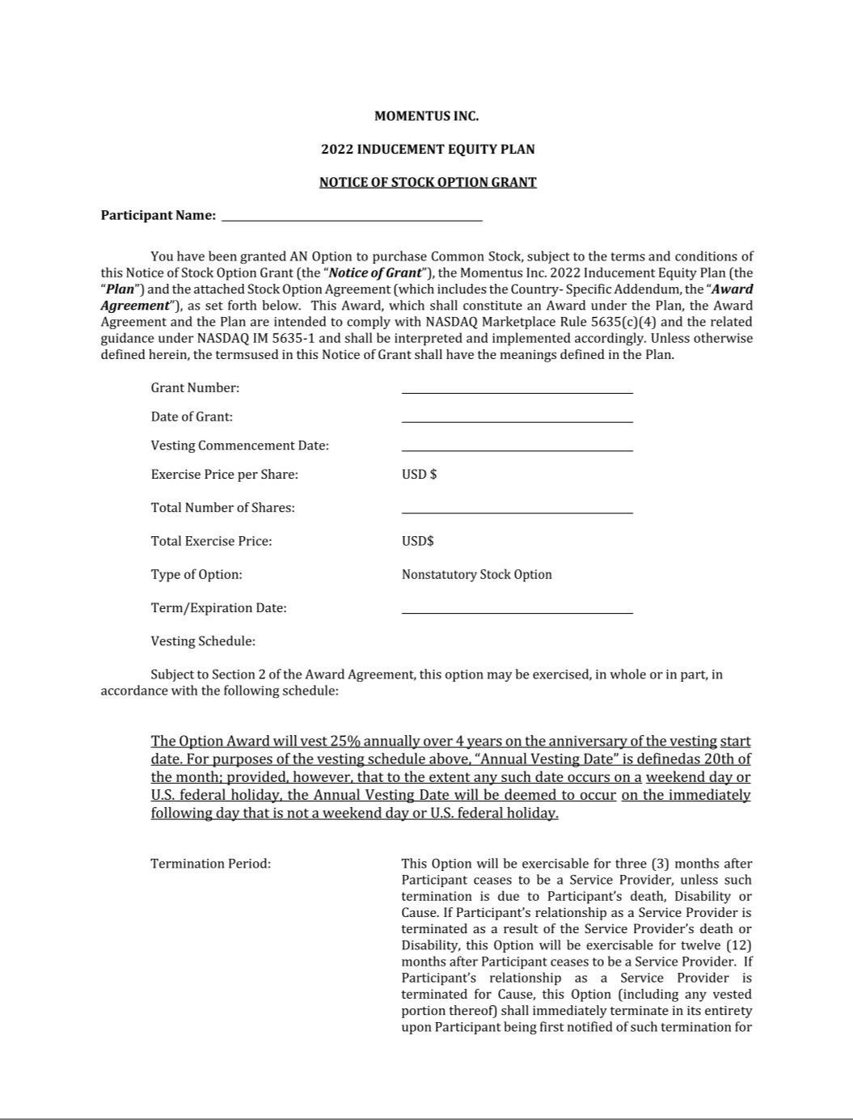

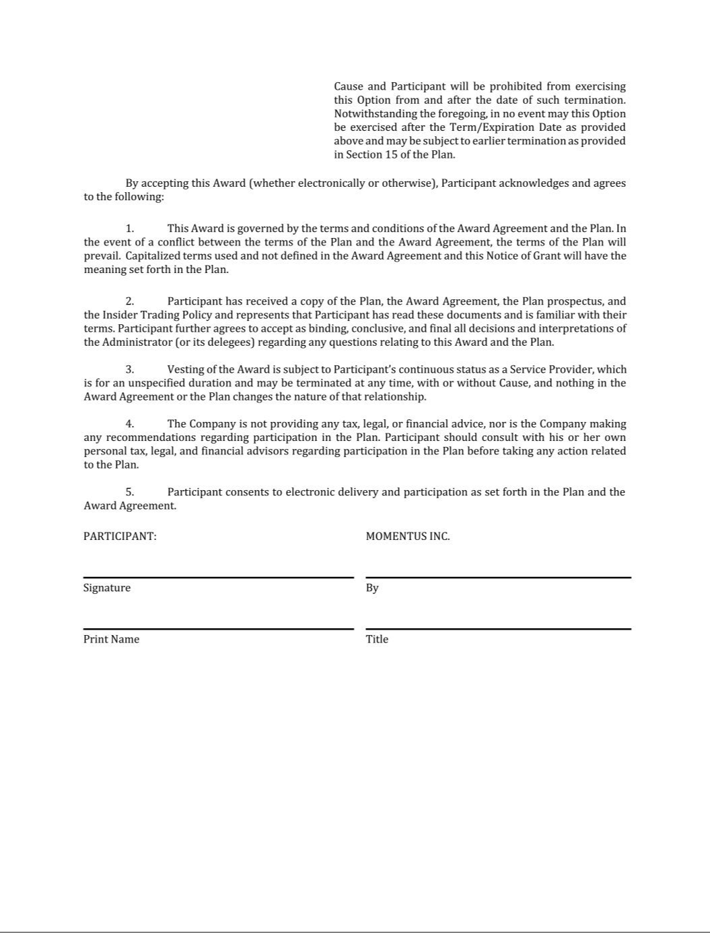

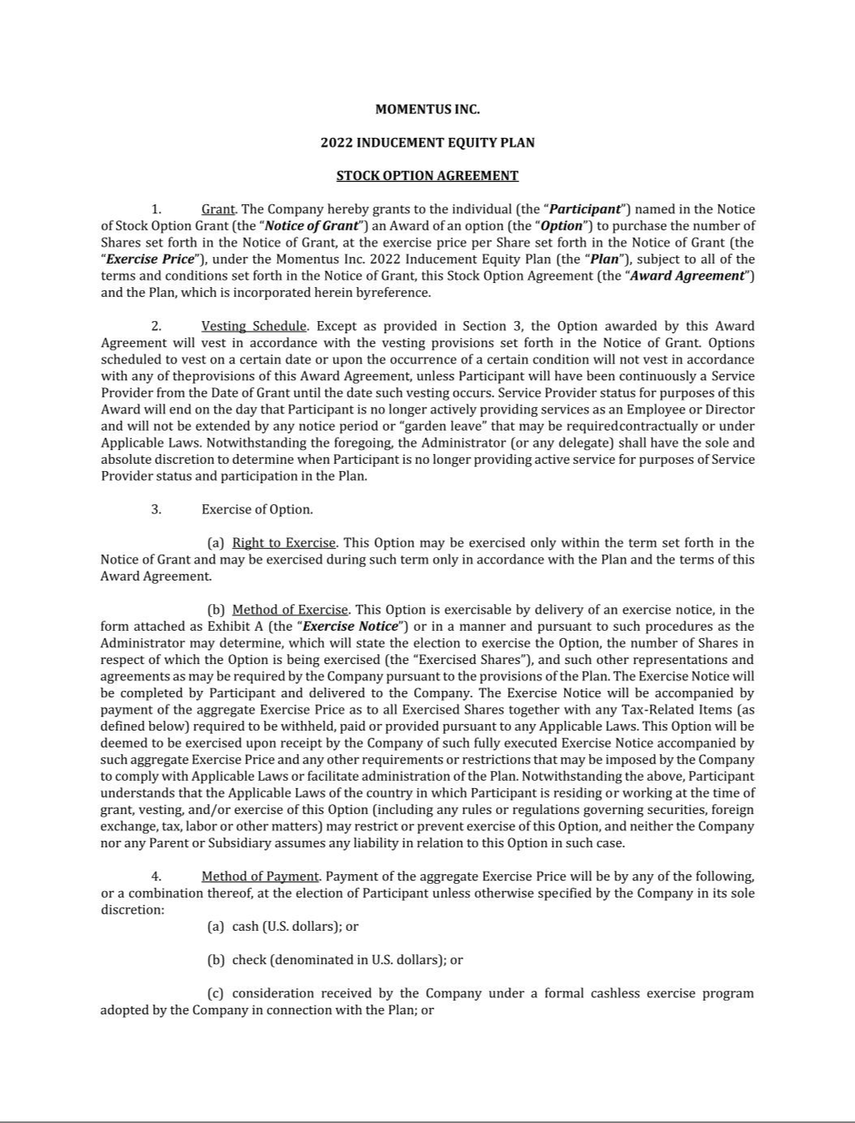

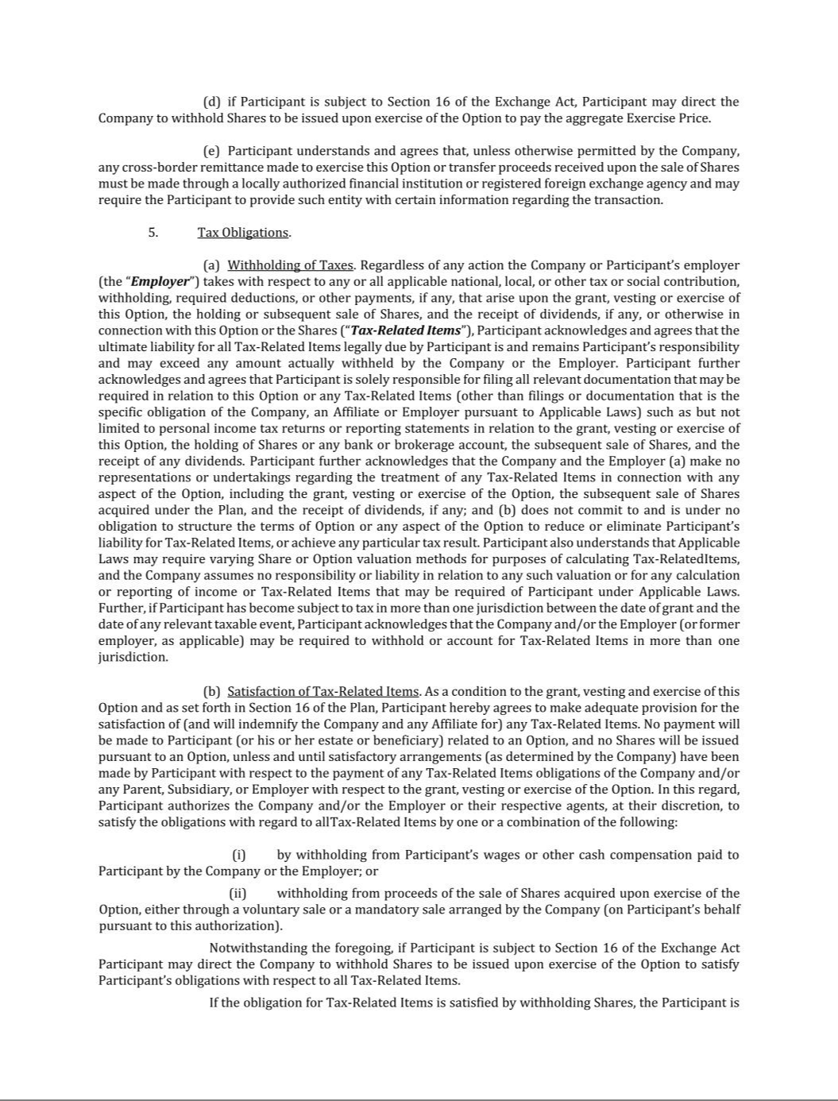

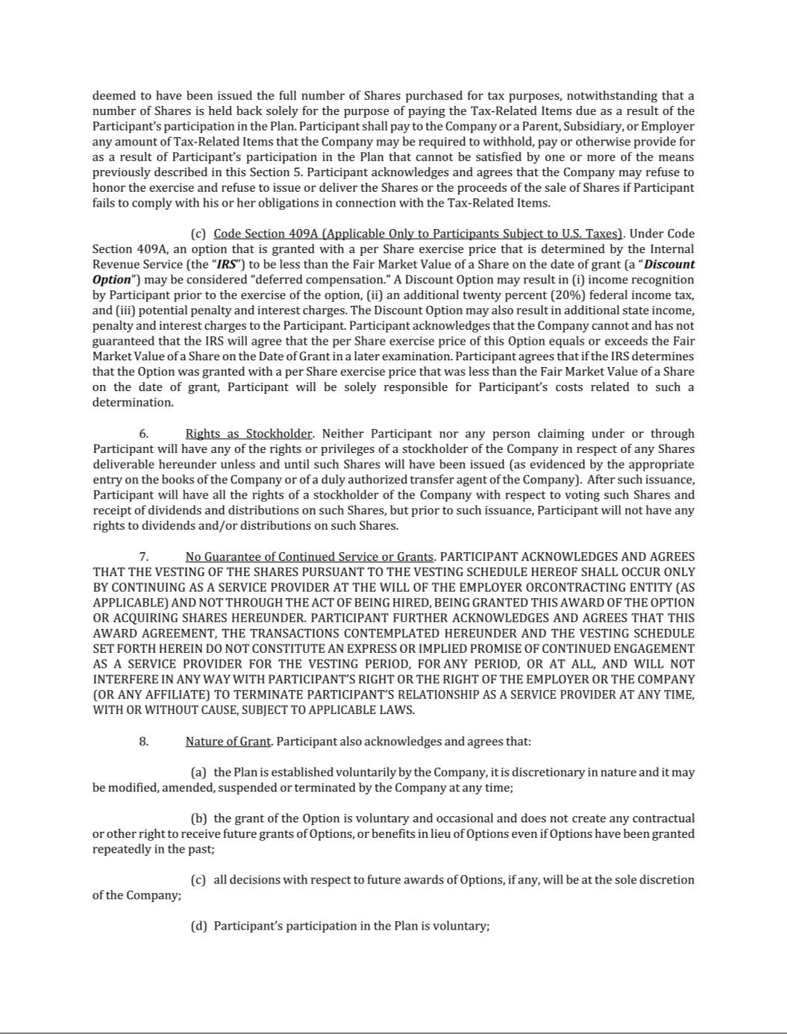

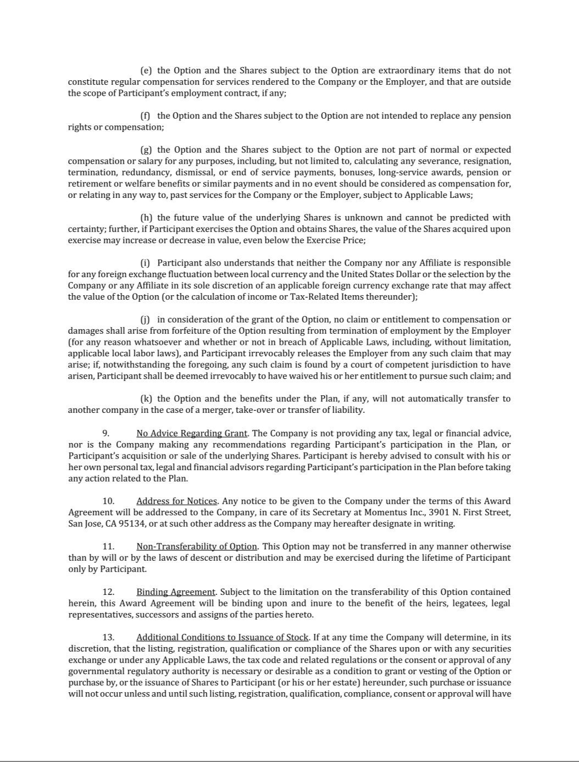

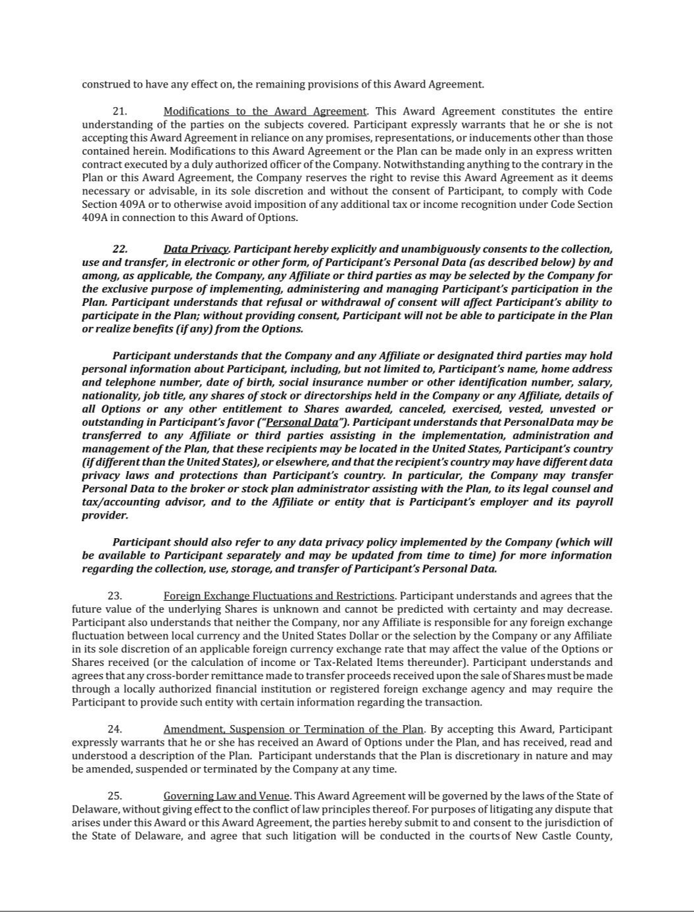



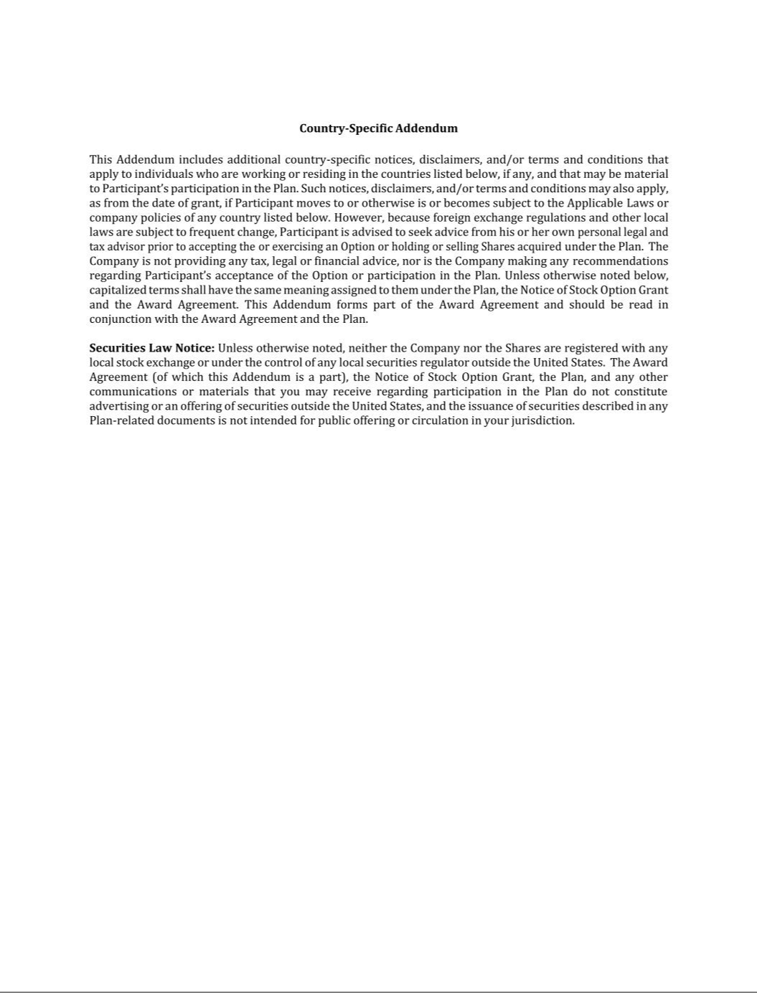

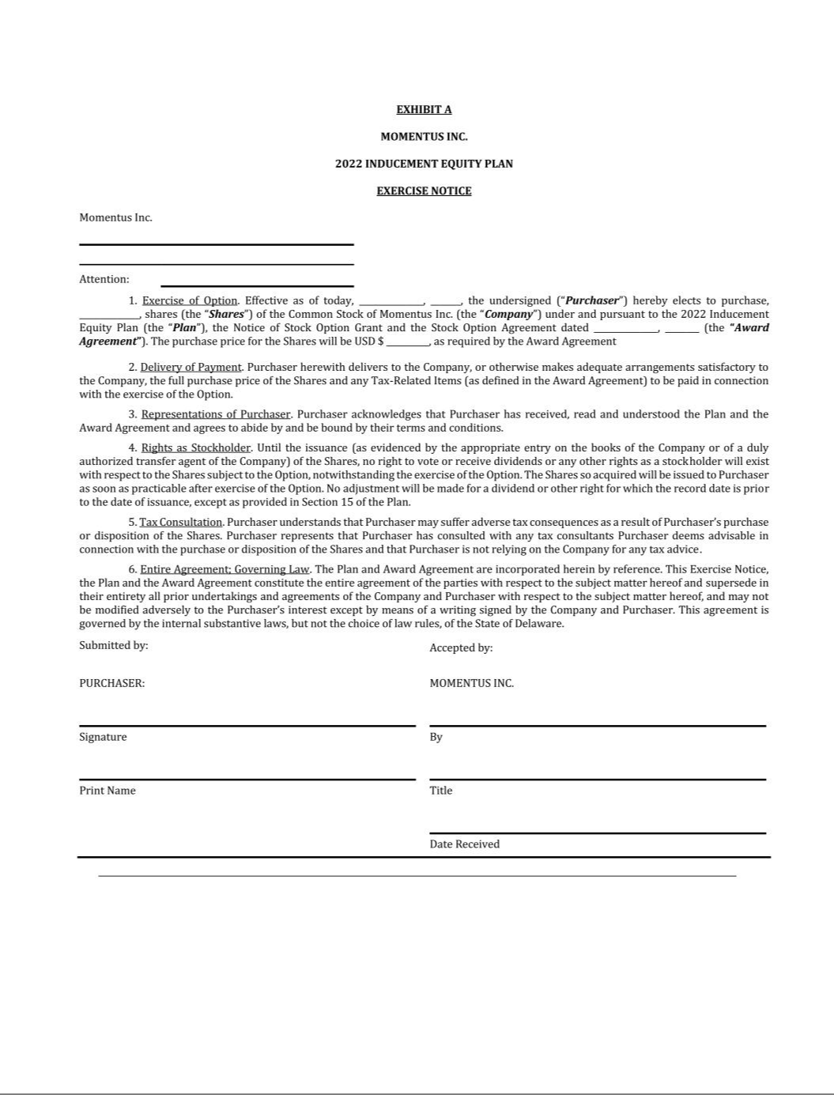

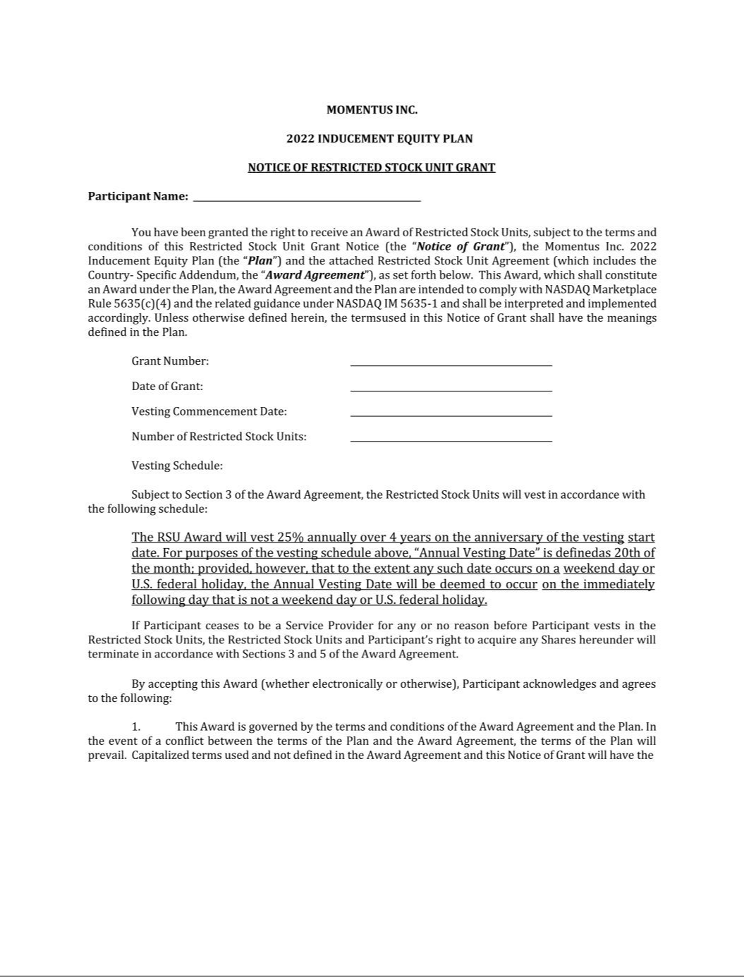

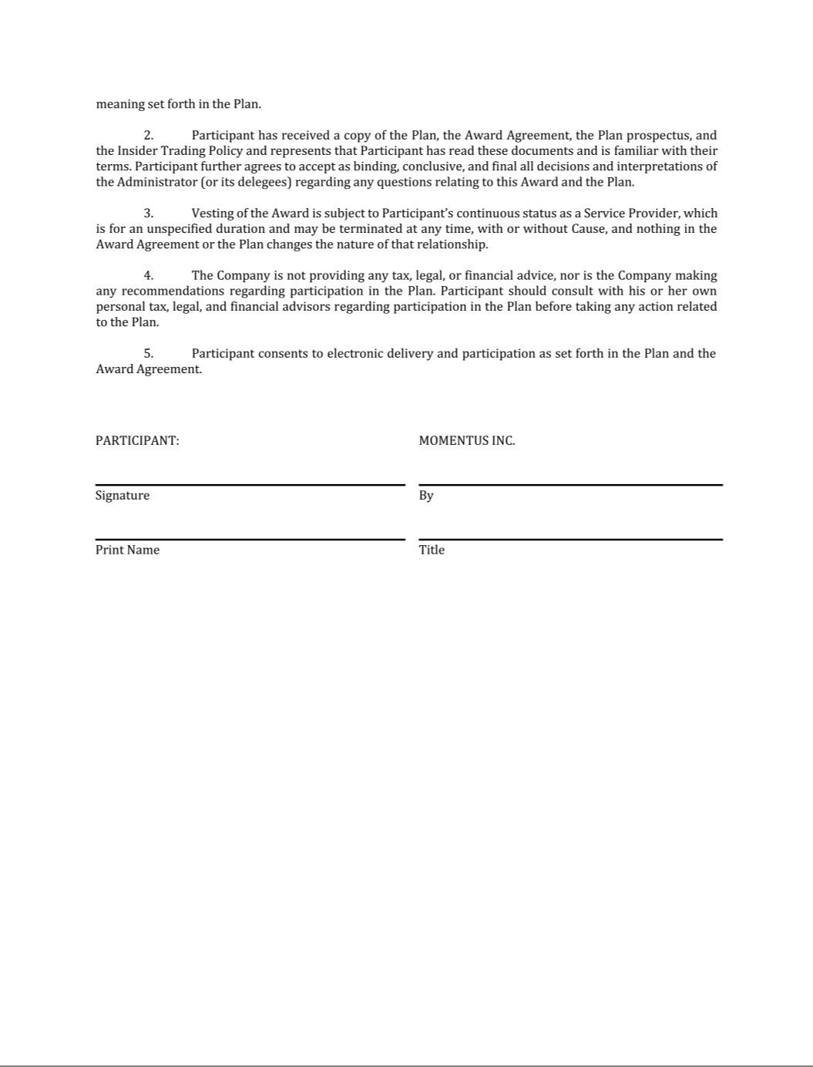

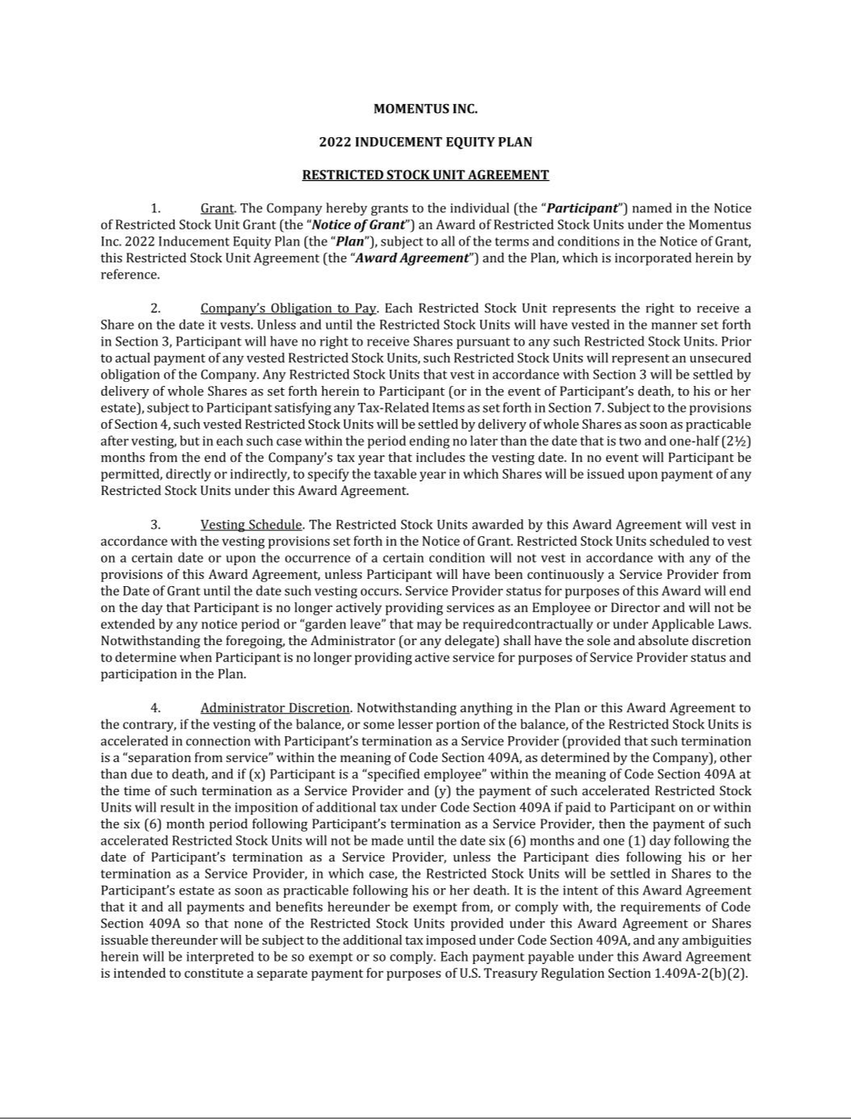

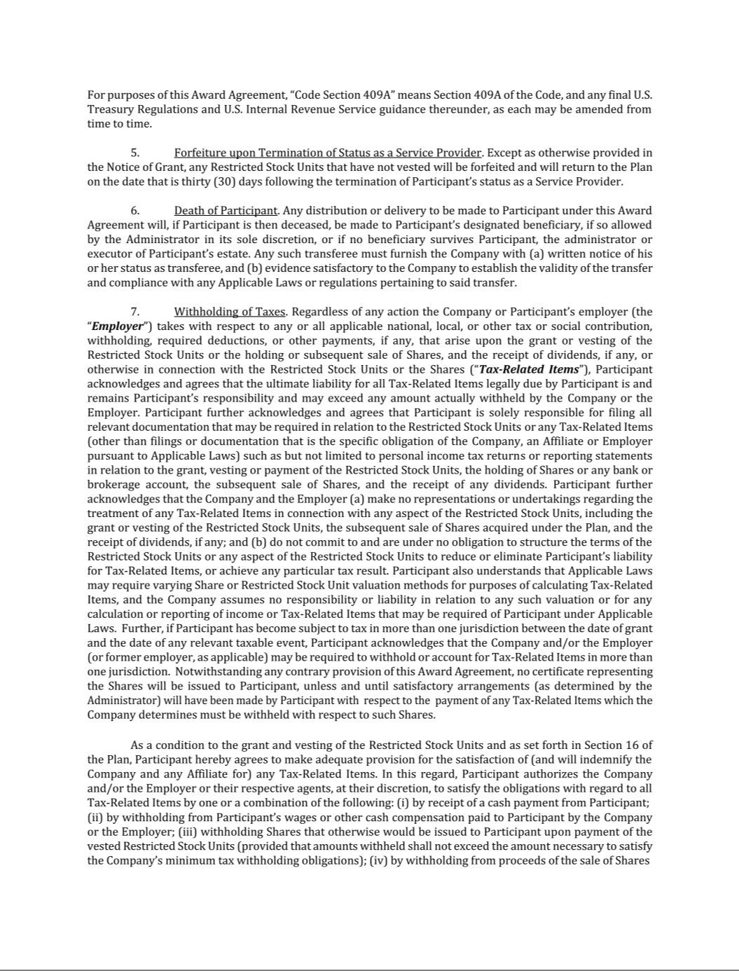

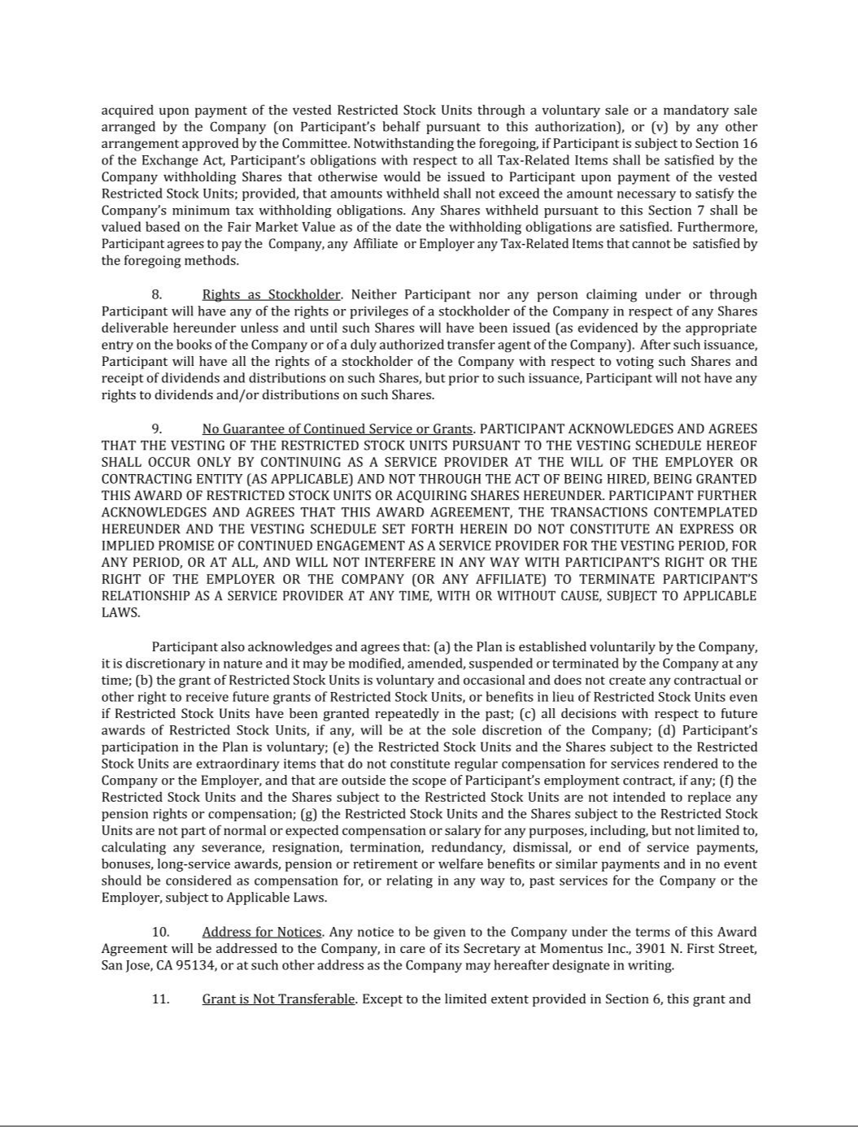

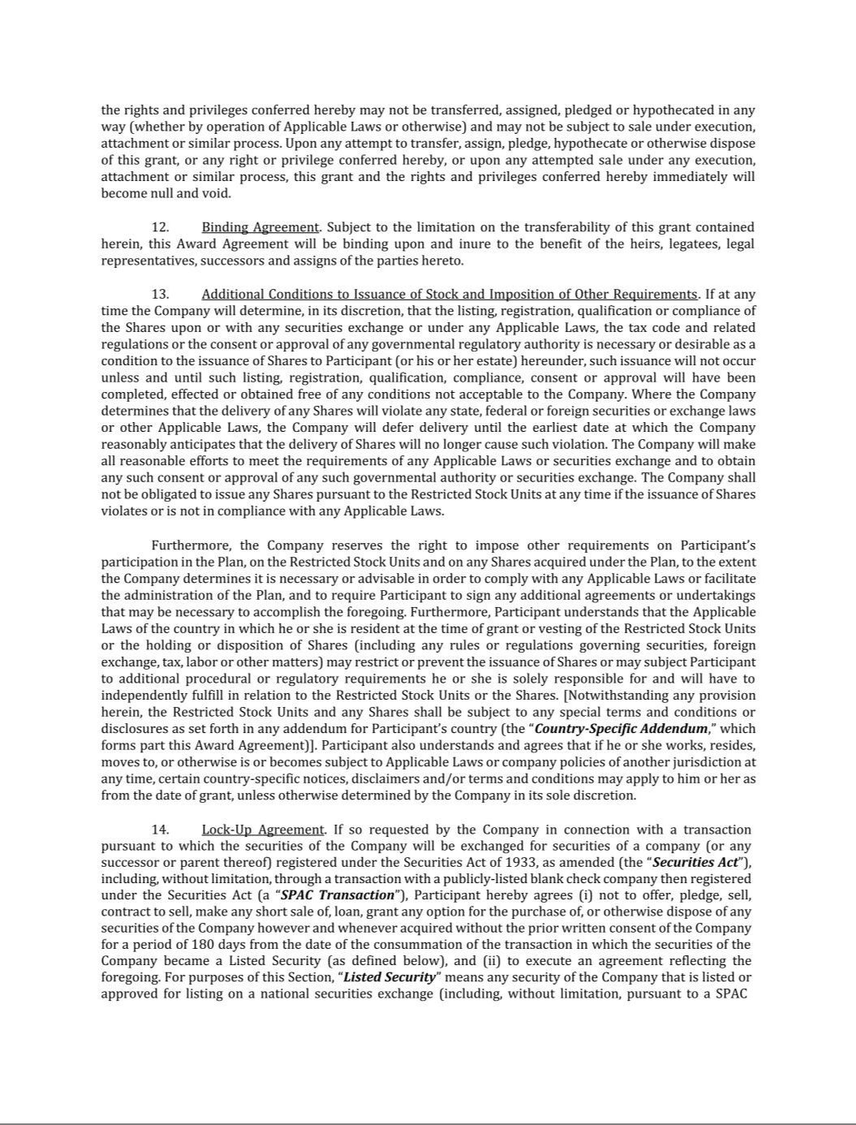

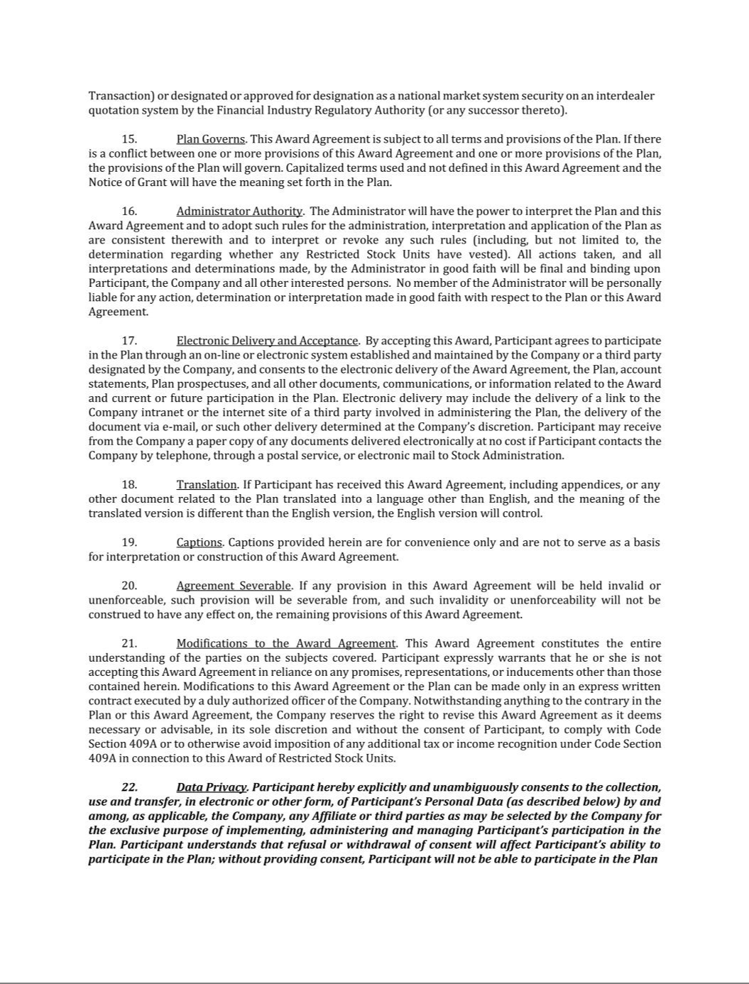

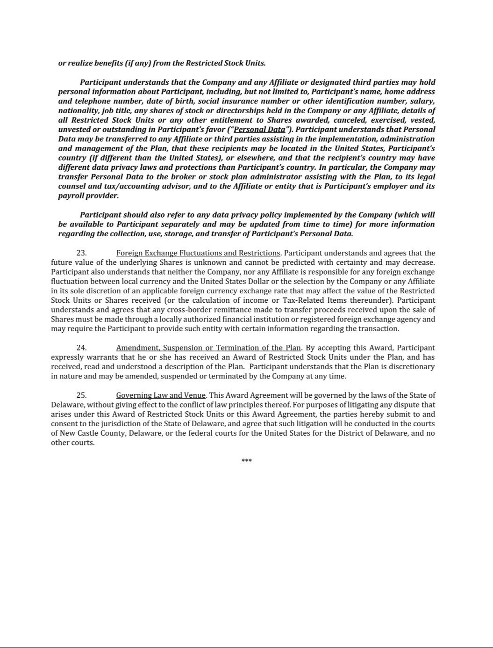

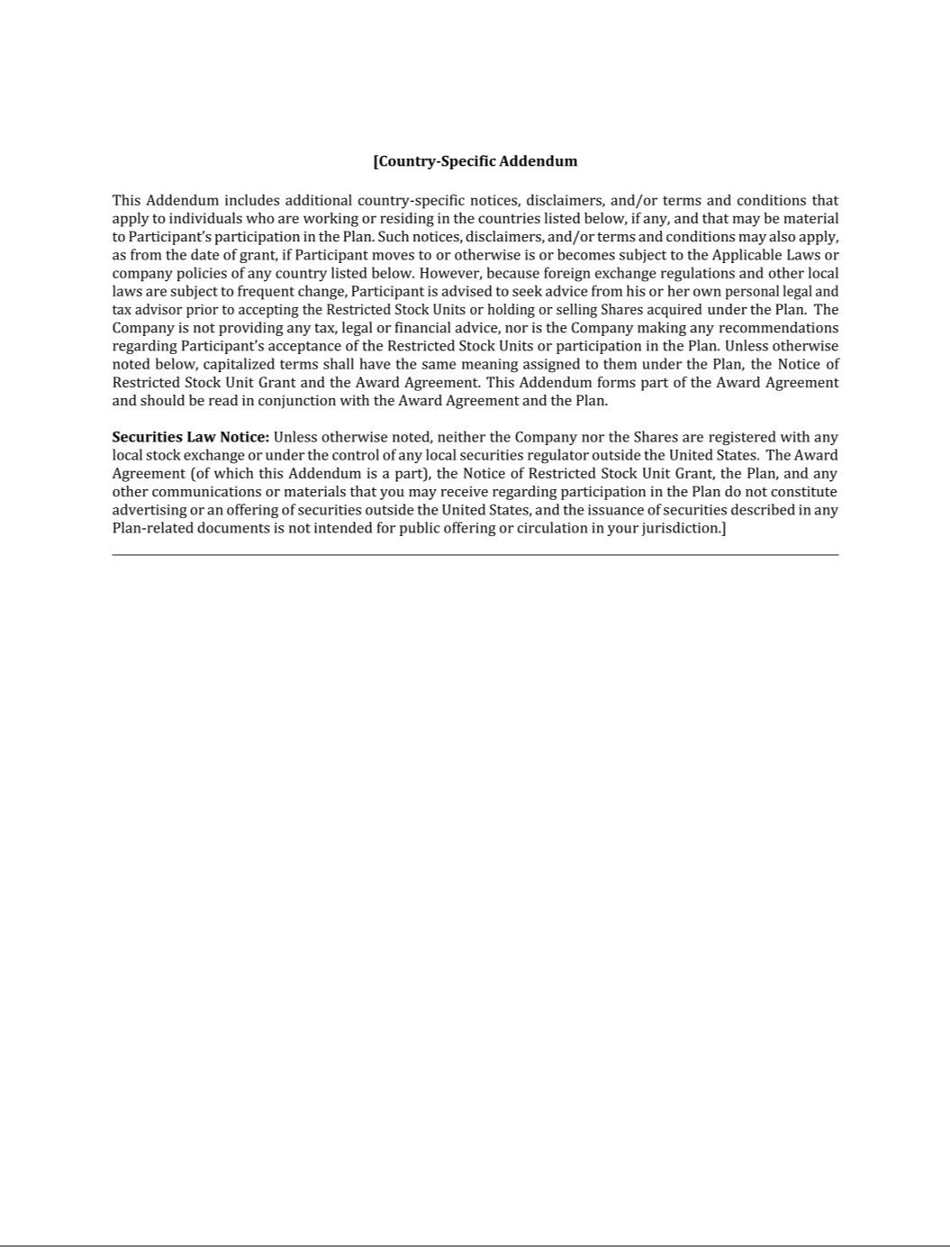

Exhibit 31.1

CERTIFICATION OF PRINCIPAL EXECUTIVE OFFICER

PURSUANT TO 18 U.S.C. SECTION 1350,

AS ADOPTED PURSUANT TO SECTION 302 OF

THE SARBANES-OXLEY ACT OF 2002

I, John Rood, certify that:

- I have reviewed this Quarterly Report on Form 10-Q of Momentus Inc.;

- Based on my knowledge, this report does not contain any untrue statement of a material fact or omit to state a material fact necessary to make the statements made, in light of the circumstances under which such statements were made, not misleading with respect to the period covered by this report;

- Based on my knowledge, the financial statements, and other financial information included in this report, fairly present in all material respects the financial condition, results of operations and cash flows of the registrant as of, and for, the periods presented in this report;

- The registrant’s other certifying officer and I are responsible for establishing and maintaining disclosure controls and procedures (as defined in Exchange Act Rules 13a-15(e) and 15d-15(e)) and internal control over financial reporting (as defined in Exchange Act Rules 13a-15(f) and 15d-15(f)) for the registrant and have:

  - designed such disclosure controls and procedures, or caused such disclosure controls and procedures to be designed under our supervision, to ensure that material information relating to the registrant, including its consolidated subsidiaries, is made known to us by others within those entities, particularly during the period in which this report is being prepared;

  - designed such internal control over financial reporting, or caused such internal control over financial reporting to be designed under our supervision, to provide reasonable assurance regarding the reliability of financial reporting and the preparation of financial statements for external purposes in accordance with generally accepted accounting principles;

  - evaluated the effectiveness of the registrant’s disclosure controls and procedures and presented in this report our conclusions about the effectiveness of the disclosure controls and procedures, as of the end of the period covered by this report based on such evaluation; and

  - disclosed in this report any change in the registrant’s internal control over financial reporting that occurred during the registrant’s most recent fiscal quarter (the registrant’s fourth fiscal quarter in the case of an annual report) that has materially affected, or is reasonably likely to materially affect, the registrant’s internal control over financial reporting; and

- The registrant’s other certifying officer and I have disclosed, based on our most recent evaluation of internal control over financial reporting, to the registrant’s auditors and the audit committee of the registrant’s board of directors (or persons performing the equivalent functions):

  - all significant deficiencies and material weaknesses in the design or operation of internal control over financial reporting which are reasonably likely to adversely affect the registrant’s ability to record, process, summarize and report financial information; and

  - any fraud, whether or not material, that involves management or other employees who have a significant role in the registrant’s internal control over financial reporting.

 |  | By: | /s/John Rood
 |  | Name: | John Rood
Dated: | May 10, 2021 | Title: | Chief Executive Off

Exhibit 31.2

CERTIFICATION OF PRINCIPAL FINANCIAL OFFICER

PURSUANT TO 18 U.S.C. SECTION 1350,

AS ADOPTED PURSUANT TO SECTION 302 OF

THE SARBANES-OXLEY ACT OF 2002

I, Jikun Kim, certify that:

- I have reviewed this Quarterly Report on Form 10-Q of Momentus Inc.;

- Based on my knowledge, this report does not contain any untrue statement of a material fact or omit to state a material fact necessary to make the statements made, in light of the circumstances under which such statements were made, not misleading with respect to the period covered by this report;

- Based on my knowledge, the financial statements, and other financial information included in this report, fairly present in all material respects the financial condition, results of operations and cash flows of the registrant as of, and for, the periods presented in this report;

- The registrant’s other certifying officer and I are responsible for establishing and maintaining disclosure controls and procedures (as defined in Exchange Act Rules 13a-15(e) and 15d-15(e)) and internal control over financial reporting (as defined in Exchange Act Rules 13a-15(f) and 15d-15(f)) for the registrant and have:

  - designed such disclosure controls and procedures, or caused such disclosure controls and procedures to be designed under our supervision, to ensure that material information relating to the registrant, including its consolidated subsidiaries, is made known to us by others within those entities, particularly during the period in which this report is being prepared;

  - designed such internal control over financial reporting, or caused such internal control over financial reporting to be designed under our supervision, to provide reasonable assurance regarding the reliability of financial reporting and the preparation of financial statements for external purposes in accordance with generally accepted accounting principles;

  - evaluated the effectiveness of the registrant’s disclosure controls and procedures and presented in this report our conclusions about the effectiveness of the disclosure controls and procedures, as of the end of the period covered by this report based on such evaluation; and

  - disclosed in this report any change in the registrant’s internal control over financial reporting that occurred during the registrant’s most recent fiscal quarter (the registrant’s fourth fiscal quarter in the case of an annual report) that has materially affected, or is reasonably likely to materially affect, the registrant’s internal control over financial reporting; and

- The registrant’s other certifying officer and I have disclosed, based on our most recent evaluation of internal control over financial reporting, to the registrant’s auditors and the audit committee of the registrant’s board of directors (or persons performing the equivalent functions):

  - all significant deficiencies and material weaknesses in the design or operation of internal control over financial reporting which are reasonably likely to adversely affect the registrant’s ability to record, process, summarize and report financial information; and

  - any fraud, whether or not material, that involves management or other employees who have a significant role in the registrant’s internal control over financial reporting.

 |  | By: | /s/Jikun Kim
 |  | Name: | Jikun Kim
Dated: | May 10, 2022 | Title: | Chief Financial Off

Exhibit 32.1

CERTIFICATION PURSUANT TO

18 U.S.C. SECTION 1350,

AS ADOPTED PURSUANT TO SECTION 906 OF

THE SARBANES-OXLEY ACT OF 2002

In connection with the Quarterly Report on Form 10-Q of Momentus Inc., a Delaware corporation (the “Company”), on Form 10-Q for the fiscal quarter ended March 31, 2022, as filed with the Securities and Exchange Commission on the date hereof (the “Form 10-Q”), I, John Rood, Chief Executive Officer of the Company, certify, pursuant to 18 U.S.C. section 1350, as adopted pursuant section 906 of the Sarbanes-Oxley Act of 2002, that to the best of our knowledge:

- the Form 10-Q fully complies, in all material respects, with the requirements of section 13(a) or section 15(d) of the Securities Exchange Act of 1934, as amended; and

- the information contained in the Form 10-Q fairly presents, in all material respects, the financial condition and result of operations of the Company.

 |  | By: | /s/John Rood
 |  | Name: | John Rood
Dated: | May 10, 2021 | Title: | Chief Executive Officer

This certification shall not be deemed “filed” for purposes of Section 18 of the Securities Exchange Act of 1934, as amended (the “Exchange Act”), or incorporated by reference in any filing under the Securities Act of 1933, as amended, or the Exchange Act, except as shall be expressly set forth by specific reference in such a filing.

Exhibit 32.2

CERTIFICATION PURSUANT TO

18 U.S.C. SECTION 1350,

AS ADOPTED PURSUANT TO SECTION 906 OF

THE SARBANES-OXLEY ACT OF 2002

In connection with the Quarterly Report on Form 10-Q of Momentus Inc., a Delaware corporation (the “Company”), on Form 10-Q for the fiscal quarter ended March 31, 2022, as filed with the Securities and Exchange Commission on the date hereof (the “Form 10-Q”), I, Jikun Kim, Chief Financial Officer of the Company, certify, pursuant to 18 U.S.C. section 1350, as adopted pursuant section 906 of the Sarbanes-Oxley Act of 2002, that to the best of our knowledge:

- the Form 10-Q fully complies, in all material respects, with the requirements of section 13(a) or section 15(d) of the Securities Exchange Act of 1934, as amended; and

- the information contained in the Form 10-Q fairly presents, in all material respects, the financial condition and result of operations of the Company.

 |  | By: | /s/Jikun Kim
 |  | Name: | Jikun Kim
Dated: | May 10, 2022 | Title: | Chief Financial Officer

This certification shall not be deemed “filed” for purposes of Section 18 of the Securities Exchange Act of 1934, as amended (the “Exchange Act”), or incorporated by reference in any filing under the Securities Act of 1933, as amended, or the Exchange Act, except as shall be expressly set forth by specific reference in such a filing.

